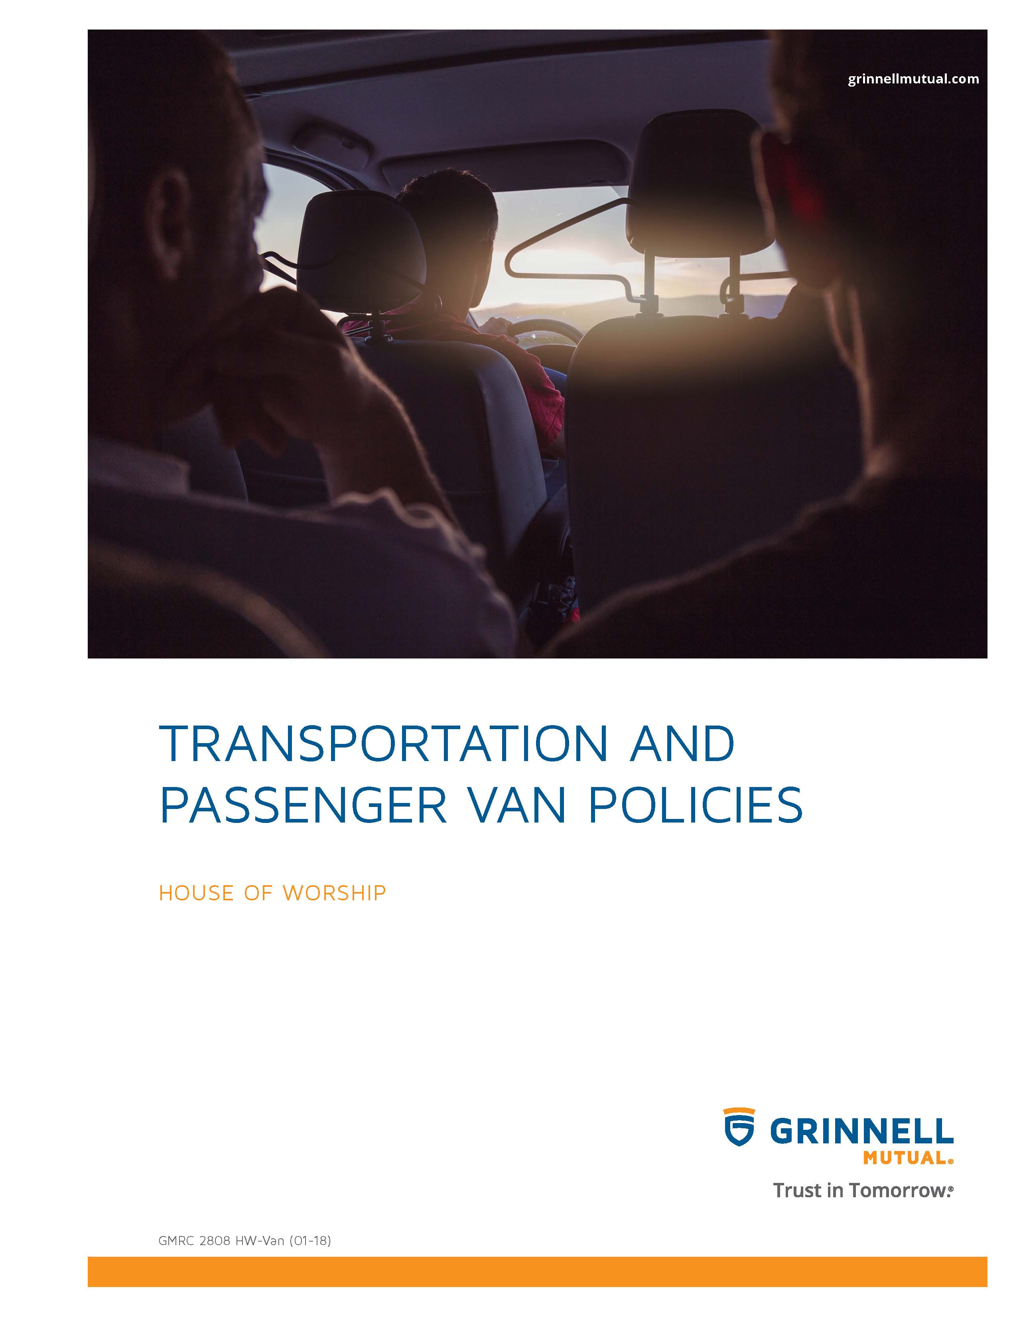

Disclaimer
This booklet has been developed by Grinnell Mutual Reinsurance Company and is for informational purposes only. It was designed to provide reasonably accurate information in regard to the subject matters covered. The information contained herein has been obtained from sources that we believe to be competent and reliable.
Grinnell Mutual Reinsurance Company is aware that this booklet will not fit the operations of all companies. Applicable state/federal statutes must supersede any conflicting statements made or referred to in this booklet.
Grinnell Mutual Reinsurance Company cannot be held responsible or liable for any damages, direct or indirect, which may arise, in part or in whole, from the use of this booklet or from any representation or misrepresentation contained therein. Also, it cannot be assumed that all acceptable safety and health measures are listed in this booklet.

Table of Contents
Vehicle Safety 2
Considerations When Operating Vans 3
Accident Reporting 4
Inspection Records and Preventive Maintenance 5
Other Information Sources 5
Appendixes
A. Vehicle Inspection Report 6
B. Preventive Maintenance Report 7
C. Vehicle Accident Summary Report 8
D. Supervisors Motor Vehicle Accident Investigation Report 9
E. Passenger Van Agreement 10
F. 15-Passenger Van Safety Acknowledgement 11
G. Other Informational Sources 12

TRANSPORTATION & PASSENGER VAN POLICIES
VEHICLE SAFETY
The following Vehicle Safety Rules/Regulations may not all apply to your house of worship. Please add any formal or informal vehicle rules/regulations your house of worship may have in place to this list and delete those that do not apply to your house of worship. Developing a Vehicle Safety Program unique to your house of worship’s operation should be more effective in helping you to control frequent/severe vehicle losses.
All employees, volunteers, and house of worship members who drive a vehicle owned or leased by the house of worship must abide by the following safety rules:
1. The Driver of the vehicle is required to inspect the vehicle (before taking it on the road) to ensure that it is in safe working condition. This includes properly working brakes, horns, and back-up alarms. Note an example of Vehicle Inspection Report in Appendix A.
2. Any defects in the vehicle should be reported promptly to (insert name of individual or group that is responsible for overseeing house of worship vehicle safety).
3. All DRIVERS are required to obey all state, local, and house of worship traffic regulations.
4. Engines are to be stopped and ignition keys removed when parking, refueling, or leaving the house of worship owned/leased vehicles.
5. Employees, volunteers, and house of worship members are not permitted to use personal cars or motorcycles for house of worship business, unless specifically authorized by (insert name of individual or group overseeing safety associated with motor vehicle operations). If personal vehicles are driven on house of worship business, proof of personal auto coverage (i.e. copy of personal auto declarations page or copy of the insurance card from the vehicle) will be requested on an annual unannounced basis from all individuals that operate their own vehicles on house of worship business.
6. Passengers that are not house of worship employees, volunteers, house of worship members or individuals that have received prior approval from appropriate house of worship personnel to be transported, should not be transported in a house of worship owned, house of worship leased, or house of worship member vehicles at any time.
7. All drivers of house of worship owned, house of worship leased, employee/member, or volunteer owned vehicle should be driven in a safe manner and all drivers of such vehicles should practice defensive driving techniques at all times.
8. Seat belts and shoulder harnesses are to be worn at all times.
9. Vehicles must be locked when unattended to avoid criminal misconduct.
10. Vehicles must be parked in legal spaces and must not obstruct traffic.
11. Employees, volunteers and members should park their vehicles in well-lighted areas at or near entrances to avoid criminal misconduct.
12. Employees, volunteers and house of worship members transporting other members, visitors, or others on business for the house of worship should keep their headlights on at all times.
13. A vehicle, when loaded with any material extending 4 feet or more beyond its rear, shall have a red flag or cloth 12 inches square attached by day or a red light visible for 300 feet by night on the extreme end of the load.
14. Articles, tools, equipment, etc. placed in cars or vans are to be placed and secured in such a manner as not to impair vision or in any way interfere with proper operation of the vehicle.
15. When you cannot see behind your vehicle (van), the driver should walk behind the van prior to backing.

16. Personal use of house of worship owned or leased vehicles is not permitted without written approval from (insert the name of the individual or house of worship group that is permitted to make decisions on issues such as this). Family members of house of worship employees that are provided with an owned or leased house of worship vehicle are prohibited from driving said vehicle at any time unless prior written approval has been obtained from (insert the name of the individual or group listed above that is permitted to make decisions such as this on behalf of the house of worship organization). (Exception: in case of an emergency, where the employee is not able to operate the house of worship vehicle, no prior written approval is required). Violation of this policy may result in disciplinary action which may include termination of employment.
17. Every accident should be reported to (insert title of individual or group within the house of worship that monitors motor vehicle accidents such as the Safety Director, house of worship Council, house of worship Board, etc.). The INDIVIDUAL LISTED IN PRIOR SENTENCE should investigate all accidents and review them with the employee or volunteer driving the house of worship owned or leased vehicle at the time of the accident. Note an example of a Supervisor’s Motor Vehicle Accident Investigation Report in Appendix D.
18. When operating vehicles within the house of worship parking lot or at an off-premise function parking lot, speeds must not exceed 5 mph.
19. Drivers should not, at any time, operate a house of worship owned, leased, or privately owned vehicle (transporting house of worship members, volunteers, or visitors) if fatigued, if alcohol has been consumed or if legal or illegal substances have been consumed. These conditions can dramatically affect the driver’s reaction time in the event of an emergency or impair the driver’s judgment and thus increase the probability of a motor vehicle accident.
CONSIDERATIONS WHEN OPERATING VANS
1. All passengers and cargo transported in vans should be placed, if at all possible, IN FRONT OF THE REAR AXLE OF THE VAN. This practice will help to decrease the probability of van rollover.
2. All drivers of vans should require, without exception, passengers fill each row of seats beginning in the front of the vehicle prior to sitting in the rows towards the middle or rear of the vehicle. This should help decrease the probability of van rollover accidents.
3. All passenger van drivers should require, without exception, that each passenger within the van wear the seat and shoulder belt supplied with the vehicle prior to trip departure. Failure to wear the seat/shoulder belts should be grounds for removing the passenger from the vehicle. Approximately 80% of passengers that die in passenger van rollovers were not wearing seat belts and were ejected from the vehicle.
4 Within passenger vans, always place passengers 12 years of age or younger in rear seats (after the front seats are filled by adults or older children). This is extremely important if the vehicle is equipped with front or side air bags.
5. Passenger vans should not be used, at any time, to tow trailers or other vehicles.
6. Passenger vans should not be used, at any time, to transport cargo on the roof of the vehicle. This practice will increase the probability of the vehicle, with an already high center of gravity, being involved in a rollover accident.
7. On long trips, a minimum of two experienced drivers of passenger vans should travel in each vehicle. This will allow for changing of drivers prior to one becoming fatigued and operating a motor vehicle in an unsafe condition.
8. In addition to evaluating a prospective driver’s motor vehicle record (MVR), each prospective driver of a passenger van should be required to complete a road test monitored by (insert name of the individual or individuals responsible for evaluating motor vehicle safety at your house of worship). Those individuals that do not successfully complete a road test should not be permitted to operate a motor vehicle for your organization. A re-evaluation of the driver’s skill level should not be permitted until the driver has successfully completed a defensive driving course or has obtained a minimum of one (1) year additional experience operating the vehicle for which he/she was being evaluated to operate.

9. Although not required within vans transporting less than 15-passengers and 1 driver, it is recommended that all drivers of vans with 10 or more passengers, including the driver, be required to have a Commercial Drivers License (CDL) or have passed a defensive driving course.
10. All drivers of vans with 10 or more passengers should be required to have a minimum of 1 year experience driving equipment similar to the type for which they were hired by the house of worship.
11. Drivers of passenger vans with 10 or more passengers should be limited to those screened and hired for such purposes. Volunteers not meeting the above listed requirements should not be permitted, at any time, to operate vans transporting passengers.
12. All drivers of vans with 10 or more passengers should be informed of the potential for vehicle rollover and preventive measures to avoid vehicle rollovers.
13. Vehicles should not be used for livery, taxiing or transportation of persons for pay or donations.
14. Vehicles should not be provided to other organizations or individuals for non-house of worship functions.
15. All 15-passenger vans must have a dual rear wheel system, after market Roadmaster Active Suspension (RAS) system or one of the following factory installed ESC (Electronic Stability Control) systems:
a. StabiliTrak
b. Advance Trac
c. Vehicle Dynamics Control
d. Precision Control System
16. All drivers of vans with 10 or more passengers should be required to sign a van safety acknowledgement form. Note an example of a 15-Passenger Van Safety Acknowledgement in Appendix F.
17. The National Highway Traffic Safety Administrations 15-Passenger Van Safety Alert, designed to be hung from rearview mirrors within these vans, should be present in all such vehicles to remind drivers of methods to prevent vehicle rollover.
18. All vans with 10 or more passengers should be loaded from the front of the vehicle to the back. Passengers, luggage, and cargo should NOT be present behind the rear axle of the van, unless all seats in front of the rear axle are filled.
19. All vehicles should be equipped with a seatbelt for each passenger. Those vehicles not meeting these requirements should be retrofitted to add seatbelts for the rated capacity of the vehicles OR those seats without a seat belt for each passenger should be removed from the vehicle.
20. Van drivers should have a cell phone and a list of emergency numbers. The cell phone should be used for emergencies only, and is to be used only when the van is safely parked.
21. All van passengers should be requested to sign a passenger agreement before being allowed to ride in the van on trips. Note an example of a Passenger Van Agreement in Appendix E.
ACCIDENT REPORTING
1. Driver Conduct at the Scene of the Accident
a. Take immediate action to prevent further damage or injury.
(1) Pull onto the shoulder or side of the road.
(2) Activate hazard lights (flashers) and place warning signs promptly.
(3) Assist any injured person, but don’t move them unless they are in danger of further injury.
b. Call the Police
If someone is injured, request medical assistance.

c. The vehicle should not be left unattended, except in an extreme emergency.
d. Exchange identifying information with the other driver. Make no comments about assuming responsibility.
e. Secure names, addresses, and phone numbers of all witnesses, or the first person on the scene if no one witnessed the accident.
f. Call the house of worship immediately and report the accident to the Safety Director or Supervisor.
2. Complete the Vehicle Accident Report Form
Complete the Vehicle Accident Report Form. A copy can be obtained from the (insert title of person or group responsible for fleet safety within your house of worship here, such as Safety Director, Supervisor, house of worship Council, house of worship Board, etc.) and provide it to the (insert title of person listed that should receive completed Accident Report Form here). Write legibly. Answer all questions completely or mark “not known”. Use additional sheets of paper as needed to provide pertinent information. Note an example of a Vehicle Accident Summary Report in Appendix C and a Supervisor’s Motor Vehicle Accident Investigation Report in Appendix D.
INSPECTION RECORDS & PREVENTIVE MAINTENANCE
All drivers of house of worship owned or leased vehicles must regularly inspect and confirm that vehicles remain in good repair, and receive appropriate preventive maintenance in a timely manner. All vehicle parts and accessories must be in a safe and proper working order at all times. Note an example of a Preventive Maintenance Report in Appendix B. The following apply:
1. Within passenger vans, check tire pressure prior to each trip. The tires should not be OVER INFLATED OR UNDER INFLATED. The tire pressure should be equal to that recommended on the sidewall by the tire manufacturer or vehicle owner’s manual. Tire blowouts are one of the leading causes of van drivers losing control of vehicles and van rollovers occurring.
2. Prior to the start of each trip, a vehicle walk around inspection should be conducted by the driver. Any defective condition should be noted and corrective actions implemented prior to the start of the trip. Special attention should be given to leaking fluids, poor tire tread, frayed or damaged engine belts, headlight/taillight with defective bulbs, etc.
3. All van drivers must complete a vehicle inspection report at the beginning of each day the van is issued. Note an example of a Vehicle Inspection Report in Appendix A.
4. Drivers of all passenger vans should complete a vehicle Preventive Maintenance Report form on a monthly basis. Notify the (insert title of individual that monitors fleet maintenance program here) of any unsafe conditions or defective parts immediately. Before the vehicle is driven again, any safety defects must be repaired. Note an example of a Preventive Maintenance Report in Appendix B.
5. A copy of the last vehicle inspection report must be kept in the vehicle for at least 3 months.
6. Quarterly preventive maintenance must be conducted on each vehicle.
7. Maintenance and inspection records must be kept in the house of worship office with other important documents for 1 year or for 6 months after the vehicle is sold or the lease on the vehicle expires.
8. All vehicles are subject to a search at any time.
OTHER INFORMATION SOURCES
Note Appendix G for a list of helpful resources on 15-passenger vans.

Appendix A
VEHICLE INSPECTION REPORT
(Use your safety belt)
Date:
House of Worship Name |  |  |  |  |  |  |  |  |  | Vehicle Number
Location (City, State)
Driver Name |  |  |  |  |  |  | Driver Signature
Instructions: Drivers will perform necessary inspections. A (√) indicates satisfactory condition. An (X) indicates unsafe or improper conditions. An (O) indicates condition does not apply. Corrected deficiencies should be circled by (insert title of house of worship member(s) responsible for monitoring motor vehicle safety at the house of worship).
INSIDE  Parking brake (apply)  Apply brake  START ENGINE  Oil pressure (light or gauge)  Instrument panel (telltale lights, buzzer, gauges)  Horn  Windshield wiper and washer  Heater-defroster  Mirrors  Steering wheel (excess play)  Turn on all lights including 4-way flasher  Starts properly  EMERGENCY EQUIPMENT  Fire extinguishers  Flags, standards, warning lights  First-aid kit  FRONT  Headlights  Identification lights  Turn signals and 4-way flasher  OTHER |  |  |  |  |  |  |  | SIDE  (Left) (Right)  Fuel tank and cap  Side marker lights  Reflectors  Tires and wheels-lugs and serviceability  Cargo tie-downs or doors  REAR  Tail lights  Stop light  Turn signals and 4-way flasher  Identification lights  Reflectors  Rear end protection (bumper)  Cargo tie-downs/doors  MECHANICAL OPERATION  Engine knocks, misses, overheats, etc.  Transmission noisy, hard shifting, jumps out of gear, other:  Steering loose, shimmy, hard, other:  Air, oil, water, leaks  Springs broken, other:  Brakes noisy, pulls soft, other:  Speedometer, tachometer
Start time: |  |  |  |  | Mileage: |  |  | End time: |  |  |  | Mileage:
Remarks/Other Defects:
Defects corrected (initial)  Yes No |  |  |  |  |  |  |  | Defect correction unnecessary (initial)
Certified by: |  |  |  |  |  |  |  |  |  |  | Date

Appendix B
PREVENTIVE MAINTENANCE REPORT
Date/Time |  |  |  | House of Worship |  |  |  |  | Location
Inspected by: |  |  |  |  |  | Employee I.D. Number
Vehicle License |  |  |  |  |  | Vehicle Number
 |  |  |  |  |  | Satisfactory |  |  | Needs Attention
Brakes:
Brake adjustment: Left Right
Brake hoses
Brake drums
Brake shoes
Parking brake
Brake pedal travel
Steering
Steering suspension
Change in steering action
Steering components
Tires
Wear/Defect
Overloading
Groove depth 2/32” minimum
Wheels
Cracks
Loose Nuts
Rims
Windows
Windows and Windshields
Wipers and Washers
Lights
Headlights
Taillights
Turn signals
Reflectors
Mirrors
Horn
Instruments/Gauges
Seat belts
Battery
Radiator and Hoses
Exhaust system
Suspension
Fuel system
Oil/Water leaks
Oil level
Water level
Transmission
Engine performance
General condition of body and interior
Comments:

Appendix C
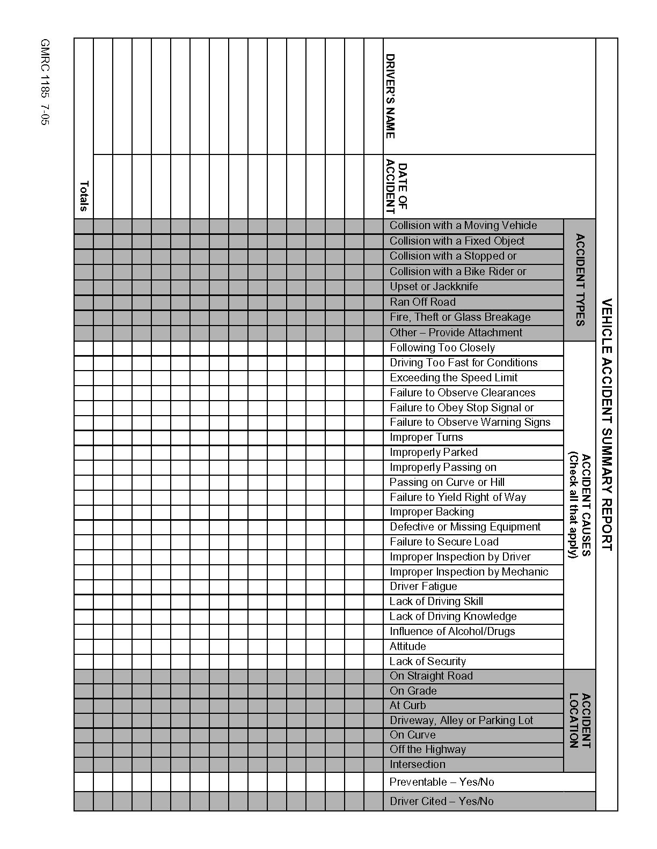

Appendix D
SUPERVISOR’S MOTOR VEHICLE ACCIDENT INVESTIGATION REPORT
DRIVER | VEHICLE |  | DATE OF ACCIDENT
LOCATION OF ACCIDENT |  |  | TIME OF ACCIDENT
DESCRIPTION OF ACCIDENT: (What happened?)
SEAT BELT WORN?
CAUSES OF ACCIDENT: (Why did it happen?)
RECOMMENDATIONS FOR PREVENTION OF A RECURRENCE: (What should be done?)
FOLLOW UP: (What actions were taken? Were they effective?)
– INDICATE WITH DIAGRAM WHAT HAPPENED  – SHOW POSITION OF VEHICLES  – INDICATE DIRECTION (NORTH, SOUTH, EAST, WEST) WITH ARROWS |  | CLASSIFICATION OF ACCIDENT REVIEW  PREVENTABLE NON-PREVENTABLE

ACCIDENTS USUALLY PREVENTABLE
Intersection Cut In or Out
Backing Pulled from Curb
Hit Other in Rear Hit Stationary Object
Skidded Hit Pedestrian
ACCIDENTS USUALLY NON-PREVENTABLE
Hit in Rear Hit When Properly Parked

Investigating House of Worship Employee’s Signature Signature or member of (insert title of Senior House of Worship
Leadership group such as House of Worship Council,
House of Worship Trustee, etc.)

Date Of Report Reviewed by (insert name of individual selected to oversee
motor vehicle safety for the House of Worship)

Reviewed By Manager Date

Appendix E
PASSENGER VAN AGREEMENT
The following safety rules are designed for use prior to each trip regardless if it is taken in a house of worship owned or leased vehicle or a private vehicle. The driver for the trip will ensure all participants read and understand the following “rules for the road”.
- Seat belts must be worn at ALL times.
- No hazardous, disruptive activity or noise will be permitted while the vehicle is moving. All passengers must follow the driver’s requests.
- Keep all objects inside the vehicle.
- All windows must be kept clear of objects that may disrupt the driver’s view.
- In cases of a crash or emergency, stop and do not exit the vehicle unless instructed by the driver or a designee. Use caution and whenever possible, exit on the sidewalk or shoulder side of the vehicle, never on the traffic side.
- Equipment and luggage should be properly secured.
- Violation of these rules may result in the termination of the trip for the entire group or the removal of a participant from the trip.
- The safety of others and myself is a priority on this trip.
I have read, understand and will comply with these rules during the entire trip.
Name: Date:
Name: Date:
Name: Date:
Name: Date:
Name: Date:
Name: Date:
Name: Date:
Name: Date:
Name: Date:
Name: Date:
Name: Date:
Name: Date:
Name: Date:

Appendix F
15-PASSENGER VAN SAFETY
ACKNOWLEDGEMENT
Anyone who may, for any reason, need to drive a house of worship owned, rented or leased vehicle for the purpose of transporting 10-15 passengers must complete the 15-Passenger Van Safety Training program and initial/sign this form.
Acknowledgement of the possible risk associated with operating a 15-passenger van.
- 15-passenger vans have a rollover risk similar to other light trucks and vans.
- The risk of rollover increases dramatically as the number of occupants is increased from fewer than five to more than ten. Vans should be loaded according to manufacturer’s recommendations.
- The weight of the van, particularly when fully occupied, causes the center of gravity to shift rearward and upward increasing the likelihood of rollover.
- The shift in the center of gravity will also increase the potential for loss of control in panic maneuvers.
- The weight of the van when fully occupied requires additional stopping distance.
- The width of the van allows for less lane room.
- The length of the van increases distance needed for making turns, changing lanes and backing.
I have read and understand the possible risk involved while operating a 15-passenger van.
(initials)
I am aware that the handling characteristics of a 15-passenger van may change dramatically, especially when fully loaded. Extra caution is required when operating this vehicle.
(initials)
The wearing of seat belts by the operator and passengers are mandatory at all times.
(initials)
I have completed the required 15-passenger van defensive driver training and road test.
(initials)
Operator’s Name: Department:
Operator’s Signature: Date:

Appendix G
OTHER INFORMATIONAL SOURCES
15-Passenger Van Information
National Highway Traffic Safety Administration
www.nhtsa.dot.gov
Insurance Institute of Highway Safety
www.hwysafety.org
National Transportation Safety Board
www.ntsb.gov
NCAA
www.ncaa.org
National Safety Council
www.nsc.org

