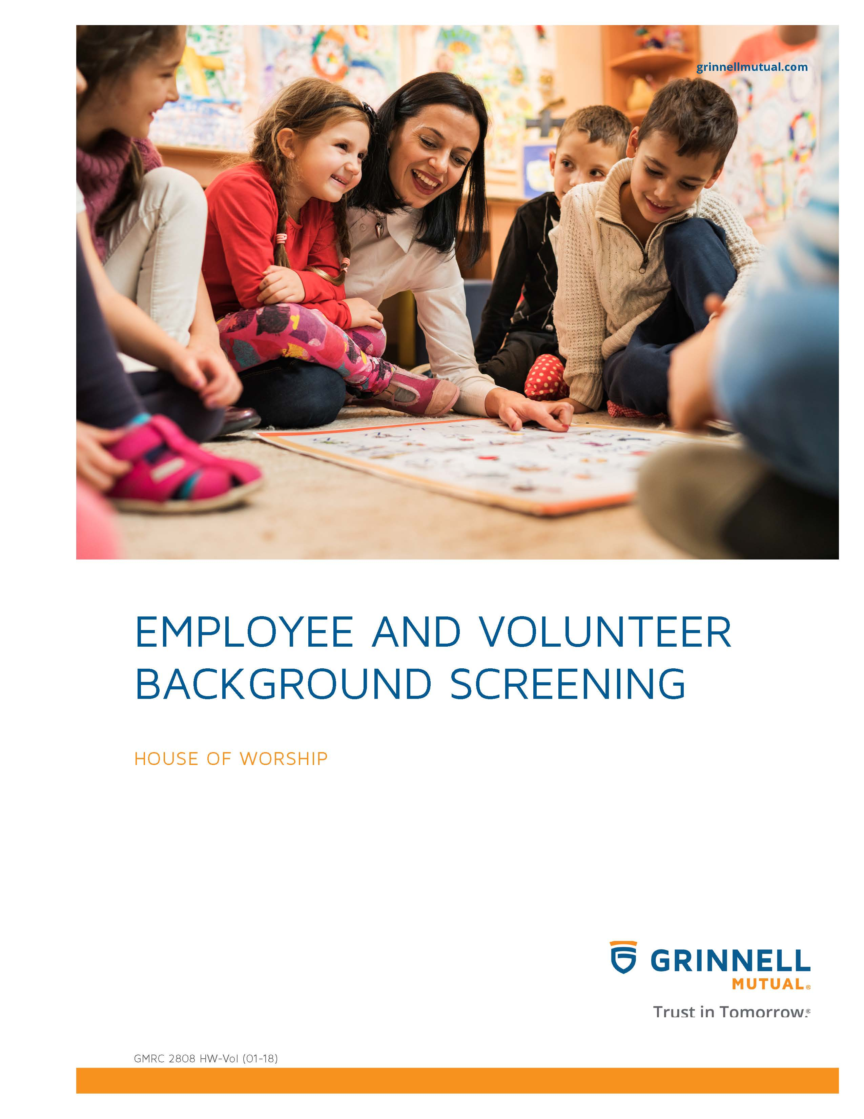

Disclaimer
This booklet has been developed by Grinnell Mutual Reinsurance Company and is for informational purposes only. It was designed to provide reasonably accurate information in regard to the subject matters covered. The information contained herein has been obtained from sources that we believe to be competent and reliable.
Grinnell Mutual Reinsurance Company is aware that this booklet will not fit the operations of all companies. Applicable state/federal statutes must supersede any conflicting statements made or referred to in this booklet.

Grinnell Mutual Reinsurance Company cannot be held responsible or liable for any damages, direct or indirect, which may arise, in part or in whole, from the use of this booklet or from any representation or misrepresentation contained therein. Also, it cannot be assumed that all acceptable safety and health measures are listed in this booklet.

Table of Contents
Reasons for a Screening Program 4
Paid and Volunteer Staff Screening and Selection Process 4
Screening and Record Security 5
Other Pertinent Information 6
Appendix
Sample Volunteer or Paid Staff Application Form 7

Employee & Volunteer Background Screening
Problems that occur in a house of worship can have harmful effects, both physically and emotionally, on the victim of misconduct and an adverse effect on the entire congregation as well as the reputation of the house of worship.
If an incident happens when a child, youth, or adult is in the care of a house of worship, the impact on both the victim and the house of worship can be emotionally, financially, and legally devastating. The house of worship is liable for what happens in and on its premises and may be the target of law suits.
There are steps that the house of worship leaders and congregation can take to reduce the risks and deal with the issues.
All individuals involved in the activities in your house of worship, both paid and volunteer, should be screened. If you are just starting a screening program, you should screen all existing staff and volunteers, not just new employee applicants and volunteer applicants. This will let everyone know that all staff and volunteers are being treated equally.
By implementing the screening program, you can significantly decrease the likelihood that misconduct will occur and you will demonstrate that your house of worship has acted with reasonable care to select appropriate staff and volunteer workers.
REASONS FOR A SCREENING PROGRAM
A screening procedure is designed to provide a safe and secure environment for the congregation. Establishing a screening procedure is a small price to pay for protecting the house of worship from employees and volunteers who exhibit inappropriate or illegal behavior.
Performing screening and reference checks may deter high-risk individuals from applying for positions in a house of worship and may identify applicants with a history of inappropriate conduct.
A date should be established to have all screenings done and screen everyone, whether they are existing paid staff, new staff, existing volunteers, or new volunteers. Everyone will get the sense that he/she is being treated fairly and that the house of worship is indeed serious in preventing abuses and misconduct. Legitimate employees and volunteers will not be offended with the screening process.
Screening is an extremely important administrative process and requires continued accountability and dialogue by a number of house of worship leaders. It should be a continuing process from year to year.
Decisions on hiring staff and the use of volunteers should be based upon investigation and logic rather than upon good feelings and wishful thinking.
For further information on background screenings, refer to the book, Church Safety and Security, a Practical Guide, by Robert Cirtin and/or www.safeatchurch.com.
The house of worship may want to develop a policy that restricts eligibility for any volunteer position to members in good standing for a period of 12 months. This will allow the house of worship leadership to evaluate individuals prior to the participation in volunteer work.
An application form, which includes background permission checks, should be developed and adopted by the house of worship. This form should include questions as they relate to the individuals previous work/volunteer experience with adults, children, or youth, the reason for wanting to work/volunteer in the house of worship, and their area of interest. Prior to implementing applications and reference check forms used by your house of worship, they should be reviewed by legal counsel familiar with your state’s employment laws. Note the Appendix for a sample Volunteer or Paid Staff Application form.
PAID AND VOLUNTEER STAFF SCREENING AND SELECTION PROCESS
A screening policy should be adopted by the house of worship for screening of employees and volunteer applicants wishing to participate in activities involving the congregation, staff, children, or youth.
The standard application completed by the applicant that includes an authorization for the release of information to conduct background checks should be used. Note the Appendix for a Sample Volunteer or Paid Staff Application form.
The applicant should have lived in the community for 1 year and provided references that they are a person in good standing in the community.
If the individual is new to the community or a new member, before working with children, youth or adults, they must provide at least 2 references, including his/her previous house of worship leader, indicating the member’s good community standing for at least 1 year in the previous community. References should be checked and documented.
There should be an in-person interview with the applicant by the house of worship leadership and one other person or committee member.
The house of worship should develop some questions that can be used to evaluate the appropriateness of staff and volunteers who will be working with adults, children, or youth. The following are some questions that could be used:
1. How long have you lived in this community?
2. Why do you want to work with children, youth or adults?
3. If children are one group they would like to work with, ask what their experience as a child was and would it have an impact on them working with children in this position.
4. How would your current relationships with family and friends impact your work with children, youth, or adults in this position?
5. Have you had personal experience with child abuse (verbal, sexual/physical, religious, and emotional)?
6. Has an issue or a suspicion ever been raised that you have abused, molested, or touched an adult, child, or youth inappropriately? If so, how was it resolved?
Background records should be checked and documented. Those records could include but not be limited to, criminal records, sex offender registry, child abuse registry, etc. These records should be checked in any state where the applicant has resided during the past 5 years and other states, if any.
Those individuals convicted of sexual or physical abuse should not be accepted for volunteer or paid service in any house of worship’s sponsored activity or program for children, youth, or adults.
Driving and/or motor vehicle records should be checked if the applicant will be transporting children, youth, or adults.
For the screening process, information provided should be available only to those authorized to participate in the screening process and it should be used exclusively for that purpose.
Prior to conducting a background check, written permission must be obtained from the prospective employee or volunteer. Background checks can be conducted by local and national organizations that conduct background checks. If you have questions, check with your house of worship legal counsel prior to establishing a program.
SCREENING AND RECORD SECURITY
The information obtained in the screening process for employees and volunteers should be maintained in complete confidentiality.
These records should be maintained in a locked cabinet along with a person’s application and be considered highly confidential.
Employee and volunteer screening records should only be available to house of worship leadership, chairperson of the personnel committee, and immediate supervisor.
A log should be kept on what files, what date, who reviewed the file, and for what purpose.
The house of worship is responsible for maintaining appropriate documentation on staff members and volunteers.

OTHER PERTINENT INFORMATION
Consideration should be given to providing an identification badge that indicates the volunteer worker or staff member has been appropriately screened and is approved to work with children, youth and adults. Therefore, if someone does volunteer, but has not been screened or does not have the appropriate badge, they should not be used (even in an emergency) unless they are in the company of another “approved” adult and are never left alone with a child, youth, or adult.
When the screening process is completed, applicants should be notified when they are approved to work with children, youth, or adults. They should be required to sign a statement that they have read, understand, and agree to abide by house of worship policies, practices, and procedures.
While participating in or assisting with child/youth/adult programs, volunteers or paid staff are prohibited from the use, possession, distribution of illegal drugs, alcohol, pornography or the misuse of legal drugs.

SAMPLE
VOLUNTEER OR PAID STAFF APPLICATION FORM
Screening for Volunteer and Paid Staff Working with Children and Youth
(NAME OF HOUSE OF WORSHIP)
Indicate areas in which you are interested:
SS Teacher SS Superintendent House of Worship Helper Music Leader Youth Fellowship Youth Leader Youth Counselor Overnight Counselor Transportation
Other
Date: Social Security No. Date of Birth:
Name:
(Please print)
Current address: Phone:
(Please print)
Employer: Phone:
Length of current employment Supervisor:
List current Volunteer activities: Day(s) and time(s)

Do you have any training/certification in first aid or CPR?
Date of last certificate issued:
Have you been or currently serving as paid staff or volunteer worker with children or youth in which you have already undergone and met screening requirements? Yes No
If yes, with whom?
Valid (State) Drivers license and clear driving record? Yes No If yes, license number:
Have you ever been convicted or pleaded guilty of a criminal offense against a person? Yes No If yes, please explain (if you wish to speak with a member of the professional house of worship staff, please indicate). A “yes” necessitates a criminal records check.

Were you a victim of abuse or molestation while a minor? Yes No If you answer “yes”, you may discuss your answer in confidence with the senior pastor or associate pastor. Answering yes will not automatically disqualify an applicant for children or youth work.

House of Worship History and Prior Experience
Date of membership at (Name of house of worship):
If not a member, how long have you been a constituent?
If not a member, list other house of worship affiliation:
Volunteer or staff activities at (Name of house of worship):
List or check below all other child care, teaching or other child/youth work you have been involved in on either a paid or volunteer basis:
Check areas of experience: SS teaching Nursery Choir Bells Youth Program
After school programs Child care Overnights Substitute YBS Camp Room parent
Weekday helper SS superintendent Small groups
Other; Explain:
State the position for which you are applying:
List the factors that you believe prepares you for the position:
Please state the day and time you are available:
References
Do you have any physical limitations you believe prevent you from doing certain types of activities? Yes No
At least one of these references should be a (Name of house of worship) member. If you are a member or constituent of this house of worship for 1 year or less, one of your references should be the senior pastor or associate pastor(s) from the house of worship you most recently lived in before coming to this community.
Name: Position:
Relationship: Phone:
Name: Position:
Relationship: Phone:
Name: Position:
Relationship: Phone:
Applicant’s Statement
The information contained in this application is current to the best of my knowledge. I authorize any references or house of worship listed in this application to give you any information, including opinions that they may have regarding my character and fitness for children or youth work. In consideration of the receipt and evaluation of this application by (Name of house of worship), I hereby release any individual, house of worship, youth organization, charity, employer, reference, or any other person or organization, including record custodians, both collectively and individually, from any and all liability for damages of any kind or nature which may at any time result to me, my heirs, or family, on account of compliance or any attempts to comply, with this authorization. I waive any right that I may have to inspect any information provided about me by any person or organization identified by me in this application.
Should my application be accepted, I agree to be bound by the Bylaws and Policies of (Name of house of worship) and the book of Discipline of the (Name of house of worship).
I further state that I HAVE CAREFULLY READ THE FOREGOING RELEASE, I KNOW AND UNDERSTAND THE CONTENTS OF IT, AND I SIGN THE RELEASE AS MY OWN FREE ACT. I understand that this is a legally binding agreement.
Applicant’s Signature: Date:
Witness: Date:

