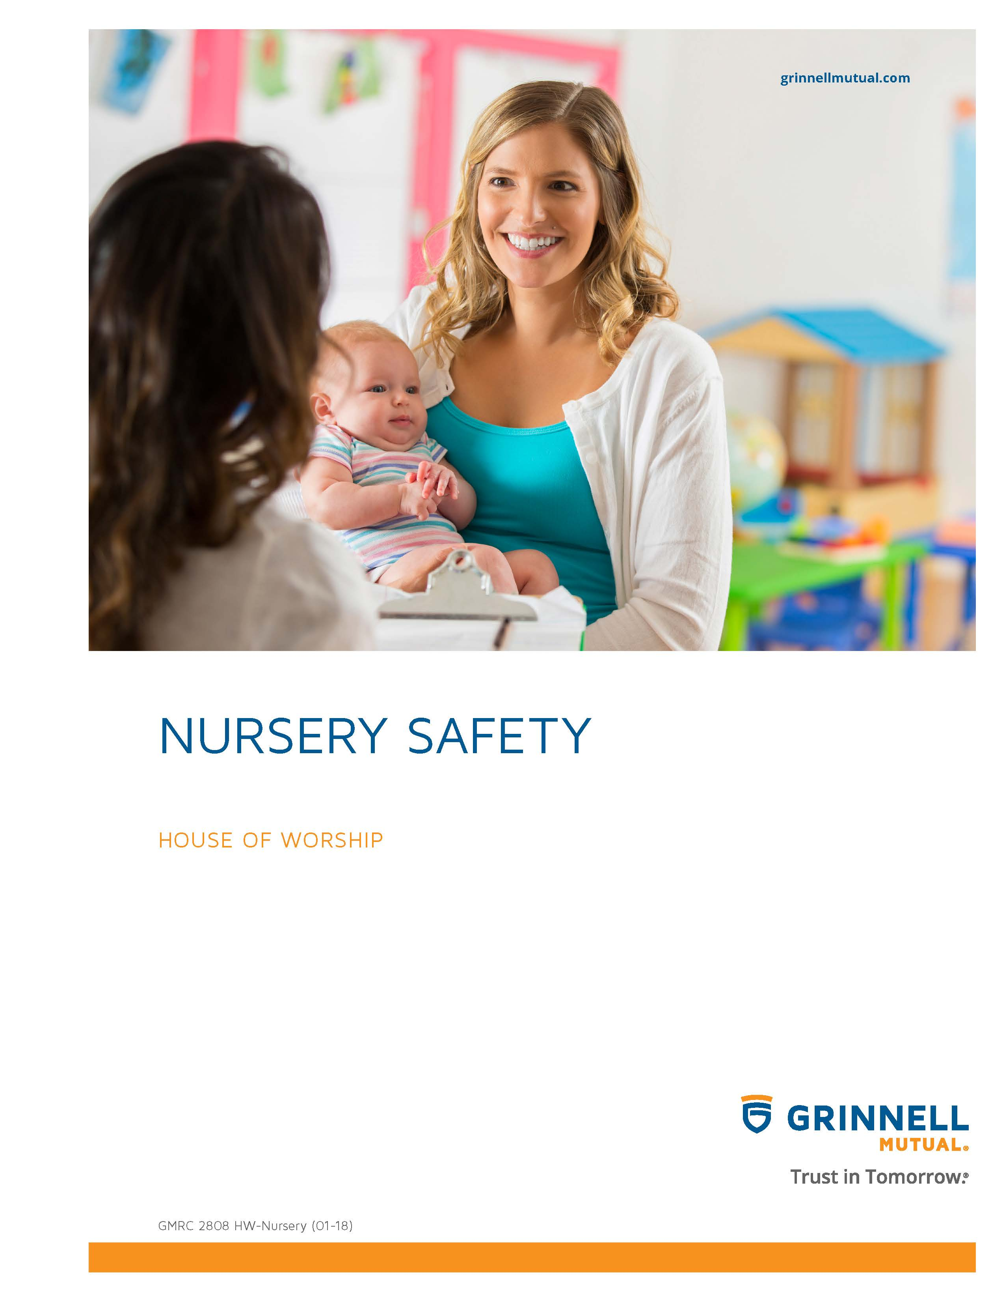

Disclaimer
This booklet has been developed by Grinnell Mutual Reinsurance Company and is for informational purposes only. It was designed to provide reasonably accurate information in regard to the subject matters covered. The information contained herein has been obtained from sources that we believe to be competent and reliable.
Grinnell Mutual Reinsurance Company is aware that this booklet will not fit the operations of all companies. Applicable state/federal statutes must supersede any conflicting statements made or referred to in this booklet.
Grinnell Mutual Reinsurance Company cannot be held responsible or liable for any damages, direct or indirect, which may arise, in part or in whole, from the use of this booklet or from any representation or misrepresentation contained therein. Also, it cannot be assumed that all acceptable safety and health measures are listed in this booklet.

Table of Contents
Nursery Safety Policies 1
General Policies & Guideline Considerations 1
Selection of Volunteer & Paid Staff Workers 1
Supervision of Nursery Age Children 2
Response to Allegations 2
Nursery Safety Procedures 3

Nursery Safety Policies
It is in the best interest of a house of worship and its children to adopt policies, procedures, and practices to assist the house of worship in protecting the children from physical, mental, and emotional harm.
It will be the responsibility of the house of worship to educate ministers, house of worship staff, and volunteers in the identification and prevention of sexual or physical misconduct. In many cases, sexual or physical misconduct will violate criminal statutes and may lead to the prosecution and imprisonment of offenders.
The house of worship should establish a policy of zero tolerance for sexual or physical misconduct and should aggressively pursue investigation of reports of misconduct.
The information provided in this document includes items that each house of worship should consider as they adopt procedures. There are some guidelines that can establish clear directions, but the information is general and allows each house of worship to expand upon or develop specific content of policies and procedures that can be implemented according to the needs of the house of worship.
The information contained in this document is not all inclusive. It should be discussed with the house of worship leadership, and the information adopted according to the religious beliefs and activities of the house of worship.
General Policies & Guideline Considerations
SELECTION OF VOLUNTEER & PAID STAFF WORKERS
1. A screening policy should be adopted by the house of worship for screening of employees and volunteer applicants wishing to participate in activities involving children.
2. An application form for all volunteers and paid staff should be developed. This form should include questions as they relate to the individual’s previous work with children, the reason for wanting to work with children and youth, their area of interest in working with children, etc.
3. Prior to implementation, application and reference check forms used by your house of worship should be reviewed by legal counsel familiar with your state’s employment laws.
4. An individual should be required to live in the community for 1 year and provide references they are a person of good standing in the community.
5. If the individual is new to the community or a new member, before working with children, they must provide at least 2 references, including his/her previous pastor indicating the member’s good community standings for at least 1 year in the previous community. References should be checked and documented.
6. The volunteer or paid staff person should have an in-person interview conducted. This interview could be conducted by the senior pastor and one other person or a committee within the house of worship.
7. Background records should be checked and documented. Those records could include, but not limited to, criminal records, sex offender registry, child abuse registry, etc.
8. Individuals convicted of sexual or physical abuse should not be accepted for volunteer or paid service in any house of worship sponsored activity or program for children.
9. The house of worship shall provide annual training to all house of worship staff and volunteers, focusing on the house of worship’s policies and practices on the Nursery Safety Policy. Individuals should be trained on other current issues related to child protection. Attendance at these sessions should be required for those who have direct contact with children.
10. Volunteer and paid staff should be required to sign a statement that they have read, understand, and agree to abide by the house of worship’s Nursery Safety Policy.
11. Volunteers or paid staff are prohibited from the use, possession, distribution, or being under the influence of alcohol, illegal drugs, or the misuse of legal drugs while participating in or assisting with programs or activities specifically for children.
SUPERVISION OF NURSERY AGE CHILDREN
1. At least two non-related adults (over the age of 21) should be assigned to and be present at all house of worship sponsored activities involving children.
2. Any youth helper or youth teacher (youth is defined as an individual under the age of 18) must present written parental/guardian permission to the adult supervisor of the activity before being authorized to work with children.
3. There should be at least 2 non-related adults present in any classroom at all times.
4. Children participating in indoor activities in classrooms should be visible from outside the classroom. If a door does not have a window, the door should be left open and be gated, if necessary. Doors should never be locked while persons are inside the room.
5. A volunteer or paid staff member shall not place themselves in a situation where they are alone with a child, absent proper parental/guardian authority.
6. Volunteers or staff of the house of worship may visit and observe children programs at anytime.
7. Anytime a paid staff member or volunteer is required to be alone with a child, parental/guardian permission should be obtained. If contact with a parent/guardian cannot be made, another adult should be notified.
8. Children needing to use the bathroom should be accompanied by 2 non-related adults. If the adults enter the bathroom to assist the child, they should not enter the stall with the child unless there is an emergency and they should leave the bathroom door open. If the child needs assistance or there is an emergency with any child, the stall door and bathroom door should be left open.
9. There should be established a sign-in/sign-out procedure. Parents/guardians or other persons responsible for nursery age children should record via sign-in procedure on the nursery registration form with the staff/volunteer on duty as to whom the child may be released. If the person picking up the child is unknown to the staff/volunteer person, a picture ID should be requested to verify the release person’s identity. A child should not be released to a person not previously authorized via the sign-in procedure, which will be on the registration form. The sign-in procedure should require an emergency contact number for the parents/guardians. The registration form should note allergies or any special needs of the child.
10. In a nursery setting, always have a minimum of 2 non-related adults present when changing children’s clothing.
11. Make certain there is enough help in the nursery to provide enough attention to each child’s needs.
12. An appointed monitor should check each nursery room to make sure it is properly staffed and that things are running smoothly. This person can also monitor hallways for unwanted visitors and help supervise restroom breaks.
13. There should be a communications system established to call the parent/guardian to the nursery during worship or other house of worship activities.
RESPONSE TO ALLEGATIONS
1. All allegations of incidents involving improper touching, physical abuse, or sexual abuse of a child during the course of any and all house of worship sponsored activities must be immediately brought to the attention of the senior pastor or the appropriate committee within the house of worship, except if the alleged perpetrator is within this reporting chain, that person shall be bypassed and the report made to another individual or individuals in the reporting chain.
2. If an incident is reported, it is the responsibility of the senior pastor or other individual in the authority chain to see that proper notification is made to the following: parents/guardians, legal and social welfare authorities as may be mandated by state law, and insurance company (in accordance with the insurance contract).
3. All allegations of sexual misconduct should be fully and fairly investigated and corrective and/or disciplinary action taken as warranted.
4. The house of worship should not attempt to conduct a detailed investigation of any alleged incident on its own, but should cooperate fully with all legal entities involved.
5. Individuals who do not satisfactorily pass the screening should be excluded from service and/or contact with children, but may be offered opportunities to work or volunteer in other areas of the house of worship. Consideration should be given for pastoral guidance and counseling to assist the individual in understanding the house of worship’s duty to provide the highest level of protection to its children, its youth, and to members of the house of worship.
NURSERY SAFETY PROCEDURES
1. Possible injuries to children in a nursery setting range from minor injuries, such as cuts and bruises to more serious injuries, such as broken bones or contusions.
2. It is important to establish procedures that include guidelines for injuries, sanitation, housekeeping, and emergencies.
3. The nursery should be inspected at regular intervals, with a focus on the physical conditions and/or equipment in the area that could result in injury to children. Emphasis should also be placed on preventing falls, electrical shocks, the spread of communicable diseases, etc.
4. When inspecting a nursery, view the area from the height and perspective of the children who use the nursery.
5. The following is some information that should be considered by your house of worship, in the interest of nursery safety:
a. The nursery should be kept clean and as germ free as possible. All surfaces should be wiped down with a disinfectant each week, or more often, if the nursery is used during the week. These areas would include tables, chairs, counter tops, changing areas, cribs, etc. Toys should be wiped down and sanitized with a disinfectant. Crib and playpen mattress covers should be properly cleaned. There should be proper disposal facilities for soiled diapers.
b. Don’t allow ill children who have a fever, or who have other contagious diseases, in the nursery. If a child becomes ill during nursery hours, contact the parent/guardian to come and get the child.
c. All toys should be age appropriate and have no small pieces that a child could choke on. They should not be allowed to play with un-inflated balloons, marbles, and other small items. A toy that has small moving parts that can come loose from the toy should be removed from the nursery to prevent children from swallowing small parts.
d. Use toy chests that will not trap children inside.
e. All furniture in the nursery, such as cribs, chairs, playpens, etc. should be in good working condition. They should not have any sharp edges, broken pieces, or loose components.
f. Make certain that furniture donated or purchased by the house of worship, such as cribs, playpens, etc., meet existing safety requirements, be in good working condition, and have no missing, loose, or broken screws and brackets. Make sure furniture items have the correct spacing between slats and openings, no cracking or peeling paint or splinters, etc. Because of the dangers of using walkers in the nursery, it is recommended that walkers not be used. Cribs used should be certified by the Juvenile Products Manufacturer’s Association or meet ASTM or Consumer Products Safety Commission standards.
g. Any areas where baby diapers are changed, where babies spit up, or leave other bodily fluids should be cleaned up immediately and the areas sanitized.
h. Make certain that all electrical cords are out of the reach of children and that electrical outlets are appropriately covered to prevent electrical shock. Do not allow cords for DVD players, VCR’s, clocks, etc. to dangle. They could create a potential strangulation hazard or a child could pull the piece of equipment over on top of themselves or others.
i. Don’t leave furniture or toys stacked in the nursery where children are likely to climb on them. These items could topple over and injure the child or others in the area.
j. Gates should be installed on stairwells and windows which are accessible to young children. Window blind cords should be kept out of the reach of children to prevent them from becoming entangled in the cord.
k. Care needs to be taken in the proper and safe storage of cleaning supplies, paints, and other hazardous materials. They should be stored in child-resistant locked enclosures away from the nursery area.
l. Supplies utilized in nursery activities, such as crayons, paints, etc. should be non-toxic.
m. Fire and emergency evacuation plans should be posted and known by each nursery worker. Depending on the location of the nursery within the building, emergency lighting may need to be installed in order to provide the necessary illumination in the event of a power failure.
n. Nursery workers should be trained in First Aid and CPR. There should be a well-stocked First Aid kit available. Important telephone numbers should be posted, such as ambulance service, local hospital, local poison control center, local police department, etc.

