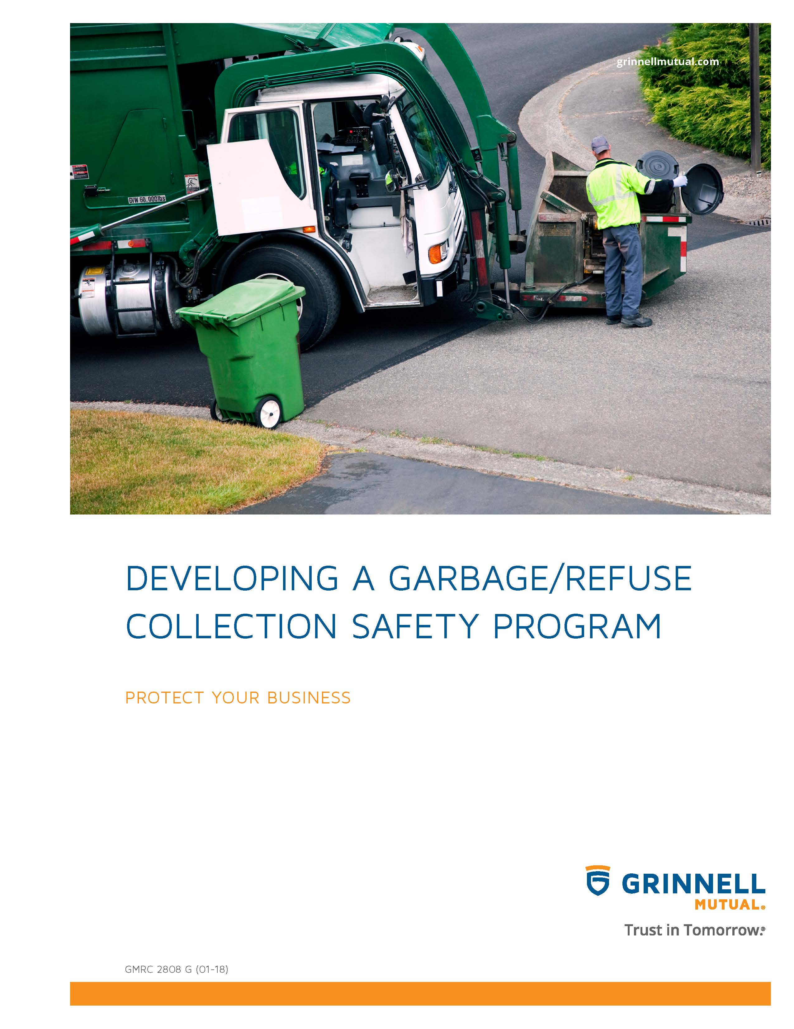

blank

Disclaimer
This booklet has been developed by Grinnell Mutual Reinsurance Company and is for informational purposes only. It was designed to provide reasonably accurate information in regard to the subject matters covered. The information contained herein has been obtained from sources that we believe to be competent and reliable.
Grinnell Mutual Reinsurance Company is aware that this booklet will not fit the operations of all companies. Applicable state/federal statutes must supersede any conflicting statements made or referred to in this booklet.

Grinnell Mutual Reinsurance Company cannot be held responsible or liable for any damages, direct or indirect, which may arise, in part or in whole, from the use of this booklet or from any representation or misrepresentation contained therein. Also, it cannot be assumed that all acceptable safety and health measures are listed in this booklet.

blank
Table of Contents

Section I – Introduction 1

Safety Policy Statement 1

Safety Program for the Organization 1

Safety Director 2

Employee Training 2

Emergency Action Planning 3

Accident Investigation 3

Self Inspection/Hazard Identification 3

Section II – Safety Foundation 5

A. Company Safety Policy Statement 5
B. Management Commitment to Safety 5
C. Assignment of Responsibilities 5
D. Accountability for Safety 6
E. Opinion Survey 7
F. Employee Suggestions 7

Section III – Safety Training 9

A. New Employee Safety 9

B. Safety Meetings/Training 9

Section IV – General Safety 13

A. Emergency and Evacuation Procedures 13
1. Emergency Procedures 13
2. Evacuation Procedures 13

B. Safe Operating Procedures 13
1. Rules/Regulations 13
2. Housekeeping 14
3. Material Handling and Back Safety 14
4. Office Safety 15
5. Clothing 15
6. Fire Prevention 15

Section V – Accident Management 17

A. Accident and Near Miss Reporting Procedures 17

B. Accident Investigation 17

Section VI – Safety Violation 21

Section VII – Special Emphasis Programs 23

A. Chemical Handling Procedures/Hazard Communication Program 23

B. Personal Protective Equipment 29

C. Smoking Policy 34

Violence Prevention Program 34

Lockout/Tagout 35

Table of Contents (Cont’d)

Section VII – Special Emphasis Programs (Cont’d)

Confined Space 44

Fleet Safety Rules/Regulations 52

Section VIII – Inspections 59

Section IX – OSHA (Occupational Safety and Health Administration) 61

A. OSHA Record Requirements 61

B. OSHA Inspection: What you can expect during an OSHA Inspection 61

Section X – Acknowledgement Form 75

Appendixes A-1

A. Sample Safety Policy Statements A-1

B. Sample Checklist – Planning For Emergencies B-1

C. Self-Inspection Checklist C-1

D. Safety And Health Audio Visuals D-1

E. Resources E-1

Section I – Introduction
One of the most valuable assets any company has is its employees. This is true if the company is a small business, a large corporation, or government agency. Therefore, it follows that investing in a workplace injury and illness prevention program is one way of protecting your assets, both physical and human.
It is well known that the direct costs of work injuries are substantial. Also, there are many indirect or hidden costs of injuries, which are often three-to-four times greater than the direct costs. Many of these costs are associated with – productive time lost by an injured employee – productive time lost by employees and supervisors attending the accident victim – time and cost to start up operations interrupted by the accident – time and cost to hire or retrain other individuals to replace the injured worker until his/her return to work – time and cost for repair or replacement of any damaged equipment or materials – cost of continuing all or part of the employee's wages, in addition to the incurred medical costs – reduced morale among your employees and perhaps lower efficiency – increased insurance premiums – administrative costs generated by the incidents – overtime costs – adverse publicity. By developing a Safety Program, it will enable you to avoid possible losses in the future.
A formal safety program will also assist your company in complying with Federal and State safety, health, and environmental laws. Lack of compliance with these laws can result in citations, fines, unfavorable publicity and, in some cases, civil suits.
Establishing a quality safety program at your place of business will take some time and involve some resources. However, you should be pleasantly surprised with the results. You will have happier employees, as they will know you are committed to safety on the job. The reward you receive will surely exceed the cost of your investment in safety protection.
The objectives of any safety program is to reduce the frequency and severity of accidents, to comply with State and Federal OSHA regulations, and to provide a safe and healthful workplace.
SAFETY POLICY STATEMENT
A company that attempts to prevent accidents without a definite guiding policy, one that is planned, publicized, and promoted, will find it difficult to prevent accidents. If Management wants acceptable safe performance, it must first write a safety policy statement. This policy statement should be brief, to the point, and define Management’s attitude.
In order for your safety policy statement to be effective, you must clearly communicate it to all your employees by both explanation and by example.
Your policy statement should be typed and displayed within your place of business at a prominent location for employees and the general public to observe.
The company policy statement should be reviewed with all employees, and they should sign a document indicating they have read and understand the company safety policy statement.
See Section II and Appendix A on Model Safety Policy Statement development.
SAFETY PROGRAM FOR THE ORGANIZATION
The safety policy statement is a beginning, but certainly not a complete program. A comprehensive Safety Program should be developed for your organization. Also, irregularly executed inspections or safety meetings and brief spurts of executive interest are no substitute for pro-active, consistent, and visible management support and leadership for a well planned and executed safety program.
Top management needs to lead and set a positive example. If the safety program is a "low priority" for the CEO, it will likely be a "low priority" for employees. Low priority will mean inadequate attention, and that will sooner or later result in an accident, or accidents that can disable, maim, or kill.
OSHA's "General Industry Digest" notes that management commitment and employee involvement are "complimentary and form the core" of any safety program. The book provides several recommendations for achieving these two goals. Recommended actions that bear directly on drafting the safety policy include:
• Stating the worksite policies on safety and health clearly.
• Establishing and communicating safety goals and defining objectives to meet that goal.

• Assigning and communicating responsibility for all aspects of the program.
• Reviewing program operations at least once a year so that deficiencies can be identified and revised as necessary.
Make sure your program assigns responsibility and accountability to all employees in your organization. A good safety program makes it clear that every employee from you through the supervisory level to the line worker is responsible for his or her part in the program. You should make their safety and health duties clear and each of them should be held accountable for his or her safety and health related duties. Accountability should be built into job descriptions, performance reviews, and daily interaction in the workplace.
Management at all levels should accept responsibility for the organization's injury rate and should provide pro-active, visible leadership on safety management. They should also provide the resources required to design and implement a safety program that meets at least the legal requirements at the state and federal level.
• For employees, accountability should include adherence to safety rules and procedures, and prompt reporting of any hazard.
Employees must be involved in all aspects of the program from the beginning. They are the people most in contact with the potential and actual safety hazards at the worksite. They will have constructive input into the development of your safety program. The ultimate success will depend upon their support - support that will be more forthcoming for a program which they have had meaningful input.
Your safety policy should be tailored to fit your organization’s corporate philosophy, needs, and culture.
See Section II for Development of Safety Program.
SAFETY DIRECTOR
Management is ultimately responsible for ensuring that a safety program is implemented and maintained. Management needs to provide the commitment, leadership, and resources. However, it is common and practical to delegate some implementation duty to an appointed safety director, while maintaining overall control and monitoring the performance of the safety program.
The safety director or designee should meet the following criteria.
• conceptually committed to safety and health in the workplace
• has or is given the time to develop and implement the program
• has or is given sufficient authority to develop and implement the program
• is supported by adequate resources to develop and implement the program
• sincerely cares about employee welfare
• has a high degree of credibility with the employees
In some situations, the safety director function can be added to an existing position. In larger companies or companies with high accident frequencies or severities or inherently hazardous processes, a full-time person is often required.
The success of your program hinges on the success of the individual you choose, and he or she cannot succeed without your full cooperation and support. Remember, that when you appoint someone as your safety director and delegate the authority to manage the program, the ultimate responsibility for safety in your workplace rests with you.
See Section II – C.2. for Safety Director Program Responsibilities.
EMPLOYEE TRAINING
As an Owner or Manager you must ensure that all employees know about the material and equipment they work with, what known hazards are in the operation, and how you are controlling the hazards.
Each employee needs to know the following:
• No employee is expected to undertake a job until he or she has received job instructions on how to do it properly and has been authorized to perform that job.
• No employee should undertake a job that appears unsafe.

Combine safety training with other training, the result you want is everyone knowing what they need to know to keep themselves and fellow workers safe and healthy.
During employee orientation, they should be given a copy of the company's Safety Policy Statement, and the company's Safety Program should be discussed with them.
After the initial employee orientation, and for existing employees, your safety program can be communicated by a variety of techniques and methods. Regular meetings could be scheduled during which safety is openly discussed. Attendance should be required for all employees. If properly planned, effective safety meetings can be held in a 15-20 minute time frame. Other methods could be posters on bulletin boards, safety and health booklets, safety signs, newsletters, safety banners, safety films/videos, etc. See Appendix D for a list of safety films/videos.
As changes are made to your safety program, keep your employees informed. The more you do to keep them informed of the changes and improvements you are making, the greater are the chances for your success.
All safety training meetings should be documented. The date of the meeting, name of the instructor, subject discussed, and the names of the employees attending the meeting should be documented on an attendance form.
See Section III for an example of a New Employee Safety Checklist.
EMERGENCY ACTION PLANNING
Planning and training for an emergency is essential in order to minimize the harmful consequences of an emergency incident. If personnel are not thoroughly trained for emergencies so their response is immediate and precise, they may expose themselves and others to greater danger, rather than reduce their exposure. The types of emergencies that may arise at your work site depend on the nature of your operation and its geographical location. They could include fire, severe weather, chemical spills, earthquakes and bomb threats. The extent to which training and drills are needed will depend upon the potential severity and complexity of the emergency. You should have an emergency procedure for handling injuries, transporting ill or injured workers, and notifying medical facilities, with a minimum of confusion. The procedures for reporting injuries and illnesses should be understood by all employees.
Emergency phone numbers should be posted. They should include at least the fire department, hospital emergency room, ambulance, and law enforcement.
See Section IV – A for additional information on Emergency and Evacuation Procedures and see Appendix B for Planning for Emergencies Sample Checklist.
ACCIDENT INVESTIGATION
Management can gain valuable information from a thorough investigation of accidents, occupational health problems and near-miss incidents. Variances from or defects in present operating procedures, unsafe work practices, and even environmental hazards may be determined.
Determining the causes of accidents – and doing something about them – will reduce accident incidence, lower workers' compensation costs, and enhance employee morale, because workers will feel they are working with a management and company that cares and wants to correct hazards and unsafe work procedures.
REMEMBER, AN ACCIDENT INVESTIGATION IS NOT DESIGNED TO FIND FAULT OR BLAME, IT IS AN ANALYSIS TO DETERMINE CAUSES THAT CAN BE CONTROLLED OR ELIMINATED.
See Section V for assistance in developing an Accident Investigation Program and sample accident investigation forms.
SELF INSPECTION/HAZARD IDENTIFICATION
The assessment of your workplace should be conducted by the person responsible for the safety program and/or a professional safety and health consultant.
Conduct a comprehensive safety and health survey of your entire facility that is designed to identify any existing or potential safety and health hazards. This initial survey should focus on evaluating workplace conditions with respect to safety and health regulations and generally recognized safe and healthful work practices. It should include checking on the use of any hazardous materials, observing employee work habits and practices, and discussing safety and health problems with employees.

Create the systems and procedures necessary to Prevent and Control the Hazards that have been identified through your worksite analysis. These control procedures will be your basic means for preventing accidents. The OSHA standards that have been promulgated can be of great assistance to you since they address controls in order of effectiveness and preference. Where no standard exists, creative problem solving and consultant resources should help you create effective controls. The basic formula OSHA follows is, in order of preference:
1. Eliminating the hazard from the machine, the method, the material or the plant structure.
2. Abating the hazard by limiting exposure or controlling it at its source.
3. Training personnel to be aware of the hazard and to follow safe work procedures to avoid it.
4. Prescribing personal protective equipment for protecting employees against the hazard.
See Appendix C for Self-Inspection Checklist, to help you get a good start on creating this initial survey.

Section II – Safety Foundation

A. Company Safety Policy Statement
(Company Name) is dedicated to providing a safe and healthy work environment for all of our employees and customers. The Company shall follow operating practices that will safeguard employees, the public, and Company operations. We believe all accidents are preventable. Therefore, we will make every effort to prevent accidents and comply with all established safety and health laws and regulations. (For additional sample Safety Policy Statements, see Appendix A)

B. Management Commitment to Safety
Management is concerned about employee and guest safety. Accidents, unsafe working conditions, and unsafe acts jeopardize employees, customers, and Company resources. Injuries and illnesses result in discomfort, inconvenience and possibly reduced income for the employee. Costs to the Company include direct expenses (workers’ compensation premiums, damaged equipment or materials, and medical care) and indirect expenses (loss of production, reduced efficiency, employee morale problems, etc.). These indirect costs are reported to cost 4-10 times more than the insured costs of an accident. Accordingly, Management will provide sufficient staffing, funds, time, and equipment so that employees can work safely and efficiently.

C. Assignment of Responsibilities
Safety is everyone’s responsibility. Everyone should have a safe attitude and practice safe behavior at all times. To best administer and monitor our safety policies, the following responsibilities are delegated. This list should not be construed as all-inclusive and is subject to change as needed.
1. (Corporate President, Owner, or Manager) will:
a. Provide sufficient staffing, funds, time, and equipment so that employees can work safely and efficiently.
b. Demand safe performance from each employee and express this demand periodically and whenever the opportunity presents itself.
c. Delegate the responsibility for a safe performance to the Manager, Supervisors, and employees, as appropriate.
d. Hold every employee accountable for safety and evaluate performance accordingly.
e. Periodically review the Safety Program effectiveness and results.
2. (Safety Director) will:
a. Provide the resources, direction, and audits to integrate safety into the management system.
b. Establish and maintain a safety education and training program.
c. Periodically conduct safety surveys, meetings, and inspections.
d. Advise Supervisors and employees on safety policies and procedures.
e. Assure that all newly hired employees have been given a thorough orientation concerning the Company’s Safety Program.
f. Prepare and maintain safety records, analysis, evaluations, and reports to improve the Company’s safety performance and comply with all government agencies, insurance carriers, and internal procedures.
g. Work with management, supervisors and employees to maintain and implement new and ongoing safety programs and comply with recommendations provided by outside consultants, OSHA inspectors, and insurance companies.
h. Make available all necessary personal protective equipment, job safety material, and first-aid equipment.
i. Review all accidents with Management, Supervisors, and/or employees and ensure that corrective action is taken immediately.
j. File all workers’ compensation claims immediately and work with the workers’ compensation carrier to ensure proper medical treatment is provided to injured workers and they are returned to work as quickly as medically possible.

3. Supervisors
Each employee who is in charge of a specific work area, supervises the work of others, or to whom an employee is assigned for a specific task or project, is responsible and accountable for their safety. Supervisors will:
a. Establish and maintain safe working conditions, practices, and processes through:
(1) Safety Meetings
(2) Safety Training
b. Observe work activities to detect and correct unsafe actions.
c. Ensure that all injuries are reported promptly and cared for properly. Make available first aid treatment.
d. Investigate all accidents promptly. Complete an accident report and provide it to the Manager or Supervisor the same day the accident occurs. Review all accidents with the employees and correct the causes immediately.
e. Assist in the review of employment applications and personnel files to determine physical qualifications for specified job classifications.
f. Consistently enforce safety rules/regulations, programs, and protective measures (i.e. use of personal protective equipment, machine guarding, proper clothing, etc.).
g. Post signs, notices, and instructions as needed or required.
h. Brief employees of any new hazards before they start work and weekly and/or monthly host brief safety meetings to discuss safety practices related to job hazards and general safe work behavior.
i. Work with top management and employees to maintain and implement new and ongoing safety programs and comply with recommendations provided by outside consultants, OSHA inspectors, and insurance companies.
4. Employees
Each employee is responsible for his/her own safety. No task should be completed unless it can be completed safely. Employees will:
a. Comply with all company safety programs, rules, regulations, procedures, and instructions that are applicable to his/her position with this organization.
b. Refrain from any unsafe act that might endanger him/her self or fellow workers.
c. Use all safety devices and personal protective equipment provided for his/her protection.
d. Report all hazards, incidents, and near-miss occurrences to their Manager or Supervisor, regardless of whether or not injury or property damage was involved.
e. Promptly report all injuries and suspected work related illnesses, however slight, to his/her immediate Supervisor or Manager.
f. Participate in safety meetings, training sessions, and surveys as requested and provide input into how to improve safety.
g. Notify the Manager or Supervisor immediately of any change in physical or mental condition or use of prescription drugs that would affect the employee’s job performance or the safety of him/her self or others.
h. Notify the Human Resources Manager or General Manager within five days of any serious driving, drug/alcohol, or criminal convictions.
i. Be a safe worker on (and off) the job. Help coworkers do their job safely. Come to work everyday with a safe attitude.

D. Accountability for Safety
Everyone is accountable for safety. The Corporate President/Owner will establish safety objectives and develop and direct accident prevention activities. All employees should strive to reach those objectives and will be evaluated accordingly. All Managers and Supervisors annual appraisals will include safety (results to objectives in their area and companywide) as well as an audit of their performance of their safety responsibilities. All employee salary reviews will be affected by the company’s safety performance record. Appraisals, which include safety records, will also be performed on all employees seeking a promotion.

E. Opinion Survey
The Company requests ongoing comments and feedback from all employees. In addition, annually, the company may request all employees’ opinions and input on the company’s safety program through an opinion survey. Be honest. You know your job better than anyone else does. Therefore, you can provide valuable input into performing the job safely. Changes to existing safety programs, rules, procedures, etc. may be influenced by your responses. Full cooperation of all employees is expected.

F. Employee Suggestions
Safety suggestions from employees are welcomed and encouraged. To make a safety suggestion, complete the employee safety suggestion form on the following page and provide it to your immediate superior. The suggestion(s) will be reviewed by management personnel at the next Manager’s meeting. Responses to suggestions will be discussed with the individual and posted where applicable on the company’s bulletin board.

EMPLOYEE SAFETY SUGGESTION FORM
Employee Name (optional): Date:
Supervisor Name:
Current Practice Or Condition

Suggestion

Benefits Expected From Change

(FOR SAFETY COMMITTEE USE, If applicable)
Year: Number:
Suggestion Implemented? Yes – as submitted Yes - with changes No
Implementation Date:
Comments/Changes Made/Reason for change or not implemented:

Section III – Safety Training
A. New Employee Safety
The Business Owner or Manager should provide safety training to all newly hired employees. Each new employee will be given a copy of the safety manual.
1. General safety orientation containing information common to all employees should be reviewed, before beginning their regular job duties. Recommendations include (at a minimum):
a. Review the Safety Manual, with extra time spent on: accident and hazard reporting procedures, emergency procedures, first aid, and special emphasis programs which are included within this program.
b. Encourage and motivate employee involvement in safety. Make each employee accountable for their safety and the safety of their coworkers.
c. Review any known workplace hazards.
d. Conduct training on any topics that are not scheduled to be addressed within a reasonable timeframe and are relevant to the employee’s job.
2. Job-specific training provided before performing the task should include:
a. Specific safety rules, procedures, hazards, and special emphasis programs (Chemical Handling Procedures/Hazard Communication Program, Personal Protective Equipment, Smoking Policy, Violence Prevention Program, Lockout/Tagout, Confined Space Program, Fleet Safety) that will impact them as they complete their job with the organization.
b. Identify employee’s and employer’s responsibilities.
Continual training should be provided to new hires. Each new hire should be assigned to work with an experienced employee for at least 6 months. The senior employee should act as a mentor and ensure that the new employee is working safely and exhibits a positive safe attitude.
The Business Owner or Manager should complete the New Employee Safety Checklist for each new employee during their safety training.

B. Safety Meetings/Training
Supervisors should hold a minimum of (insert appropriate number here) safety meetings per month. Safety meetings will begin at (insert time and day of month).
1. All employees are required to attend safety training meetings if they are present at work the day of the meeting. Exceptions should be cleared in writing with your immediate Supervisor the first full workday preceding the day of the safety meeting. Employees and Supervisors should offer comments and safety suggestions at the safety meeting and regularly throughout the work week as needed.
2. Safety training will be conducted on a topic announced in advance of the meeting.
3. Supervisors should update employees on any changes in procedures, new equipment, and general safety issues.
4. Emergency procedures will be periodically reviewed.
5. Employees are reminded to put safety first and look out for their coworker.
6. Employees with outstanding safety records will be recognized during these meetings. Quizzes and surveys may be administered after safety training or meetings.
7. Supervisors should provide a summary of the safety issue(s) discussed and verbally review the information with all employees that may have been absent from that month’s safety meeting.
8. The Safety Training Log should be completed following every safety meeting/training session and maintained by the Manager or the Department Supervisor.

NEW EMPLOYEE SAFETY CHECKLIST
Employee Name: ID:
Date Employed: Date Checklist Completed:
Checklist completed by:
Department Assigned: Type of Work:
Summary of Work Experience:
Supervisor:

Ask Employee: Do you have any physical conditions or handicaps which might limit your ability to perform this job?
If so, what reasonable accommodation can be made by us?
Did the employee have a pre-employment drug test? Yes No Physical? Yes No
Any work restrictions indicated from the physical?
The Business Owner or Manager and new employee should review the following safety concerns. Check and discuss all that apply. Provide the employee with a copy of the Safety Manual.
Company safety policies and programs
Safety rules (general and specific to job)
Safety rule enforcement
Materials handling
Accident and Hazard Reporting Procedures
Housekeeping
Special hazards of the job
Emergency Procedures
Employee Responsibilities/Accountability
Hazardous materials
Location of First Aid Kits
Where to go for medical treatment
Other:

Employee shall receive additional training from:
Probationary period is from to
Performance (including safety) will be reviewed formally on
Employee agrees to cooperate fully with the safety efforts of the employer, follow all safety rules, and use good judgment concerning safe work behavior. Yes No (Have employee sign for manual)
Comments:

Signed: Signed:
Trainer Employee

SAFETY TRAINING LOG
Company Name:
Date of Meeting: Instructor:
Attending Employees
Print Name |  | Signature
1
2
3
4
5
6
7
8
9
10
11
12
13
14
15
16

Safety Topics Covered:
- Housekeeping
- Accident Reporting
- Injuries or Accidents Review
- Accident Investigation
- Emergency Procedures
- Materials Handling/Back Safety
- Fire Protection
- Other
Comments:

RESERVED FOR FUTURE USE

Section IV – General Safety

A. Emergency and Evacuation Procedures
Our goal is to provide prompt and immediate action in an emergency to protect life, property, and equipment.
1. Emergency Procedures
In case of emergency, the employee nearest the stricken person should call 911 (or the emergency phone number posted in your area) and direct a fellow employee to:
a. Notify the nearest Supervisor to come to the scene; and
b. Simultaneously dispatch available employees to quickly retrieve the first aid kit.
c. An individual trained in first-aid should apply emergency rescue procedures until medical assistance arrives.
The Manager or the Department Supervisor should be notified. The President, Manager or the Department Supervisor (in that order) or their designees will decide whether or not to evacuate, inspect or shut down a facility.
2. Evacuation Procedures
a. Each area will be assigned a primary and an alternate Evacuation Coordinator by the Manager or the Department Supervisor. They will be responsible for the effective evacuation of all persons. If neither is available, the Supervisor is then responsible for evacuation.
b. When alerted by alarm or by the Evacuation Coordinator(s) to evacuate, employees should:
1. Properly secure all classified materials in your possession and assure all classified containers and areas are properly locked.
2. Proceed to the nearest designated area of safety (i.e. fire – exit building, tornado – interior corridor – away from exterior windows and/or lowest level at the building) and assemble in the designated area.
3. Remain in the designated area, until instructions are provided.
See Appendix B for a Sample Checklist – Planning for Emergencies.

B. Safe Operating Procedures
All employees are responsible for safety. The following safe operating procedures apply to all employees working within this organization.
1. Rules/Regulations
a. Emergency telephone numbers should be posted on at least one telephone on each level within the building. Emergency phone numbers would include: ambulance service, local hospital/medical facility, fire, law enforcement, poison control center, etc.
b. Comply with all established safety rules, regulations, procedures, and instructions which are applicable to you as a member of this organization.
c. Promptly report all accidents, hazards, incidents, and near-miss occurrences to your immediate supervisor, regardless of whether or not injury or property damage was involved.
d. Do not visit, talk to, or distract another employee who is operating equipment, or who is engaged in a work activity where the possibility of injury exists.
e. Do not participate in horseplay, scuffling, pushing, fighting, throwing things, or practical jokes.
f. Observe all no-smoking signs and regulations.
g. Do not run on company premises.
h. Use handrails on steps, elevated platforms, scaffolds, or other elevations.
i. Assist others and ask for assistance in lifting and carrying heavy or awkward objects.
j. Firearms, ammunition, and explosives are prohibited on company premises.
k. Personal stereos with headphones are not to be worn in the workplace.
l. Alcohol and drug use and possession on company property of these substances are strictly prohibited.

m. Seat belts must be worn at all times while operating or riding in a company vehicle, or in a vehicle (employee owned or company owned) when on company property or when traveling within a vehicle (employee owned or company owned) on company business off company property.
2. Housekeeping
a. Practice good housekeeping by keeping the work area, aisles, walkways, stairways, roads, or other points of egress clean and clear of all hazards.
b. Store and/or return parts, materials, tools, and equipment so as not to create a tripping hazard.
c. Clean-up scrap materials, debris, and other excess materials. Place oil soaked rags, trash, and scrap in proper waste containers.
d. Keep work area floors clean, dry, and free of oils, grease and liquids. Clean up all spills immediately.
e. Store parts, materials, or equipment with protruding sharp ends or edges where personnel can not accidentally bump into them.
f. Materials and equipment are not to be stored in the aisles or near exits. Permission in writing from your immediate supervisor must be obtained for temporary or permanent storage of any materials or equipment in aisles or near exits.
3. Material Handling and Back Safety
a. Know the approximate weight of your load and make certain any material handling equipment you may operate to move materials is rated to handle the weight of the load. (Never exceed the manufacturer’s recommended safe working load for any material handling equipment. Doing so increases the probability of equipment failure, dumping of the load, personal injuries and/or damage to materials, the facility, etc).
b. Lift heavy objects as instructed, with the leg muscles and not with the back. On average, do not manually lift over 50 pounds.
c. Call for assistance as needed for handling heavy or bulky objects or materials.
d. Use an appropriate, approved lifting device (i.e. special trucks, racks, hoists, and other devices) for lifting very heavy, bulky, large or unyielding objects.
e. All ropes, chains, cables, slings, etc., and other hoisting equipment must be inspected prior to each use.
f. A load should never be lifted and left unattended.
g. Wear safety gloves when handling materials that pose cutting exposures.
h. Properly stack and secure all materials prior to lifting or moving to prevent sliding, falling, or collapse.
i. Avoid moving or lifting loads by hand whenever possible.
Tips for manual lifting:
(1) Get a good footing.
(2) Place feet about shoulder width apart.
(3) Bend at the knees to grasp the weight.
(4) Keep back as straight as possible.
(5) Get a firm hold.
(6) Lift gradually by straightening the legs.
(7) Don’t twist your back to turn. Move your feet.
(8) When the weight is too heavy or bulky for you to comfortably lift - GET HELP.
(9) When putting the load down, reverse the above steps.
Note: If lifting stacked materials, materials should be carefully piled and stable. Piles should not be stacked as to impair your vision or unbalance the load. Materials should not be stacked on any object (i.e. floor, shelving units, ladders, scaffolds, etc.) until the strength of the supporting members has been checked.

4. Office Safety
a. Practice good housekeeping throughout the office area. Do not leave materials or position telephone or electrical cords in the aisles.
b. Report or correct any obvious hazards as soon as they are discovered.
c. Do not carry articles weighing more than 20 pounds when ascending or descending stairs that rise more than 5 feet.
d. Close files and desk drawers. Arrange heavy or large files in the rear of file cabinet drawers to prevent tipping when draws are open. Always store heavy materials in the lower drawers and light objects on upper shelves. Do not open more than one drawer at a time, as tipping of the cabinet or desk may occur. Secure cabinets to each other and/or to building structural members to improve stability.
e. Report damaged furniture and broken veneer surfaces immediately.
f. Do not carry pointed or sharp objects in hand, pockets, or attached to clothing with points or blades exposed.
g. Do not leave paper cutters with the blade in the open or upright position.
h. Remove, secure, or arrange material on file cabinets and desks to prevent materials from falling from office furniture.
i. Do not stand on chairs, desks, boxes, wastebaskets, or any other furniture or object. These items are not be used as substitutes for an approved step-stand or stepladder.
j. Report slippery floor surfaces to your Supervisor immediately.
k. Clean up spills on floors immediately.
l. Position desks and files so that drawers do not extend into the aisle or walkway when open.
5. Clothing
a. Clothing: Wear safe and practical working apparel. Be sure that any clothing you wear is not highly flammable. Neckties and loose, torn or ragged clothing should not be worn while operating machines with revolving spindles or cutting tools.
b. Shoes: Low-heeled, closed-toe shoes, or proper work boots with sufficient heavy soles must be worn in areas where foot/toe injuries are likely to occur.
c. Jewelry: Do not wear rings or any form of jewelry or ornamentation when working around machinery or exposed electrical equipment.
6. Fire Prevention
a. Good housekeeping is the first rule of fire prevention. Oily rags, paper shavings, trim, and miscellaneous scrap materials should be cleaned up and placed in trash receptacles.
b. All flammable liquids should be stored in an approved manner and dispensed from a UL Listed or Factory Mutual Approved portable flammable liquid safety containers.
c. Liquefied Petroleum (LP) Gas presents special fire and explosion hazards. Only qualified persons are to handle LP gas. LP gas equipment should be inspected daily for leaks, etc.
d. Open fires of any kind are not permitted.
e. Combustible materials or equipment in combustible containers should be stored properly.
f. Fire extinguishers should be located near an exit door.
g. Fire extinguishers should be recharged and inspected regularly. A tag indicating the date the unit was recharged should be affixed to each extinguisher.
h. Access to fire hydrants should be maintained at all times. Fire hydrants should never be blocked or obstructed in any way.
i. All combustible waste materials, rubbish, and debris should be disposed of daily.
j. Smoking is prohibited in any hazardous area and “No Smoking” signs should be posted in these areas.
- Compressed gas cylinders should be transported and stored in an upright position.
- Compressed gas fuel cylinders should be separated from oxygen cylinders by at least 20 feet or by a 5 foot high ½-hour fire rated wall.
- No material should be stored within 3 feet of an electrical panel, outlet, or fire suppression equipment.

RESERVED FOR FUTURE USE

Section V – Accident Management

A. Accident and Near Miss Reporting Procedures
If you or a customer has a near-miss situation while working, notify your Supervisor immediately. The situation will be investigated and corrective action implemented to prevent future injury. Employees and witnesses must fully cooperate in the investigation.
If you are injured on the job:
1. Contact your Supervisor, or the nearest coworker (who should notify a Supervisor) if you are unable to contact your Supervisor due to the severity of your injury.
2. The designated employee who is trained in first-aid and/or CPR should be immediately notified to assist in the situation.
3. First aid kits, which are prominently displayed throughout the workplace, should be made available and medical supplies promptly refilled (by the Manager).
4. If needed, the Supervisor or his/her authorized representative should transport the injured worker to the company’s designated medical facility to receive appropriate medical attention.
5. If rescue personnel are summoned, the Supervisor should delegate an individual to wait for the rescue team and escort them to the injured employee.
6. All witnesses to the accident should be available to speak with the Management and/or Supervisor and cooperate in all accident investigations.
7. The Manager or immediate Supervisor should immediately notify the insurance company of the accident and file a workers’ compensation claim.
Every accident or near-miss situation should be reported immediately. Injured employees and witnesses to the accident will assist the Supervisor in completing an accident investigation. Injured employees must comply with the medical treatment provided by the treating physician and cooperate with the insurance company and its designees.

B. Accident Investigation
When an accident occurs, it is an indication that something has gone wrong. Accidents don’t just happen, they are caused. The basic cause(s) of accidents are unsafe acts and/or conditions. The Supervisor must investigate every accident to determine the cause and to initiate corrective action to assure that similar type accidents will not reoccur from the same causes.
Supervisors should complete the Supervisors Accident Investigation Report and submit a copy to the (Insert Appropriate top management title here such as Corporate President, Owner, Manager, General Manager) for review. The (insert title of person mentioned in prior sentence here) should evaluate the corrective action(s) taken or suggested by the Supervisor and instruct if additional changes should be made.
Tips on accident investigations:
1. Every accident is caused. Carelessness is not a cause, but the result of some deficiency. Telling employees to be more careful will not eliminate the real accident cause.
2. An accident investigation is not a trial to find fault or to place blame. Its purpose is to find accident causes so that corrective measures may be taken to prevent future accidents.
3. Most accidents result from a combination of human error (unsafe behavior) and a physical hazard (unsafe condition). Do not overlook the possibility of multiple errors and hazards.
4. Don’t stop at the obvious answer. For instance, a fall on greasy floor surface does not happen because someone slipped. The accident happened because the grease was allowed to remain on the floor and the worker walked onto it. Determine why the operator did this and why the grease was not cleaned up. Only by correcting both problems can you prevent future accidents.
5. The accident investigation should be conducted as soon after the accident as possible. Facts should be gathered while the accident is fresh in the minds of those involved. If possible, question every employee who was involved, or witnessed, the incident. Delay interviewing injured employees until after medical treatment has been received.
6. Other employees who did not witness the accident, but work in the area, may contribute information regarding the injured worker’s activities prior to the accident and conditions at the time of the accident.

7. The accuracy and completeness of the information received from the injured worker(s) and witness(es) depends on how well the interview is conducted. Supervisors should:
a. Put employees at ease.
b. Ask what happened and how it happened.
c. Permit employees to answer without interruptions.
d. Show concern.
e. Remember, nothing is gained with criticism or ridicule.
f. Ask “why” questions, only to clarify the story.
g. Repeat the story, as you understand it.
h. Give the employee the chance to correct any misunderstandings that you may have.
i. Photographs of the conditions as they exist immediately following the accident, including photos of the damaged equipment, are very helpful.
j. Damaged equipment should be removed or secured for future testing and used as evidence.
k. Employees should not be permitted, under any circumstances, to operate machines or equipment that was damaged in an accident until all necessary repairs have been completed and all damaged parts have been repaired or replaced.
l. Take immediate action to correct any obvious unsafe conditions. Determine the basic accident causes and correct or recommend action to prevent reoccurrence.

SUPERVISOR’S ACCIDENT INVESTIGATION REPORT
(Completed by Supervisor of Injured Employee)
Company |  |  |  | Address
Name of Injured Employee |  |  | Dept |  | Position |  | How long in position?
Date of Accident | Time of Accident |  |  |  | Nature of Injury
Injury Resulted in: Injury Fatality Property Damage (specify)
Medical Treatment  None First Aid EMT or Paramedic Doctor or Clinic Hospital |  |  |  |  |  | Days Lost Time?
Drug Tested? Yes No Alcohol Tested? Yes No
What was the injured employee doing at the time of the accident?
How did the accident occur (brief description)?
What environmental factors (unsafe conditions) contributed to the accident? (See next page for examples)
What behavioral factors (unsafe acts) contributed to the accident? (See next page for examples)
What corrective actions can be taken to prevent recurrence? (See next page for examples)
What corrective actions have been taken to prevent recurrence?
Names of Witnesses
Supervisor |  | Date |  | Reviewed by: |  |  |  | Date

Supplemental Information for completing the Accident Investigation Report
Note: Each accident will involve at least one of the following conditions as a contributing factor.
Environmental Factors (Unsafe Conditions)
Conditions | Definition of Condition | Suggested Corrective Action
Unsafe procedures | Hazardous Process. Management failed to make adequate plans for safety. | A. Formulation of safe working procedures
Improperly guarded | Work areas, machines, or equipment that are unguarded or inadequately guarded. | A. Inspection  B. Checking plans, blueprints, purchase orders, contracts, and materials for safety  C. Include guards in original design, order, and contract  D. Provide guards for existing hazards
Defective through use | Buildings, machines, or equipment that have become rough, slippery, sharp edged, worn, cracked, broken, or otherwise defective through use or abuse. | A. Inspection  B. Proper Maintenance
Defective through design | Failure to provide for safety in the design, construction, and installation of buildings, machinery, and equipment. Too large, too small, not strong enough. | A. Source of supply must be reliable  B. Checking plans, blueprints, purchase orders, contracts, and materials for safety  C. Correction of defects
Unsafe clothing or personal protective equipment | Management’s failure to provide or specify the use of goggles, respirators, safety shoes, hard hats, and other articles of safe dress or apparel. | A. Provide safe apparel or personal protective equipment.  B. Specify the use or non-use of certain apparel or protective equipment on certain jobs.
Unsafe housekeeping facilities | Unsuitable layout or lack of equipment necessary for good housekeeping (i.e. shelves, boxes, bins, aisle markers, etc.) | A. Provide suitable layout and equipment necessary for good housekeeping.
Improper ventilation | Poorly or not ventilated area | A. Improve ventilation
Improper illumination | Poorly or not illuminated area | A. Improve illumination

Behavioral Factors (Unsafe Acts)
Factor | Definition of Factor | Suggested Corrective Action
Lack of knowledge or skill | Unaware of safe practice; Unskilled. Not properly instructed or trained. | A. Job training  B. Improved hiring practices
Improper attitude | Worker was properly trained and instructed, but failed to follow instructions. | A. Supervision  B. Discipline  C. Improved hiring practices
Physical Deficiencies | Worker has impaired eyesight or hearing, heart trouble, hernia, previous injuries, etc. | A. Pre-employment physicals  B. Periodic physicals  C. Proper placement of workers  D. Identification of workers with temporary physical deficiencies
Substance Abuse | Worker was under the influence of (illegal or prescribed) drugs or alcohol while completing task | A. Drug-Free Workplace Policy with drug/alcohol testing  B. Discipline  C. Rehabilitation

Section VI – Safety Violation
PRIOR TO IMPLEMENTING ANY EMPLOYEE DISCIPLINARY PROCEDURE, THE ENTIRE PROGRAM INCLUDING THE ACTIONS THAT WILL BE TAKEN SHOULD THE EMPLOYEE VIOLATE SAFETY RELATED POLICIES, SHOULD BE REVIEWED WITH YOUR COMPANY’S LEGAL COUNSEL.
Should any employee commit an unsafe act, intentional or not, this action should be addressed by the immediate Supervisor and reviewed by the Business Owner or Manager. The Company reserves the right to use disciplinary actions, depending upon the seriousness of the violation and the impact of the violation upon the conduct of Company business. It is not required to complete all steps of the disciplinary procedure in every case. Discipline may begin at any step appropriate to the situation. Discipline includes, but is not limited to:
1. Verbal Reprimand
2. Written Reprimand
3. Suspension
4. Termination of Employment
The “Safety Violation Notice” form should be completed for all written reprimands. A copy should be maintained in the employee’s personnel file and submitted to the Manager, if corrective action(s) is required.

SAFETY VIOLATION NOTICE
Employee Name:
Department: Violation Date:

A safety and health survey of your operation has revealed non-compliance of certain safety rules, procedures, programs, and/or local, state, or federal regulations. As a condition of the company’s safety policy, you are required to maintain a safe work environment and to prevent unsafe actions of yourself, co-workers, and/or your employees.
This warning is for your protection and safety. The violation(s) noted and corrective action(s) are indicated below.

Rule Violated | Violation Description | Corrective Action Required*
1)
2)
3)
Corrective Action Required*
1 = Cease operation until corrective action is complete
2 = Warn personnel and instruct them on proper safety procedures
3 = Provide proper personal protective equipment
4 = Change procedure/work method
5 = Initiate and complete corrective action (include date)
6 = Other (specify above)
Comments:

Disciplinary Action Imposed
Verbal Reprimand along with this notice
Written Reprimand with a last chance warning
Suspension (from to )
Termination of Employment
Date: Supervisor:

Section VII – Special Emphasis Programs

A. Chemical Handling Procedures/Hazard Communications Program
1. Purpose:
To ensure that information about the dangers of all chemicals/hazardous materials used by the Company are known by all affected employees. A secondary purpose is to comply with the requirements of the OSHA Hazard Communication Standard and corresponding state laws.
2. Responsibility:
All employees of the company will participate in the hazard communication program and comply with all provisions of this policy. The Business Owner or Manager is responsible for maintaining this program and ensuring compliance with all local, state, and federal laws.
3. Scope:
This program covers container labeling, material safety data sheets, employee training and information, hazardous non-routine tasks, list of hazardous chemicals (i.e. cleaning chemicals, re-fueling chemicals, lawncare chemicals, office chemicals, etc.), chemicals in unlabeled pipes and safety procedures.
4. Program:
a. Container Labeling
(1) The Business Owner or Manager will verify that all containers received for use will be clearly labeled with the following: 1) contents, 2) the appropriate hazard warning (i.e. flammable, toxic, etc.), and 3) the name and address of the manufacturer. Existing labels will not be removed or defaced on incoming containers.
(2) All materials on site are to be stored in their original container with the label attached.
(3) Any material with a label missing or illegible should be reported to the Supervisor immediately for proper labeling and/or disposal in accordance with the Material Safety Data Sheet.
(4) Stationary, secondary, or portable containers should be clearly labeled with either an extra copy of the original manufacturer's label or with generic labels which have a block for identification and blocks for the hazard warning.
(5) Signs, placards, or other written materials that convey specific hazard information may be used in place of individual container labels if there are a number of stationary process containers within a work area which store similar materials.
(6) Portable containers do not need to be labeled if the chemicals are transferred to labeled containers and used by the employee making the transfer during that shift. No unmarked containers of any size shall be left unattended in the work area.
b. Material Safety Data Sheets (MSDS)
(1) Any product having a hazardous warning on its label requires a MSDS.
(2) The manufacturer, distributor, or vendor shall provide the MSDS for the hazardous product.
(3) All MSDS’s shall be forwarded to the Business Owner or Manager and reviewed by this individual and employees using the product to determine safe work practices and to determine what if any personal protective equipment may be needed. The MSDS’s will be maintained and kept at the following location:
.
(4) The MSDS provides:
(a) chemical information
(b) hazardous ingredients
(c) physical data, such as the potential for fire, explosion, and reactivity
(d) health hazards
(e) spill or leak procedures

(f) special protection and precautions
(g) personal protective equipment needed
(h) name, address, and phone of MSDS preparer or distributor
b. Employee Training and Information
(1) The Business Owner or Manager will provide training to employees when hired, prior to handling chemicals for the first time within work area (i.e. due to chemical substitution, job reassignment) and routinely thereafter on the hazardous nature of chemical products. Training will include:
(a) The Hazard Communication Policy
(b) Chemicals present in workplace operations
(c) Physical and health effects of the hazardous chemicals
(d) Appropriate work practices and controls when using chemicals
(e) Emergency and first-aid procedures
(f) How to read labels and review an MSDS to obtain appropriate hazard information
(g) Location of the MSDS file and written hazard communications program
(2) After attending the training class, each employee will sign a form to verify that they attended the training, received the written materials, and understand the company's policies on Hazard Communication. See the Training Documentation for Chemical Handling Procedures/Hazard Communication Program.
c. Hazardous Non-Routine Tasks
(1) Periodically, employees are required to perform hazardous non-routine tasks.
(2) Prior to starting work on such projects, each affected employee will be given information by the Business Owner or Manager about the hazardous chemical he/she may encounter during such an activity. This information will include specific chemical hazards, protective safety measures the employee can use, and measures the company has taken to lessen the hazards including ventilation, respirators, presence of other employees, and emergency procedures.
d. Informing Contractors and Others
(1) The Business Owner or Manager shall advise contractors that may work at our facility and other clients of our Hazard Communication Program.
(2) Copies of the MSDS’s for all materials brought onto the site will be made available upon request to each client, contractor or visitor to the facility by the Business Owner or Manager.
(3) The Business Owner or Manager will also obtain chemical information from contractors that may expose our employees to hazardous chemicals which they bring into our workplace.
e. List of Hazardous Chemicals
Attached is a list of all known hazardous substances presently being used (see sample form “List of Hazardous Chemicals”). Listed chemicals are denoted as EX for explosive, HT for highly toxic, C-R for corrosive or irritant, and CAR for proven or suspected carcinogen-mutagen in humans or animals. Further information on each chemical can be found by reviewing the MSDS sheet on that chemical.
f. Chemicals in Unlabeled Pipes
(1) Work activities are often performed by employees in areas where chemicals are transferred through unlabeled pipes.
(2) Prior to starting work in these areas, the employee shall contact the Business Owner or Manager for information regarding:
(a) The chemical in the pipes.
(b) Potential hazards.
(c) Safety precautions which should be taken.

g. Safety Procedures and Recommendations
(1) Work Habits
(a) Never work alone, eat, drink or use tobacco products within an area where chemicals are handled or within a chemical storage room. Do not store food or beverages in such an area.
(b) Wash hands before and after working within a chemical handling area, and after spill cleanups.
(c) Restrain loose clothing, long hair, and dangling jewelry.
(d) Never leave heat sources unattended.
(e) Never place reactive chemical containers near the edge of a table, bench, etc. where they may fall and break, thus releasing chemical vapors into the room and/or come into contact with other chemicals causing an unsafe reaction.
(f) Use a fume hood when working with volatile substances.
(g) Obtain and read the MSDS for each chemical before handling/dispensing any chemicals.
(h) Analyze new chemical handling procedures in advance to pinpoint hazardous areas.
(i) Analyze accidents to prevent repeat performances.
(j) Protection should be provided for not only the employees working within the chemical handling/
processing room, but also for any visitors to the area.
(k) Do not mix chemicals in the sink.
(l) Always inform co-workers of plans to carry out hazardous work.
(m) Carry out regular fire or emergency drills with critical reviews of the results.
(n) Have actions pre-planned in case of an emergency (i.e. gas shut-off location, escape routes posted, meeting places).
(2) Safety Wear
(a) ANSI approved eye or face protection should be worn at all times within those work areas where eye injuries could be expected if appropriate eye protection is not worn.
(b) Gloves, which will resist penetration by the chemical being handled and have been checked for pin holes, tears, or rips, should be worn.
(c) Footwear should cover feet completely; no open-toed shoes or sandals.
(3) Facilities and Equipment
(a) Have separate container for trash and broken glass.
(b) Never block any escape routes, and plan alternate escape routes.
(c) Never block a fire door open.
(d) Never store materials in storage aisles.
(e) All moving belts and pulleys should have safety guards.
(f) Ensure that eye-wash fountains will supply at least 15 minutes of water flow.
(g) Regularly inspect safety showers and eye-wash fountains and keep records of inspections.
(h) Keep up-to-date emergency phone numbers posted next to the phone.
(i) Place fire extinguishers near an escape route, not in a "dead end" corridor.
(j) Regularly maintain fire extinguishers, maintain records, and train personnel in the proper use of extinguishers.
(k) Acquaint personnel with the meaning of "Class A fire", "Class B fire", etc., and how they relate to fire extinguisher use.

- Secure all compressed gas cylinders when in use and transport them secured on a hand truck.
- Install chemical storage shelves with lips, and never use stacked boxes in lieu of shelves.
(n) Replace appropriate equipment and materials for spill control when they become dated.
(4) Chemical Storage
(a) Do not store materials on the floor.
(b) Separately store organic and inorganic chemicals.
(c) No above eye level chemical shelf storage should be permitted.
(d) Shelf assemblies should be firmly secured to walls.
(e) Store acids, poisons, and flammable liquids in separate dedicated cabinets.
(5) Purchasing, Use, and Disposal
(a) If possible, purchase chemicals in class-size quantities only. Label all chemicals accurately with date of receipt, or preparation, initialed by the person responsible, and pertinent precautionary information on handling.
(b) Follow all directions for disposing of residues and unused chemicals.
(c) Properly store flammable liquids in small quantities in containers with a provision for bonding to receiving vessels when the liquid is transferred.
(d) Have a Material Safety Data Sheet on hand before using a chemical.
(e) Prepare a complete list of chemicals of which you wish to dispose.
(f) Classify each of the chemicals on the disposal list into a hazardous or non-hazardous waste chemical. (Check with the local environmental agency office for details.)
(6) Substitutions
(a) Reduce risk by diluting substances instead of using concentrates.
(b) When conducting training involving chemical handling, use handouts, films, videotapes, and other methods rather than experiments involving hazardous substances.
(c) Undertake all substitutions with extreme caution.

TRAINING DOCUMENTATION FOR
CHEMICAL HANDLING PROCEDURES/HAZARD COMMUNICATION PROGRAM
I have received training and understand how to read the Materials Safety Data Sheets (MSDS) and container labels regarding hazardous products.
I have received general training on the hazardous chemicals in which I might be exposed.
I understand that I am required to review MSDS’s for any material I am using for the first time.
I know where the MSDS’s for my work area are kept and understand that they are available for my review.
I understand that I am required to follow the necessary precautions outlined in the Chemical Handling Procedures/Hazard Communication Program and MSDS’s, including use of personal protective equipment and/or apparel.
I know the location of emergency phone numbers, the location and method of operating communications systems (i.e. cell phone, 2-way radio system, etc), the location of medical, fire, and other emergency supplies.
I am aware of my right to obtain copies of the Hazardous Chemical list, written Chemical Handling Procedures/Hazard Communication Program, and MSDS’s at my request.
Employee Name:
Signature: Date:

LIST OF HAZARDOUS CHEMICALS
The following is a list of known hazardous chemicals used by our employees. Further information on each chemical can be found by reviewing the MSDS's.
CHEMICAL NAME | EX  (Explosive) | HT  (Highly Toxic) | C-R  (Corrosive/Irritant) | CAR  (Proven/Suspected  Carcinogen) | OTHER

B. Personal Protective Equipment
1. Purpose
To provide guidelines concerning the proper use of Personal Protective Equipment and to comply with OSHA standards outlined in Title 29, Code of Federal Regulations (CFR), parts 1900-1999.
2. Definition
PPE includes clothing and other accessories designed to create a barrier between the user and workplace hazards. It should be used in conjunction with engineering, work practice and/or administrative controls to provide maximum employee safety and health in the workplace.
3. Responsibility
All employees should use protective equipment described by local, state, federal, and company rules and regulations to control or eliminate any hazard or other exposure to illness or injury.
4. Training
Proper employee training on the correct usage of PPE will likely eliminate many accidents and injuries from occurring. Before performing any work that requires the use of PPE, the Business Owner or Manager, or his/her delegate, must train employees on the following:
a. When and what types of PPE are necessary;
b. How the PPE is to be used;
- What the PPE’s limitations are; and
- How PPE should be handled, maintained and stored in accordance with the PPE manufacturer’s recommendations.
In many cases, more than one type of PPE will provide adequate protection. In such cases, employees should have their choice of which type of protection they would like to use.
The company is required to document in writing that training has been performed and that employees understand all trained materials. Written certifications should contain the names of all employees trained, the date(s) of training, and the PPE requirements.
An example of Training Documentation for Personal Protective Equipment follows.
5. Types of Protection
a. Eye and Face Protection – Safety glasses with side shields should be provided by Manager or Supervisor and use of such equipment should be mandatory for all employees and visitors in those areas where eye injuries are likely to occur if appropriate eye protection is not worn.
(1) All construction areas require 100% eye protection at all times. Minimum eye protection includes approved safety glasses with side shields or mono-goggles meeting the standards specified in ANSI Z87.1-1968.
(2) Additional eye and face protection should be used by employees when:
(a) Welding, burning, or using cutting torches
(b) Using grinding equipment
(c) Operating saws, drills, cutting tools
(d) Working with any materials subject to scaling, flaking, or chipping
(e) Sanding or water blasting
(f) Working with compressed air or other gases
(g) Working with chemicals or other hazardous materials
(h) Working near any of the above named operations
(3) Selection
There are different types of eye and face protection designed for particular hazards. In selecting protection, consider type and degree of hazard. Where a choice of protection is given, worker comfort should be the deciding factor in selecting eye protection.

Employees who use corrective eye glasses should wear face shields, goggles, or spectacles of one of the following types:
(a) Spectacles with protective lenses providing optical correction;
(b) Goggles or face shields worn over corrective spectacles without disturbing the adjustment of the spectacles; or
(c) Goggles over contact lenses. (Exception: If handling chemicals and the Material Safety Data Sheet on the chemical indicates “contact lenses should not be worn when handling this chemical”, employee should be required to follow (a) or (b) above).
(4) Fit
Skilled persons should fit all employees with goggles or safety spectacles. Prescription safety glasses should be fitted by qualified optical personnel.
(5) Inspection and Maintenance
Eye protection lenses should be kept clean at all times. Continuous vision through dirty lenses can cause eye strain. Daily inspection and cleaning of eye protection with hot, soapy water is also recommended. Pitted lenses should also be replaced immediately as they can be a source of reduced vision. Deeply scratched or excessively pitted lenses are also more likely to break. Employees are responsible for taking care of their eye protection. They are also responsible for turning in eye protection that is in poor shape to their immediate supervisor.
b. Respiratory Protection – Respiratory protection devices, approved by the U.S. Bureau of Mines, should be worn by employees exposed to hazardous concentrations of toxic or noxious dust, fumes or mists as required by OSHA. The Hazard Communications Program should include respiratory protection programs.
c. Foot and Leg Protection – Workshoes/boots are to be worn by all employees handling heavy materials which are likely to cause foot/toe injuries if dropped. Tennis shoes, sandals, docksiders, hush puppies, steel toed sneakers and bare feet are prohibited.
d. Glove and Hand Protection – Gloves provided by the Company should be worn when handling objects or substances that could cut, tear, burn, or otherwise injure the hand. Gloves should not be used when operating machinery.
e. Clothing – Wear safe and practical working apparel. Be sure that any clothing you wear is not highly flammable. Neckties and loose, torn or ragged clothing should not be worn while operating tools or equipment. Jewelry of any kind should not be worn when working around machinery or exposed electrical equipment.
f. Other Personal Protective Equipment – Other required equipment to be used under unusual circumstances such as high temperature work, handling corrosive liquids, etc., not specifically covered in this section should be reviewed by the Business Owner or Manager and furnished by the Company when required.
A sample Hazard Assessment Form to assist you in determining the PPE needed by your employees follows.

HAZARD ASSESSMENT FORM
Date: Location:
Assessment Conducted By:
Specific Tasks Performed at this Location:

Hazard Assessment and Selection of Personal Protective Equipment
I. Overhead Hazards –
Hazards to consider include:
- Suspended loads that could fall
- Overhead beams or loads that could be hit against
- Energized wires or equipment that could be hit against
- Employees work at elevated site who could drop objects on others below
- Sharp objects or corners at head level
Specific Hazards Identified at this location which require Head Protection:

Head Protection
Hard Hat Needed: Yes No
If yes, type:
Type A (impact and penetration resistance, plus low-voltage electrical insulation)
Type B (impact and penetration resistance, plus high-voltage electrical insulation)
Type C (impact and penetration resistance)
II. Eye and Face Hazards –
Hazards to consider include:
- Chemical splashes
- Dust
- Smoke and fumes
- Welding operations
- Lasers/optical radiation
- Bioaerosols
- Projectiles
Specific Hazards at this location identified which require eye and/or face protection:

Eye Protection
Safety glasses or goggles needed? Yes No
Face shield needed? Yes No
III. Hand Hazards –
Hazards to consider include:
- Chemicals
- Sharp edges, splinters, etc.
- Temperature extremes
- Biological agents

Hazards to consider include: (Cont’d)
- Exposed electrical wires
- Sharp tools, machine parts, etc.
- Material handling
Specific hazards identified at this location which require Hand Protection:

Hand Protection
Type of Gloves Needed? Yes No
Chemical resistant
Temperature resistant
Abrasion resistant
Other (Explain)
IV. Foot Hazards –
Hazards to consider include:
- Heavy materials handled by employees
- Sharp edges or points (puncture risk)
- Exposed electrical wires
- Unusually slippery conditions
- Wet conditions
- Construction/demolition
Specific hazards identified at this location which require foot protection:

Foot Protection
Safety shoes Yes No
Type Needed based on Hazards Identified
Toe protection
Puncture resistant
Electrical insulation
Other (Explain)
V. Other Identified Safety and/or Health Hazards:
Hazard |  | Recommended Protection
I certify that the above inspection was performed to the best of my knowledge and ability, based on the hazards present on
.

(Signature)

TRAINING DOCUMENTATION FOR PERSONAL PROTECTIVE EQUIPMENT
I have received training on the details of my company’s Personal Protective Equipment Program.
I understand that I am required to follow all necessary precautions outlined in the Personal Protective Equipment Program.
I know the location of emergency phone numbers and communications systems, and the location of medical, fire, and other emergency supplies.
Employee Name:
Signature: Date:

C. Smoking Policy
1. Purpose
To establish guidelines whereby the company provides a smoke-free work environment for our employees and is in compliance with all federal and state Indoor Clean Air Acts.
2. Scope
This policy applies to all employees, vendors, visitors, and contractors.
3. Policy
a. Smoking is prohibited throughout the building, unless clearly posted as a “Smoking Permitted” area.
b. Employees will refrain from smoking in any company vehicle.
4. Discipline
All employees share in the responsibility for adhering to and enforcing the policy. In all cases, the right of the non-smoker to protect his/her health and comfort will take precedence over an employee’s desire to smoke. Employees who violate this policy will be subject to the company’s Disciplinary Action Program.

D. Violence Prevention Program
1. Purpose
To establish guidelines to protect employees against workplace violence.

2. Policy
Nothing is more important to the Management of this company than the safety and well being of our employees. Threats, threatening behavior, or acts of violence against employees, visitors, guests, or other individuals by anyone on company property will not be tolerated. Violations of this policy will lead to disciplinary action, which may include dismissal, arrest, and prosecution.
Any person who makes substantial threats, exhibits threatening behavior, engages in violent acts, or brings a weapon onto company property shall be removed from the premises as quickly as safety permits and shall remain off premises pending the outcome of an investigation. The company will initiate an appropriate response, including but not limited to suspension, reassignment of duties, termination of employment and/or business relationship, and/or criminal prosecution of the person(s) involved.
No existing policy, practice, or procedure should be interpreted to prohibit decisions designed to prevent a threat from being carried out, a violent act from occurring, or a life-threatening situation from developing.
All company personnel are responsible for notifying their supervisor or the management representative(s) designated below of any threats that they have witnessed, received, or have been told that another person has witnessed or received. Even without an actual threat, personnel should also report any behavior they have witnessed which they regard as threatening or violent, when that behavior is job related or might be carried out on company property. Employees are responsible for making this report regardless of the relationship between the individual initiating the threat or threatening behavior and the person(s) receiving the threat, including domestic problems which they fear may result in violent acts against them or a coworker.
All individuals who apply for or obtain a protective or restraining order which lists the company locations as protected areas must provide a copy of the petition used to obtain the order, as well as a copy of the protective or restraining order which was granted, to their immediate supervisor or the designated representative(s) listed below.
The company understands the sensitivity of the information requested and has developed confidentiality procedures that recognize and respect the privacy of the reporting employee(s).
The designated management representative(s):
Name:
Title: Dept:
Location: Telephone:
THIS IS A SAMPLE ONLY. YOUR LEGAL COUNSEL SHOULD REVIEW YOUR POLICY AND ACKNOWLEDGEMENT FORM PRIOR TO DISTRIBUTION.

E. Lockout/Tagout

1. Purpose
To establish a procedure to protect and prevent personnel from injury by 1) accidental activation of any powered or damaged equipment, and 2) the uncontrolled release of electrical energy. A secondary purpose is to remain in compliance with OSHA regulations, 29 CFR 1910.147.
2. Responsibility
The Manager is responsible for compliance. The Manager shall train Supervisors on proper lockout/tagout procedures, audit and/or oversee the application of the procedures, ensure corrective actions are taken when problems arise, and conduct an annual inspection/evaluation. Supervisors are responsible for training effected and authorized employees on the purpose and use of these procedures. The Manager should periodically monitor training activities and assist, as required, to ensure compliance with OSHA regulations and company goals. All effected and authorized employees involved in lockout/tagout procedures must receive annual training. A list of authorized, trained individuals will be maintained by the Manager. (See the attached List of Authorized Lockout/Tagout Individuals form.)
3. Scope
This procedure applies to all Company personnel and contract employees. Lockout/tagout procedures will be enforced during installation, cleaning, servicing, maintenance, or inspection work performed on any powered equipment. This procedure does not apply to adjustment or other activities, which require the equipment be operating at the time of service. Other protective measures must be in place to protect employees during adjustment or “inching” work.
4. Definitions
a. Lockout: The application of a lock, chains, or other appropriate apparatus, and a danger identification tag to de-energize electrical equipment and/or process system to ensure that the equipment or system cannot be activated. Note: OSHA regulations require that locks be used to secure equipment whenever possible. Chains can be wrapped around valve handles and then locked in such a way that the valve cannot be operated. Tags alone can be used when it is not possible to use a lock.
b. Tagout: The application of a danger identification tag when a physical lockout or de-energizing is not feasible or a lock has already been applied. Tags should bear the name of the employee applying the tag, the date of application, and a brief description of the work needed.
c. Energy Source: The switch or valve through which energy is controlled to the unit (e.g. motor control center disconnect switches, circuit breaker panel switches, valves, locking pins, etc.). This energy may be: 1) electric power, 2) mechanical power, 3) hydraulic power, 4) pneumatic energy, 5) chemical system, or 6) thermal energy.
d. Authorized Employees: A person who locks out or tags out machines or equipment in order to perform servicing or maintenance on that machine or equipment.
e. Effected Employees: An employee whose job requires him/her to operate or use a machine or equipment on which servicing or maintenance is being performed under lockout or tagout, or whose job requires him/her to work in an area in which such servicing or maintenance is being performed. An effected employee becomes an authorized employee when the effected employees’ duties include servicing or maintenance.
5. Lockout/Tagout Procedures
a. Each piece of equipment or system must be evaluated to identify all energy sources to be locked or tagged out. The evaluation should be done periodically by a Supervisor or an authorized employee with familiarity with the equipment/system, using the attached Energy Source Determination Checklist.
b. If the machine is determined by OSHA that formal lockout/tagout procedures are required, this should be done by an authorized employee and logged on the attached form List of Lockout/Tagout Procedures. These procedures should then be followed. If no specific procedures are required, or provided by the equipment manufacturer, complete the following tasks:
(1) Deactivate (turn off) and secure the equipment/system at the energy source. Relieve pressure, release stored energy from all systems, and restrain or block them. (Operators must tag the appropriate switches or controls inside the control room as part of this step).
(2) Attach a lock to each isolation device and a tag to the lock. Sign and date the tag, along with providing pertinent information.

(3) Check to ensure that no personnel are exposed to the equipment/system, then attempt to activate the normal operating controls to ensure proper lockout/tagout. A voltmeter can be used to check the switch.
CAUTION: Always return the operating control to the “neutral” or “off” position after completing this test. The equipment/system is now locked and tagged out.
6. Lockout/Tagout Removal Procedures
a. After installation, servicing, maintenance, inspection, or cleaning is complete, verify that all tools have been removed, all guards have been reinstalled, the area is clean and orderly, and the equipment is safe to operate.
b. Ensure that employees are not exposed to the equipment and all employees are aware of the removal of the lock and tag.
c. The locks and tags should be removed only by the employee who applied them, the Supervisor, or the Manager. Locks and tags may be removed by the Supervisor or Manager only after receiving approval from the employee who locked out/tagged out, and/or confirmation that the necessary repair has been completed. The tags should be signed and dated and submitted to the Manager.
d. Activate energy source as required.
7. Procedures Involving More Than One Person
If more than one individual is required to lockout or tagout equipment, each shall use his/her own assigned lockout/tagout device on the energy source. When the energy source cannot accept multiple locks or tags, a multiple lockout/tagout device (hasp) should be used. A single key should be used to lockout the equipment/system, with the key being placed in a lockout box or cabinet. This cabinet or lockout box must allow multiple locks to secure it. Each employee will then use his/her own lock to secure the box or cabinet. As each person no longer needs to maintain the lockout protection, that person will remove his/her lock from the cabinet. Proper removal procedures should be followed.
8. Annual Inspection/Evaluation of Lockout/Tagout Program
The Lockout/Tagout Program should be reviewed on an annual basis to determine if changes in the program are needed. These changes may be due to additions of machinery/equipment, revisions in the way specific machines are locked out or tagged out, machinery has been removed from the premises, etc. The attached Lockout/Tagout Annual Inspection/Evaluation Report form may be of assistance in completing this very important procedure.
9. Training Documentation
All lockout/tagout training should be properly documented. Documentation forms should be kept on file within each Manager or Supervisor’s office. Updated training should be provided when lockout/tagout procedure changes occur. Training documentation forms should be updated following each lockout/tagout training class. The attached Training Documentation for Lockout/Tagout Program form should assist you in maintaining proper documentation of your training procedures.

LIST OF AUTHORIZED LOCKOUT/TAGOUT INDIVIDUALS
Work Center | Lock Number | Name | Mechanical (yes/no) | Electrical (yes/no)

LOCKOUT/TAGOUT ANNUAL INSPECTION/EVALUATION REPORT
Date of Evaluation:
Evaluation was made by:
Policy has been reviewed:  Yes No
Comments on policy:

The following procedures have been reviewed:

The following procedures were modified:

The following procedures were added:

A review of the OSHA log 300, associated accident reports, and OSHA Form 301 were conducted? Yes No
The following injuries resulted from lockout/tagout:
Injury | Procedure Number for  Applicable Equipment | Process or Machinery
Comments:

Signature Date

ENERGY SOURCE DETERMINATION CHECKLIST
Date: Company Name:
Instructions: In order to determine all energy sources for each piece of equipment, all questions must be answered. If the question does not apply, write N/A.
Location: Work Center:
Equipment Name: Equipment #:
Serial: Lockout/Tagout Procedure #:
1. Does this equipment have:
a. Electric power (including battery)?    Yes No N/A
If yes, Motor Control Center (MCC) or power panel and breaker number:

Does it have a lockout device?      Yes No N/A
Battery location:
Battery disconnect location:
b. Mechanical power? Yes No N/A
Mark each type of energy source that applies:
(1) Engine driven? Yes No N/A
If yes, switch or key location:

Is lockout device installed? Yes No N/A
If no, method of preventing operation:

(2) Spring loaded? Yes No N/A
If yes, is there a method of preventing spring activation? Yes No
If no, how can spring tension be safely released or secured?

(3) Counter weight(s)? Yes No N/A
If yes, is there a method of preventing movement? Yes No
If yes, can it be locked? Yes No
If no, how can it be safely secured?

(4) Flywheel? Yes No N/A
If yes, is there a method of preventing movement? Yes No
If yes, can it be locked? Yes No
If no, how can it be safely secured?

ENERGY SOURCE DETERMINATION CHECKLIST (Page 2)
1. Does this equipment have: (continued)
c. Hydraulic Power? Yes No N/A
If yes, location of main control/shut-off valve:

Can control/shut-off valve be locked in the “OFF” position? Yes No
If no, location of closest manual shut-off valve:

Does manual shut-off valve have a lockout device? Yes No
If no, what is needed to lock valve closed?

Is there a bleed or drain valve to reduce pressure to zero? Yes No
If no, what will be required to bleed off pressure?

d. Pneumatic Energy? Yes No N/A
If yes, location of main control/shut-off valve:

Can control/shut-off valve be locked in the “OFF” position? Yes No
If no, location of closest manual shut-off valve:

Does manual shut-off valve have a lockout device? Yes No
If no, what is needed to lock valve closed?

Is there a bleed or drain valve to reduce pressure to zero? Yes No
If no, what will be required to bleed off pressure?

e. Chemical System? Yes No N/A
If yes, location of main control/shut-off valve:

Can control/shut-off valve be locked in the “OFF” or closed position? Yes No
If no, location of closest manual shut-off valve:

Is there a bleed or drain valve to safely reduce system pressure and drain system of chemicals? Yes No
If no, how can the system be drained and neutralized?

What personal protective clothing or equipment is needed for this equipment?

ENERGY SOURCE DETERMINATION CHECKLIST (Page 3)
f. Thermal Energy? Yes No N/A
If yes, location of main control/shut-off valve:
Can control/shut-off valve be locked in the “OFF” or closed position? Yes No
If no, location of closest manual shut-off valve:

Does manual shut-off valve have a lock valve? Yes No
Is there a bleed or drain valve to safely reduce system pressure and temperature and drain system chemicals?
Yes No
If no, how can the system be drained and neutralized?

What personal protective clothing or equipment is needed for this equipment?

Special precautions not noted above (i.e. fire hazards, chemical reactions, required cool down periods, etc.):

Recommendations or Comments:

Completed by:
Reviewed by:
Approved by:

LIST OF LOCKOUT/TAGOUT PROCEDURES
PROCEDURE NUMBER |  | EQUIPMENT, MACHINERY OR PROCESS

TRAINING DOCUMENTATION FOR LOCKOUT/TAGOUT PROGRAM
I have received training and understand all rules and regulations regarding the lockout/tagout program.
I understand that I am required to follow the necessary precautions outlined in the lockout/tagout program.
I know the location of emergency phone numbers and communications systems, and the location of medical, fire, and other emergency supplies.
Employee Name:
Signature: Date:
Department

F. Confined Space Entry
1. Purpose
To establish a procedure to protect personnel and prevent injury when entering and working in any confined space. Another purpose is to remain in compliance with OSHA regulations, 1910.146.
2. Responsibility
The Company is responsible for ensuring adherence to the elements of this procedure where confined space entry may be required. These elements should include the following:
a. Identification of tasks which may involve worker entry into a confined space, and insures all proper permits are obtained as contained with this procedure.
b. Assurance that a current classification file of all confined spaces, which may be potentially occupied throughout the course of the project, are maintained.
3. Manager or the Department Supervisor
The Manager or the Department Supervisor is responsible for overseeing the technical aspects of this procedure. These technical aspects include the following:
a. Classifying each confined space relative to the need for an entry permit.
b. Training supervisors and competent persons relative to their responsibilities and duties in connection with the confined space entry program.
c. Reviewing and approving the selection of all personal protective equipment and instrumentation.
d. Audit confined space entry program execution to confirm that the procedures listed within this program are properly instituted.
4. Competent Person
A competent person is one who is capable of identifying existing and predictable hazards in a working space. The responsibilities assumed by the competent person are those related to the actual execution of the task. As such, this individual’s principal duties include the following:
a. Prior to entry, evaluate each confined space for existing and potential hazards.
b. Monitor the atmosphere of the confined space with an acceptable analyzer. Ensure that instruments are properly maintained and calibrated.
c. Notify Manager or the Department Supervisor of any tasks to be performed within a confined space which could create a hazardous atmosphere.
d. Obtain an entry permit.
e. Prior to entry, review provisions of the entry permit with employees entering the confined space.
f. Instruct employees and direct the execution of the confined space entry according to established procedures.
g. Assure that proper personal protective equipment is provided and used, as required.
h. Designate a trained attendant for each confined space.
i. Train all personnel involved in confined space entry and emergency rescue.
j. When the entry has been completed, verify that all personnel and equipment have been removed from the confined space and signify that the space can be prepared for return to service.
5. Attendant
An attendant is a person assigned to remain immediately outside the entrance of the confined space during the time the space is occupied. The attendant is to maintain visual and/or voice contact with persons in the confined space at all times. The attendant must also have an immediate and direct means of communication by which rescue or other emergency assistance may be summoned. The attendant is not to enter the confined space unless appropriately trained and another qualified attendant is present. The attendant’s responsibilities include:
a. Ensuring that the confined space is never entered without proper authorization.
b. Ensuring that all safety and personal protective equipment is used in accordance with the provided training.

6. Definitions
a. Confined Space – A confined space is any enclosure that is not designed for normal occupancy by humans, contains an actual or potential safety and/or health hazard, and restricts egress to such an extent that personnel would have difficulty escaping in the event of an emergency. Examples of spaces fitting this description include: animal confinement pits, storage tanks and bins, air handling units, piping, boilers, ducts, vaults, trenches, and manholes.
No authorization is to be given for entry into confined spaces that are considered immediately dangerous to life and health or where the potential exists for the generation of such. Examples of a confined space include:
(1) An area where there is potential of a non-respiratory atmosphere.
(2) An area where there is potential of an engulfment by loose particles or liquids.
(3) An area where there is potential of an explosive, flammable or toxic atmosphere.
(4) An area where an entrance and/or exit is restricted (limited access or egress).
(5) An area where welding, cutting, burning, painting, chemical handling, or any type of work which would create a toxin or non-respiratory atmosphere constitutes a confined space.
b. Entry Permit – The confined space entry permit provides a checklist of pre-entry precautions that must be taken. Documentation of monitoring and authorization of entry should be provided by the Manager or the Department Supervisor. A copy of the permit should be conspicuously posted at the site of entry. The permit should contain a record of the date of entry, monitoring requirements, relative location of entry and a description of the work to be performed. Permits are issued for 8-hour shifts only and must be reevaluated before each new shift begins working.
c. Site Contact Person – The superintendent, foreman, or other assigned employee who is the main contact person on the site and who is responsible for the compliance with these rules.
7. Operating Procedures
a. Determine any unusual conditions which may require special procedures unique to the area or task to be conducted (i.e., welding).
b. Purge, drain and/or evacuate process materials, chemicals and air.
c. Isolate the confined space from all external piping, process systems, affluent systems, utilities, and ducts that could cause materials to enter the confined space. This can be accomplished by inserting blanks and skillets, disconnection and capping of lines, double blocking and bleeding valves and/or physical disconnection of equipment.
d. Immobilize all mechanical services such as agitators, mixer paddles, fan blades, etc., through recognized lockout procedures and/or through physical disconnection of the drive mechanism from the power source.
e. If an assessment (testing) of the atmosphere indicates contamination is present, the cause/source of the contamination must be determined. Furthermore, it must be determined if contamination will increase during entry. Testing should include:
(1) Oxygen Atmosphere Testing: Testing should be done with a calibrated direct-reading oxygen indicator. The oxygen should contain at least 19.5% but less than 23.5% oxygen by volume. Measurements should be taken at the top and bottom of the space. Measurements should be taken every 15 minutes by the attendant. Tests must be repeated after a stoppage exceeding 30 minutes. Results should be documented in the permit. Entry is not permitted if the oxygen level is less than 19.5% or greater than 23.5%.
(2) Lower Explosive Level (LEL): Potentially explosive vapors and dust should be at 10% below the lower explosive level before personnel may enter the proposed work area, ensuring the appropriate PPE is being worn.

(3) Toxic Atmosphere Testing: If it is determined that any of the following toxins: Tolulene, Isopropyl Alcohol, or any material that is capable of generating any material that has a ceiling PEL (Permissible Exposure Limit) or LEL (Lower Explosive Level) were previously contained in the space, testing with color detection tubes (i.e. Dragger tubes), chlorine detector, or the Bio-systems Detector should be conducted. If atmospheric contamination exceeds 10% of the PEL, the space should be ventilated until the level is below 10%. The Manager or the Department Supervisor should be contacted if the contamination is IDLH (Immediately Dangerous to Life or Health). Entry is not permitted, except for emergency procedures approved by the Manager or the Department Supervisor, if toxic gases at an IDLH level exist. Measurements should be taken every 15 minutes by the attendant.
(4) Flammable Atmosphere Testing: If the space previously contained or currently contains flammable vapors, testing with a combustible gas indicator to determine the concentration of flammable gases and vapors must be conducted. If the concentration of flammable gas or vapor exceeds 5% of the lower flammability limit, the space should be ventilated until the concentration is below 5%. Entry is not permitted if the concentration exceeds 5%. Measurements should be taken every 15 minutes by the attendant.
f. The following safety equipment is needed during confined space entry:
(1) Body harness with attached connections for chain or rope hoist.
(2) Self Contained Breathing Apparatus (SCBA), two units minimum.
(3) 20 LB ABC fire extinguisher when flammable materials are involved.
(4) Emergency escape breathing apparatus. Requirements for use should be determined on a case-by-case basis.
(5) Equipment (hoist, hand lines, etc.) for removing an incapacitated individual during an emergency.
(6) Access ladder.
(7) Atmospheric monitoring instrumentation.
g. When the use of special protective equipment (respirators, gloves, clothing, eye protection, etc.) is required, their use should be specified in the entry permit and all associated training requirements should be met.
8. Entry Procedures
a. No person should enter a confined space until all preparations for entry have been completed, the permit has been approved, all conditions of this Entry Procedure have been met, and the entry is authorized.
b. No person should enter a confined space unless an attendant is on duty. The attendant must maintain visual and/or voice contact at all times with personnel in the confined space.
c. All personnel entering confined spaces and all attendants for entry should receive annual confined space entry and emergency rescue training.
d. Personnel using monitoring equipment should be trained in its use and calibration.
e. All electrical shock hazards should be protected by use of low voltage systems and/or ground fault protector.
f. Explosion-proof electrical equipment is required for entry into spaces where potential fire and/or explosion exists.
g. If conditions in the confined space change, personnel should be removed, the changes investigated, lock-outs re-verified, and the area re-monitored.
h. If confined space work continues past the initial shift, the Supervisor or Manager should sign the permit, re-verify the lock-outs, re-monitor the atmosphere and record the data on the permit, verify that all other requirements of this procedure have been met, and inherit all of the responsibilities associated with the entry. This process should be repeated at the beginning of each subsequent shift.
i. When the job has been completed, the competent person should verify that all personnel and equipment have been removed from the confined space by signing the permit. This completed permit should then be retained by the Supervisor or Manager for the duration of the job.

j. No one should enter confined spaces without a permit. Violations are grounds for dismissal. The Manager or the Department Supervisor should identify all confined spaces by sign, placard or other appropriate means. He should also identify the “permitter.” Only authorized permitters can issue a permit. The permitter should personally inspect, examine and evaluate the confined space and should assure that all hazards have been identified before allowing entry.
(1) The permitter should discuss the following with all personnel:
(a) Emergency procedures.
(b) What the emergency – standby person must do.
(c) All permits are null and void in case of an emergency.
(d) How to request a re-check of the permit.
(e) What the permit does and does not authorize.
(f) The duration of the permit – one shift (or the duration of the entry, whichever is shorter).
(g) Permit postings. The permitter should post the permit as follows:
(i) The original - at the point of entry.
(ii) The second copy – Manager’s office.
(iii) The third copy – in the Department Supervisor’s office.
(h) The following work rules are unconditionally and automatically the requirements for confined space entry procedures:
(i) Ventilation should be of adequate volume to safely maintain the airflow within the confined space. (It is the responsibility of the Company to prove the calculations of the airflow volume).
(ii) It is the responsibility of the Department Supervisor to immediately report unsafe conditions.
(iii) A flashlight should be carried by each person entering a confined space.
(iv) Lighting used must be explosion proof, 12 volt system or flashlight.
(v) Welding, cutting, brazing, and purging operations require specific requirements – consult with the permitter.
(vi) Chemicals used or transported inside the confined space require specific requirements – consult with the permitter.
10. Rescue Equipment and Procedures
a. Equipment: The Manager or the Department Supervisor should require the following equipment to be on hand prior to confined space entry:
(1) Lifelines
(2) Safety belts
(3) Self-contained breathing apparatus
(4) Airline respirators
(5) Rescue harness and ropes
(6) Tripod
(7) Ropes, pulleys, and other rescue equipment
(8) Horns, whistles, telephones, radios, etc. for communication
(9) Fire fighting equipment
(10) Explosion proof lighting and electrical equipment
(11) 12” wide confined space or rope ladder

b. Rescue Procedures
(1) Procedures outlined above are followed, (i.e. Atmospheric tests should be performed prior to and during entry and documented on the permit, etc.).
(2) The attendant is equipped with an alarm horn prior to entry.
(3) Any entrant into a vertical exit confined space must wear a parachute type harness. Horizontal exit confined space requires a life line be worn in addition to the harness.
(4) Life lines must be attached to a fixed object outside of the confined space.
(5) All confined spaces with vertical exits should be equipped with means to attach a lifting winch (i.e. crank with handle, hoist, hauling apparatus with a rope, etc.) for victim rescue where tripod is impossible.

10. Training
Employees who perform tasks covered by the confined space entry policy (e.g. enter into confined spaces, measure atmospheric conditions in confined spaces, or perform rescue in a confined space) should be trained annually on site procedures and the use of permits and equipment.

CONFINED SPACE EVALUATION FORM
Date of Survey | Confined Space # |  | Permit Required  Yes          No  If yes, space must be labeled.
Location of Space
Description of Space
Possible atmospheric hazards
Possible content hazards
Configuration of space
Unusual hazards
1. Space can be bodily entered? Yes       No  2. Limited or restricted entry? Yes No  3. Not designed for continuous human occupancy? Yes       No |  | 4. Hazardous atmosphere? Yes       No  5. Potential for engulfment? Yes       No  6. Internal configuration hazard? Yes       No  7. Other serious safety hazards? Yes       No
Reasons for entering space and typical activities
Who usually enters space
Frequency of entry
Number of entry points
External connections to space
Survey completed by: (print and sign)

CONFINED SPACE ENTRY PERMIT
Confined Space # | Permit Expires |  | Date/Time Began |  | Date/Time Finished
Location |  |  | Job Description
Entrants |  |  | Attendants
Supervisor |  |  | Safety Approval by:
Atmospheric Testing and Monitoring
 | Limits | Time/Results |  | Time/Results |  | Time/Results
Oxygen (19.5% – 23.5%)
Flammables (< 10%)
Explosive Gases (< LEL)
Chemicals (list) (< PEL)
Instrument: |  |  | Calibration:
Hazards in Space
Contents:
Flammable Irritant Corrosive Toxic Dust Asbestos Solid Liquid Gas
Configuration:
Slippery or sharp surfaces vertical drop low overhead High or Low temperature Sloped
Nature of Work:
Welding Cutting Grinding Chipping Scraping Spray cleaning
Previous Content:
Other:
Isolation of Space
Electrical:  Lockout Tagout |  |  | Mechanical:  Block linkage Disconnect
Piping:  Lockout Tagout Blank Block and Bleed |  |  | Other:
Hydraulic: Lockout Tagout Disconnect Lines  Lock Pump and Bleed |  |  | Pneumatic: Lockout Tagout Disconnect Lines Lock Comp and Bleed
Equipment Required
Respiratory Protection: SCBA Sup. Air. ABA Pow. Air Cartridge resp: Full Half |  |  | Cartridge: Organic vapor Acid Gas Ammonia Organic vapor/acid gas HEPA Dust/Mist
PPE: Coveralls Hard-hat Safety goggles Safety shoes Leather gloves Ear plugs/muffs
Welding hood Welding jacket Splash suit Chemical gloves Faceshield
Lighting: Flashlight Handlight Light sticks Cord lights Cords Portable lights Generator
Ventilation: Ventilator 10’ sections of duct 20’ sections of duct Saddlevent CFM Required
For Entry: Body Harness Retrieval device Tripod Anchor point Access ladder Emergency Signal Communications Personal alert device
For Rescue: Body Harness Retrieval device Tripod Anchor point Access ladder Alarm horn Emergency signal Communications Personal alert device SCBA ABA Rescue harness
Escape mask Wristlets
Other:
Supervisor Signature:

TRAINING DOCUMENTATION FOR CONFINED SPACE
I have received training and understand all details concerning the confined space requirements.
I understand that I am required to follow the necessary precautions outlined in the confined space program.
I know the location of emergency phone numbers and communications systems, and the location of medical fire, and other emergency supplies.
Employee Name:
Signature: Date:
Address of Location where confined space exists:

G. Fleet Safety Rules/Regulations
The following Sample Fleet Safety Rules/Regulations may not all apply to your operation. Please add any formal or informal motor vehicle rules/regulations your organization may have in place to this list and delete those that do not apply to your operations. Developing a Fleet Safety Program unique to your organizations operations should be much more effective in helping you to control frequent/severe motor vehicle losses.
1. All employees who drive a company car or delivery vehicle must abide by the following safety rules:
a. Employees are required to inspect their assigned vehicle (before taking it on the road) to ensure that it is in safe working condition. This includes properly working brakes, horns, and back-up alarms. The attached inspection form should be used.
b. Any defects in the company vehicle should be reported promptly.
c. Employees are required to obey all state, local, and company traffic regulations.
d. Engines are to be stopped and ignition keys removed when parking, refueling, or leaving the company vehicles.
e. Employees are not permitted to use personal cars or motorcycles for company business, unless specifically authorized by the supervisor. If personal vehicles are driven on company business, proof of personal auto coverage (i.e. copy of personal auto Declarations Page or copy of the Insurance Card from the vehicle) will be requested on an annual unannounced basis from all employees that operate their own vehicles on company business. Those unable to supply proof of insurance within 24 hours of the time requested, will not be permitted to drive their own vehicle on company business in the future.
f. Passengers not employed by the company are not permitted, unless authorized by the supervisor.
g. Employees should drive safely. Defensive driving must be practiced by all employees.
h. Seat belts and shoulder harnesses are to be worn at all times.
i. Vehicles must be locked when unattended to avoid criminal misconduct.
j. Vehicles must be parked in legal spaces and must not obstruct traffic.
k. Employees should park their vehicles in well-lighted areas at or near entrances to avoid criminal misconduct.
l. Employees should keep their headlights on at all times when driving a vehicle.
m. A vehicle, when loaded with any material extending 4 feet or more beyond its rear, shall have a red flag or cloth 12 inches square attached by day or a red light visible for 300 feet by night on the extreme end of the load.
n. Articles, tools, equipment, etc. placed in cars or truck cabs are to be hung or stored in such a manner as not to impair vision or in any way interfere with proper operation of the vehicle.
o. When you can not see behind your vehicle (truck), the driver should walk behind the truck prior to backing.
p. Personal use of company vehicles is not permitted without written approval from the Management of this organization. Family members of employees that are provided with a company vehicle are prohibited from driving a company vehicles at any time unless prior written approval has been obtained from the Manager of your department. (Exception: in case of an emergency where the employee is not able to operate the company vehicle, no prior written approval is required). Violation of this policy may result in disciplinary action which may include termination of employment.
q. Operating a company vehicle while under the influence of alcohol and other drugs is prohibited. Violators are subject to termination of employment.
r. Every accident should be reported to insert title of individual within the company that monitors motor vehicle accidents such as the Manager, Human Resources Manager, Supervisor, Fleet Manager or Safety Director. The INDIVIDUAL LISTED IN PRIOR SENTENCE should investigate all accidents and review them with the Supervisor and employees.
s. All subcontractor personal vehicles must be parked in areas designated as contractor parking.
t. When operating vehicles within company parking areas or at job sites, speeds must not exceed 5 M.P.H.

2. Accident Reporting
a. Driver Conduct at the Scene of the Accident
(1) Take immediate action to prevent further damage or injury.
(a) Pull onto the shoulder or side of the road.
(b) Activate hazard lights (flashers) and place warning signs promptly.
(c) Assist any injured person, but don’t move them unless they are in danger of further injury.
(2) Call the Police
(a) If someone is injured, request medical assistance.
(b) If you are near a phone, write a note giving the location and seriousness of the accident and give it to a “reliable” motorist and ask him/her to contact the police.
(3) The vehicle should not be left unattended, except in an extreme emergency.
(4) Exchange identifying information with the other driver. Make no comments about assuming responsibility.
(5) Secure names, addresses, and phone numbers of all witnesses, or the first person on the scene if no one witnessed the accident.
(6) Call the company immediately and report the accident to the Manager or Supervisor.
b. Complete the Vehicle Accident Report Form
(1) Complete the Vehicle Accident Report Form. A copy can be obtained from the insert title of person responsible for fleet safety within your organization here such as Manager, Supervisor, Fleet Manager or Safety Director, Human Resources Manager, etc. and provide it to the insert title of person listed that should receive completed Accident Report Form here. Write legibly. Answer all questions completely or mark “not known.” Use additional sheets of paper as needed to provide pertinent information.
3. Inspection Records and Preventive Maintenance
All drivers must regularly inspect, repair, and maintain their company vehicle. All vehicle parts and accessories must be in a safe and proper working order at all times. The following apply:
a. All truck drivers must complete the vehicle inspection report at the end of each day. Drivers of company cars should complete the vehicle inspection report semi-annually. Notify the insert title of individual that monitors fleet maintenance program here of any unsafe conditions or defective parts immediately.
b. Before the vehicle is driven again, any safety defects must be repaired.
c. A copy of the last vehicle inspection report must be kept in the vehicle for at least 3 months.
d. Quarterly preventive maintenance must be conducted on each vehicle.
e. Maintenance and inspection records must be kept at the company for 1 year or for 6 months after the vehicle leaves the company’s ownership.
f. All vehicles are subject to a search at any time.

VEHICLE INSPECTION REPORT
(Use your safety belt)
Date:
Company |  |  |  | Location (City, State) |  |  |  |  |  | Vehicle Number
Driver Name |  |  |  |  |  |  | Driver Signature
Instructions: Drivers will perform necessary inspections. A (√) indicates satisfactory condition. An (X) indicates unsafe or improper conditions. An (O) indicates condition does not apply. Corrected deficiencies should be circled by management certifier.
INSIDE  Parking brake (apply)  Release trailer emergency brakes  Apply service brake (air loss should not exceed 3 psi/min on single vehicles, 4 psi/min on combinations) |  |  |  |  |  |  |  | SIDE  (Left) (Right)  Fuel Tank and Cap  Sidemarker lights  Reflectors  Tires and wheels-lugs and serviceability  Cargo tie-downs or doors
START ENGINE  Oil Pressure (light or gauge)  Air Pressure or Vacuum (gauge)  Low air or vacuum warning device (air pressure below 40 psi check on pressure build-up. Air pressure above 60 psi deplete air until warning device works. Vacuum below 8 inches Hg, check on build-up. Above 8 inches Hg. Deplete vacuum until device works.  Instrument panel (telltale lights, buzzer, gauges)  Horn  Windshield Wiper and Washer  Heater-defroster  Mirrors  Steering wheel (excess play)  Apply trailer brakes in EMERGENCY  Turn on all lights including 4-way flasher  Starts properly  EMERGENCY EQUIPMENT  Fire extinguishers  Flags, standards, warning lights  Spare fuses  Spare bulbs  Chains in season  First-aid kit  FRONT  Headlights  Clearance lights  Identification lights  Turn signals and 4-way flasher  Tires and wheels-lugs and serviceability |  |  |  |  |  |  |  | REAR  Tail lights  Stop light  Turn signals and 4-way flasher  Clearance lights  Identification lights  Reflectors  Tires and wheels, lugs and serviceability  Rear end protection (bumper)  Cargo tie-downs/doors  MECHANICAL OPERATION  Engine knocks, misses, overheats, etc.  Clutch skips, grabs, other  Transmission noisy, hard shifting, jumps out of gear, other:  Axles – noisy, other:  Steering loose, shimmy, hard, other:  Air, oil, water, leaks  Springs broken, other:  Brakes noisy, pulls soft, other:  Speedometer, tachometer  Tachograph, speed control devices  ON COMBINATIONS  Hoses, connections  Couplings (fifth wheel, tow bar, safety chains, locking devices)  OTHER  Equipment inspection enroute ( yes no)  Cargo securing devices ( yes no)
Start time: |  |  | Mileage: |  |  |  |  | End time: |  |  |  | Mileage:
Remarks/Other Defects:
Defects corrected (initial)  Yes No |  |  |  |  |  |  |  | Defect correction unnecessary (initial)
Certified by: |  |  |  |  |  |  |  |  |  |  | Date

PREVENTIVE MAINTENANCE REPORT
Date/Time |  |  |  | Company |  |  |  |  | Location
Inspected by: |  |  |  |  |  | Employee I.D. Number
Vehicle License |  |  |  |  |  | Vehicle Number
 |  |  |  |  |  | Satisfactory |  |  | Needs Attention
Brakes:
Brake adjustment: Left Right
Brake hoses
Brake drums
Brake shoes
Parking brake
Brake pedal travel
Steering
Steering suspension
Change in steering action
Steering components
Tires
Wear/Defect
Overloading
Groove depth 2/32” minimum
Wheels
Cracks
Loose Nuts
Rims
Windows
Windows and Windshields
Wipers and Washers
Lights
Headlights
Taillights
Turn signals
Reflectors
Mirrors
Horn
Instruments/Gauges
Seat belts
Battery
Radiator and Hoses
Exhaust system
Suspension
Fuel system
Oil/Water leaks
Oil level
Water level
Transmission
Engine performance
General condition of body and interior
Comments:

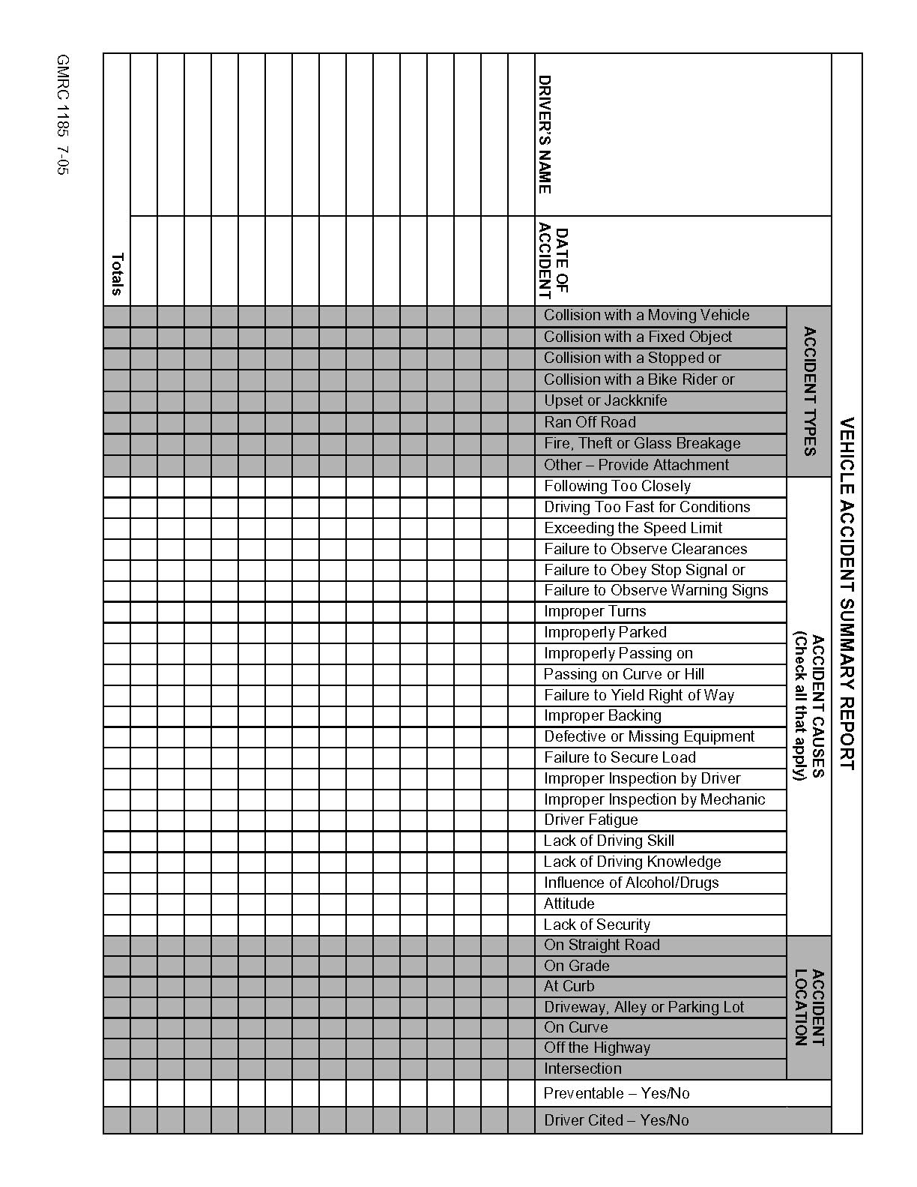

SUPERVISOR’S MOTOR VEHICLE ACCIDENT INVESTIGATION REPORT
DRIVER | VEHICLE |  | DATE OF ACCIDENT
LOCATION OF ACCIDENT |  |  | TIME OF ACCIDENT
DESCRIPTION OF ACCIDENT: (What happened?)
SEAT BELT WORN?
CAUSES OF ACCIDENT: (Why did it happen?)
RECOMMENDATIONS FOR PREVENTION OF A RECURRENCE: (What should be done?)
FOLLOW UP: (What actions were taken? Were they effective?)
– INDICATE WITH DIAGRAM WHAT HAPPENED  – SHOW POSITION OF VEHICLES  – INDICATE DIRECTION (NORTH, SOUTH, EAST, WEST) WITH ARROWS |  | CLASSIFICATION OF ACCIDENT REVIEW  PREVENTABLE NON-PREVENTABLE

ACCIDENTS USUALLY PREVENTABLE
Intersection Cut In or Out
Backing Pulled from Curb
Hit Other in Rear Hit Stationary Object
Skidded Hit Pedestrian
ACCIDENTS USUALLY NON-PREVENTABLE
Hit in Rear Hit When Properly Parked

Investigating Supervisor’s Signature Manager’s Signature

Date Of Report

Reviewed By Manager Date

RESERVED FOR FUTURE USE

Section VIII – Inspections
Periodic inspections will be conducted to identify hazardous conditions and unsafe behavior. The Manager or Supervisor within each department will conduct inspections and may request employees to participate. The inspector should look for unsafe practices and conditions that can cause an accident and take corrective action immediately. Other individuals, not employed by our company, such as OSHA representatives, insurance companies, local fire department representative, etc. may decide to make an inspection of our facility. All employees of our company are asked to treat these onsite visitors with the same courtesy, cooperation, and respect as you would any visitor to our company.
Every month, a facility inspection should be completed and provided to the (insert Manager/Supervisor or appropriate title of person within your company). The (title of person mentioned in previous sentence should be inserted here) will review the report, take any corrective action needed, and maintain a file of inspections.
Periodically top management, supervisors and/or designated employees will complete inspections on a safety-sensitive or non-routine job to ensure compliance with safety procedures. If unsafe acts or unsafe conditions are detected within an area of the organization, additional training may be provided, as needed.
Examples of the Self-Inspection Checklist can be found in Appendix C.

RESERVED FOR FUTURE USE

SECTION IX – OSHA (Occupational Safety and Health Administration)

A. OSHA Records Requirements
Copies of required accident investigations and certification of employee safety training shall be maintained by the Manager. A written report will be maintained on each accident, injury, or on-the-job illness requiring medical treatment. A record of each such injury or illness is recorded on OSHA Log and Summary of Occupational Injuries Form 300 according to instructions provided in the web site shown below. Supplemental records of each injury are maintained on OSHA Form 301. Every year, a summary of all reported injuries or illnesses is posted no later than February 1, for two months, until April 1, on OSHA Form 300. These records are maintained for five years from the date of preparation.
A copy of the OSHA 300 Log, the OSHA 300A Summary Form, and the OSHA 301 Injury and Illness Report Forms, and instructions on how to complete these forms, can be obtained by double clicking on:
http://www.osha.gov/recordkeeping/new-osha300form1-1-04.pdf

B. OSHA Inspection: What you can expect during an OSHA inspection
1. Arrival of the Compliance Officer (OSHA Inspector)
a. Request to see credentials.
b. Record his name, identification number, the name of his/her supervisor, and office location.
c. Notify the Manager or your immediate Supervisor. If neither individual is available, ask the OSHA Compliance Officer to wait until the Manager or Supervisor arrive. If he/she cannot wait, the lead person at the property should accompany the Compliance Officer on his/her inspection.
d. Do not volunteer any information, only answer questions.
2. Opening Conference
a. The scope of the inspection will be discussed.
b. The Officer will explain the reason for the inspection (i.e. employee complaint, scheduled inspection, etc.)
c. If the reason for the inspection is an employee complaint, request a copy of the complaint.
d. Take comprehensive notes and request to record the meeting and walk-around.
3. The Walk-Around (inspection)
a. The Company representative should accompany the Compliance Officer throughout the inspection.
b. The Officer may ask to interview employees. Employees should cooperate. The Company representative should attempt to participate in the interview.
c. The Company representative should be prepared to show the Officer: 1) the Safety Manual, 2) Hazard Communication Program, 3) OSHA poster, 4) OSHA 300 Log
d. If at all possible, correct any violations immediately as the Compliance Officer points them out.
e. Take photographs of the same items or areas that are photographed by the Compliance Officer.
f. Take notes. Write down every possible violation, standards cited, corrective action needed, and a deadline date.
4. Closing Conference
a. The Compliance Officer will review any violations discovered during the inspection. Compare these to the notes you took during the inspection. Point out any discrepancies and areas already corrected.
b. Be polite. Do not argue or get defensive with the Compliance Officer.
c. If you are not clear on something, ask questions.
d. This is a good opportunity to produce records of compliance efforts and other safety practices.

5. Citations and Penalties
a. Our goal is to provide a safe and healthy work environment. If the company is cited for OSHA violations, corrective action will be completed before the deadline provided by OSHA and as quickly as possible. It will be Management’s decision to appeal any citations.

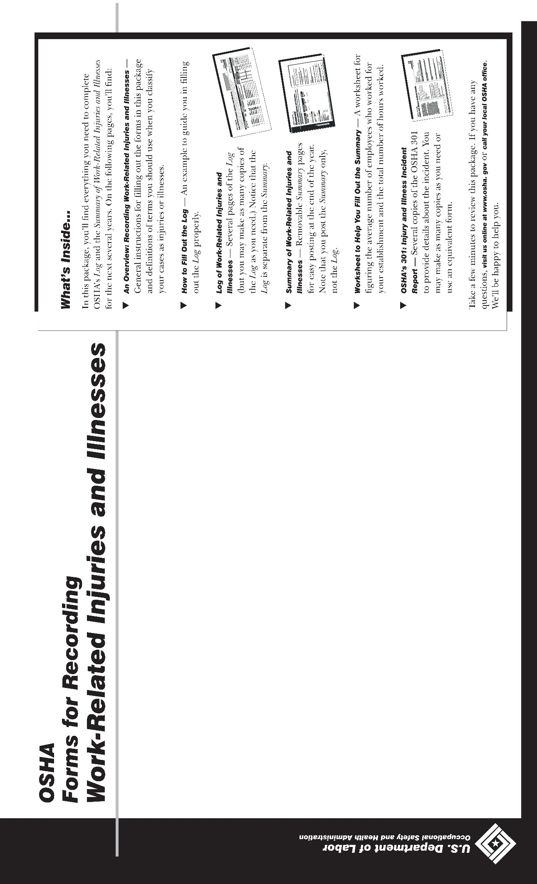

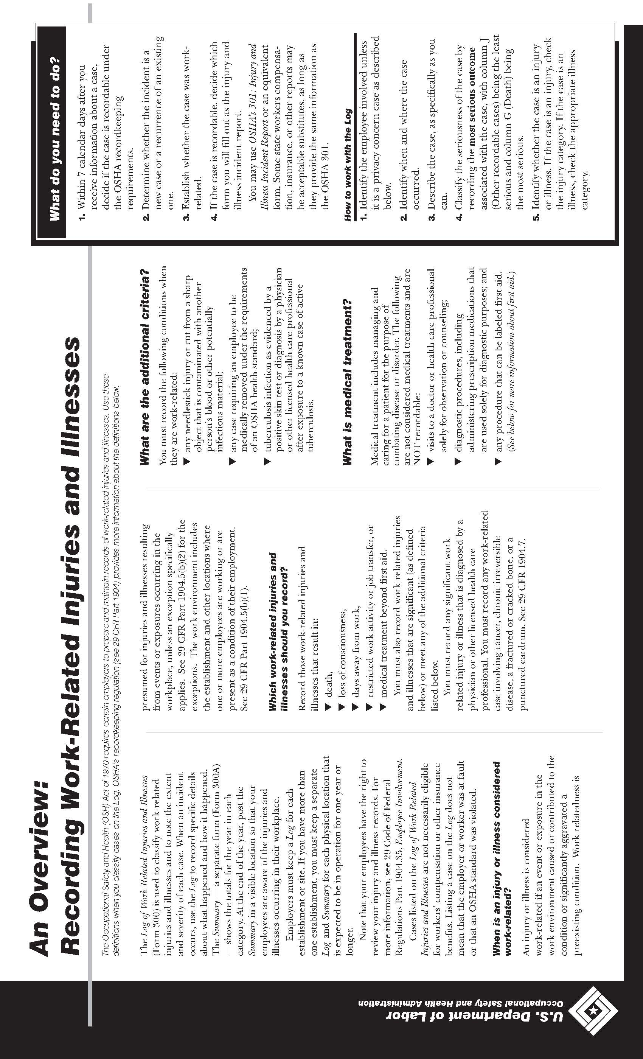

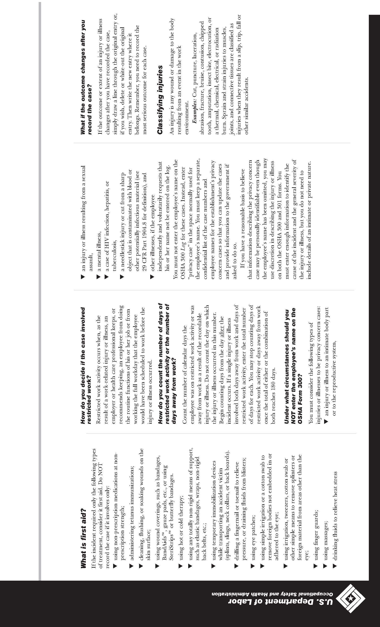

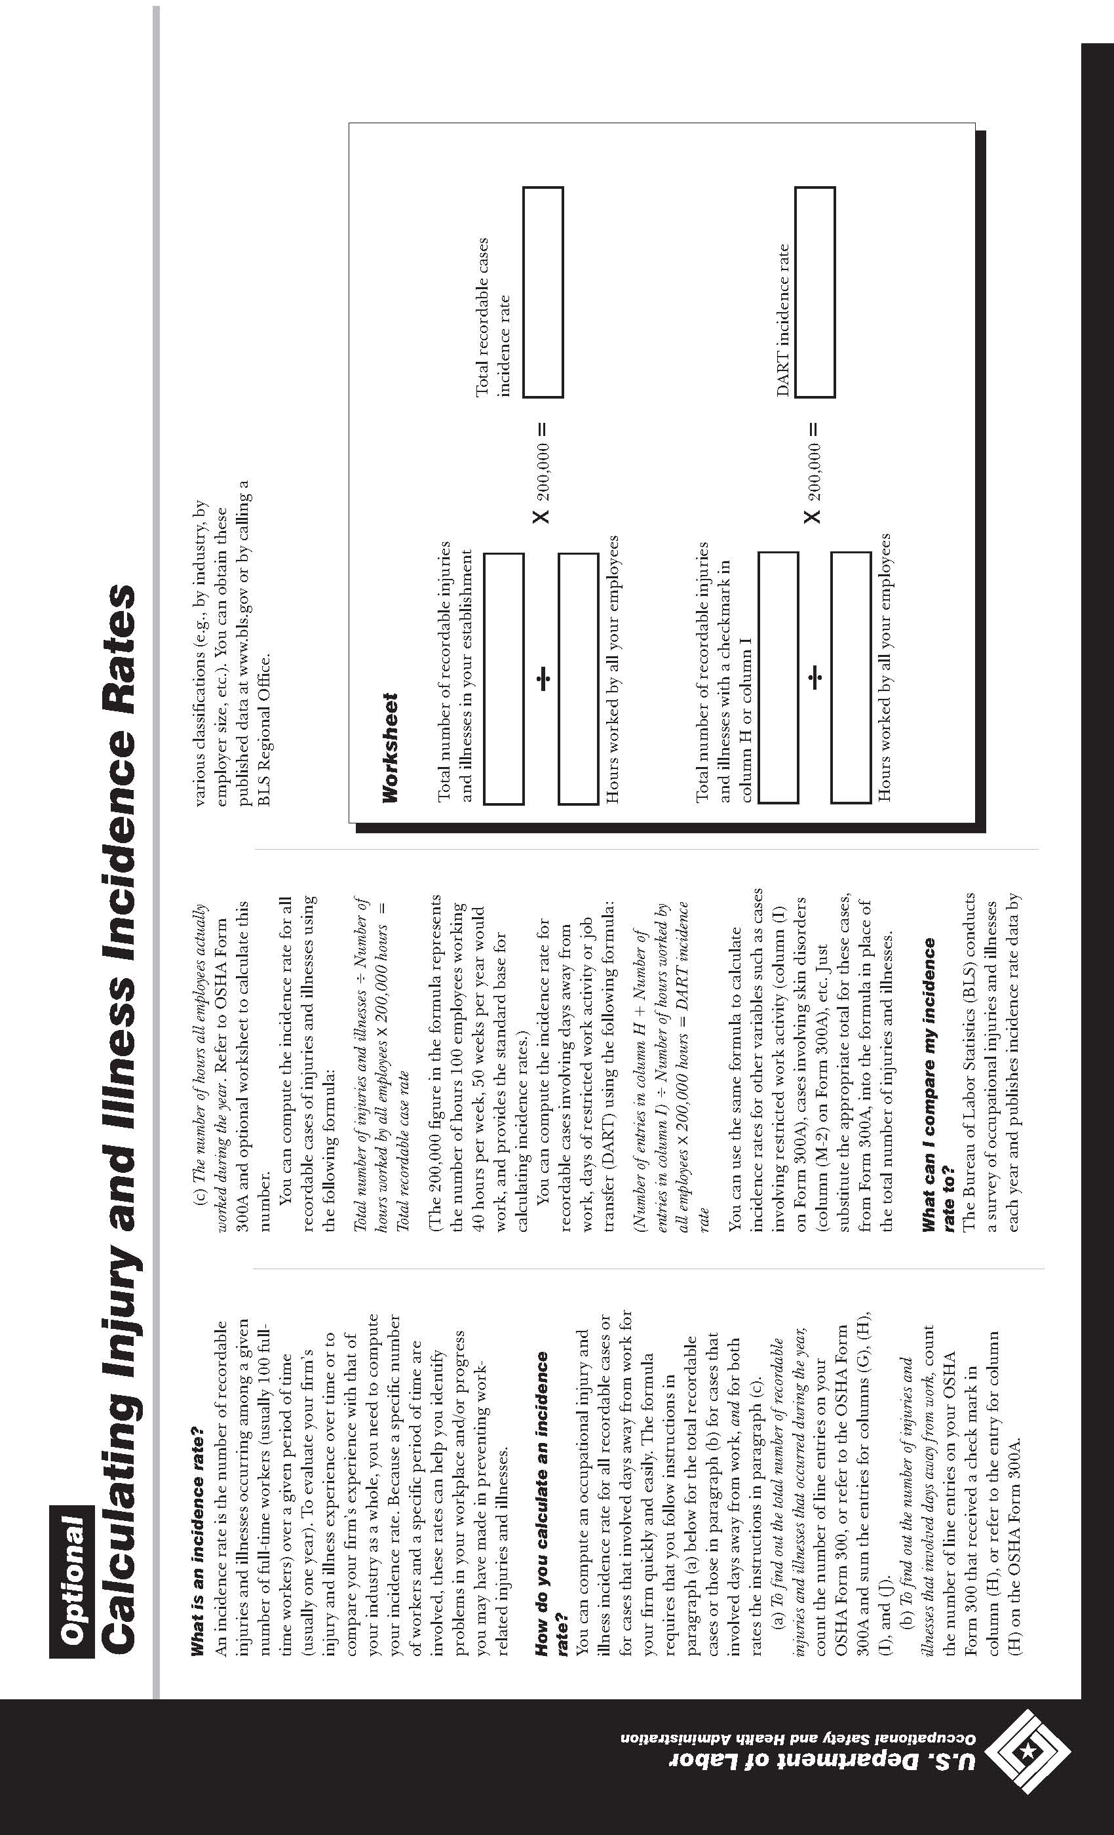

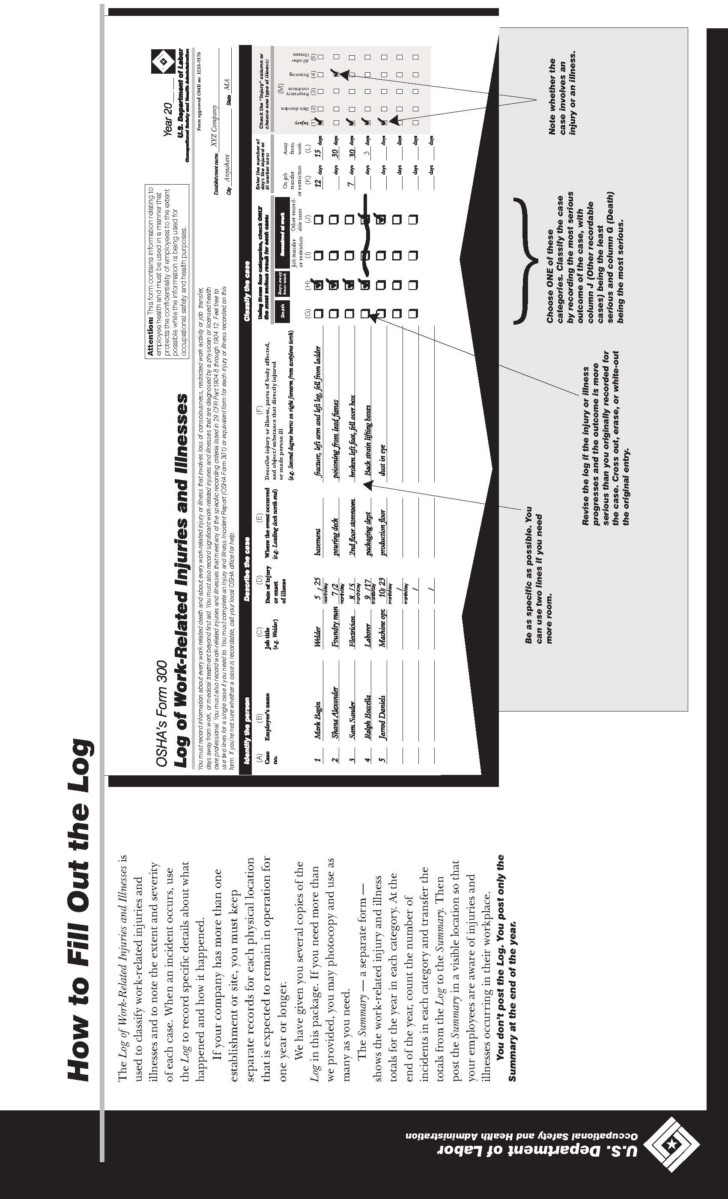
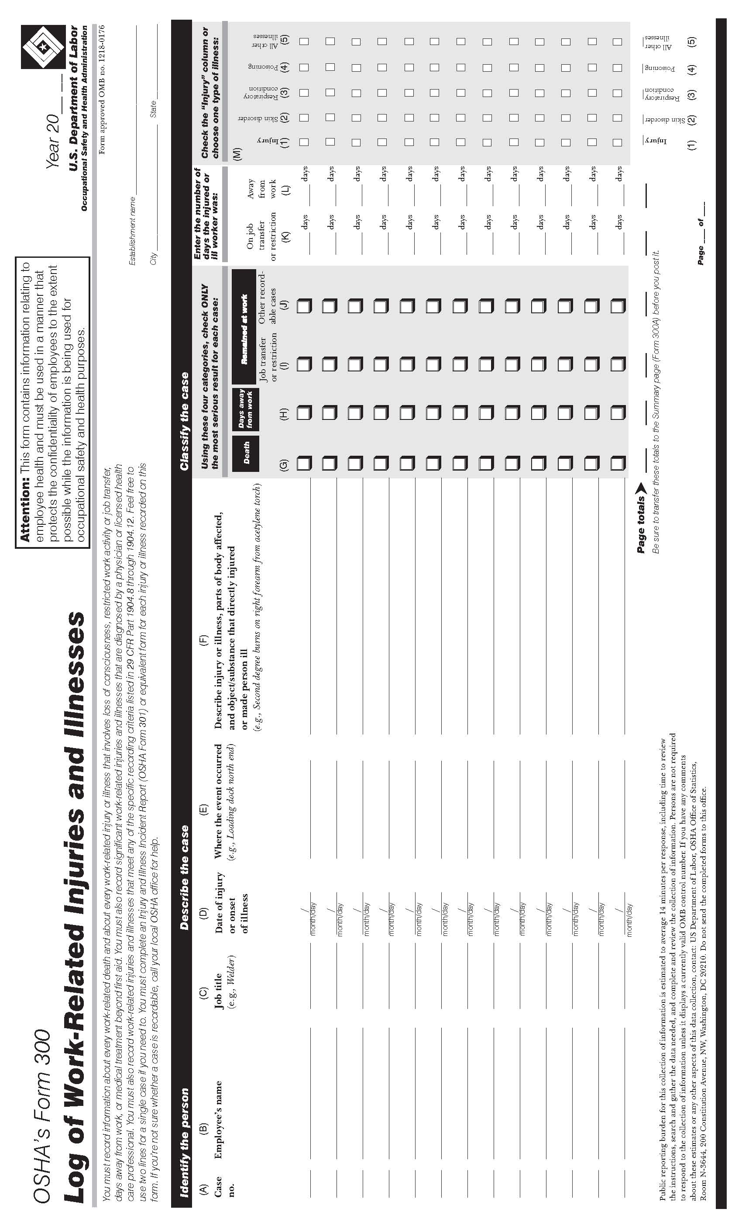

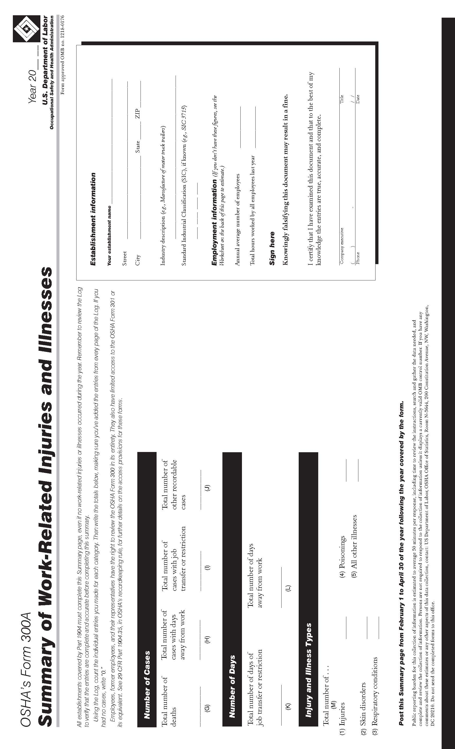

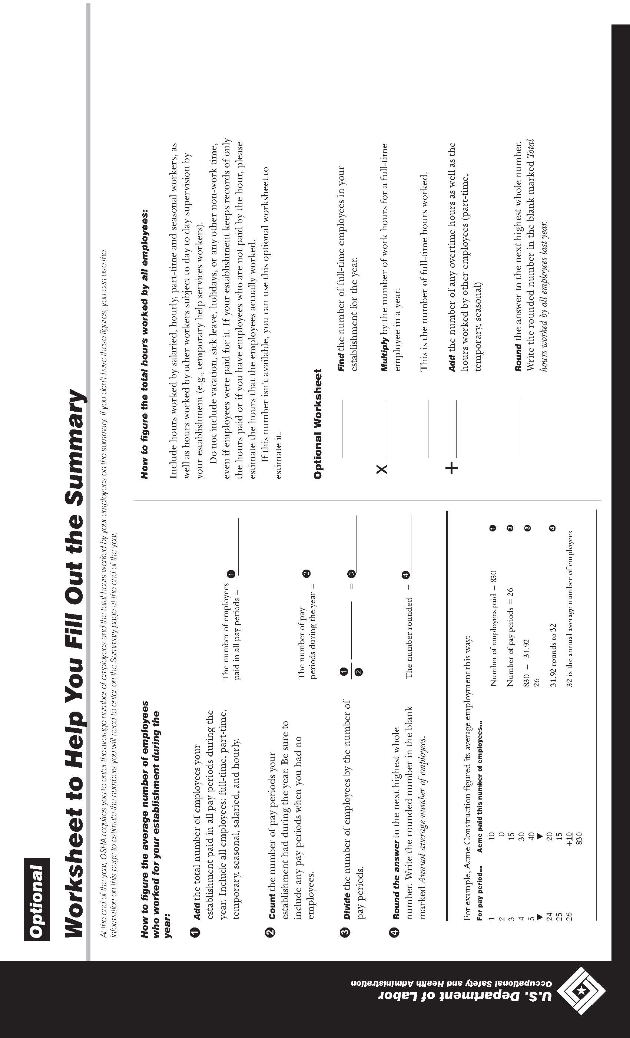

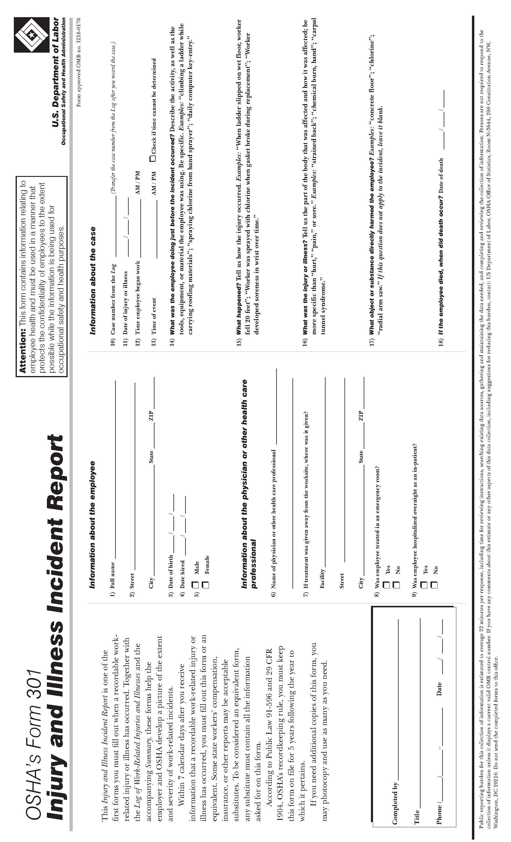

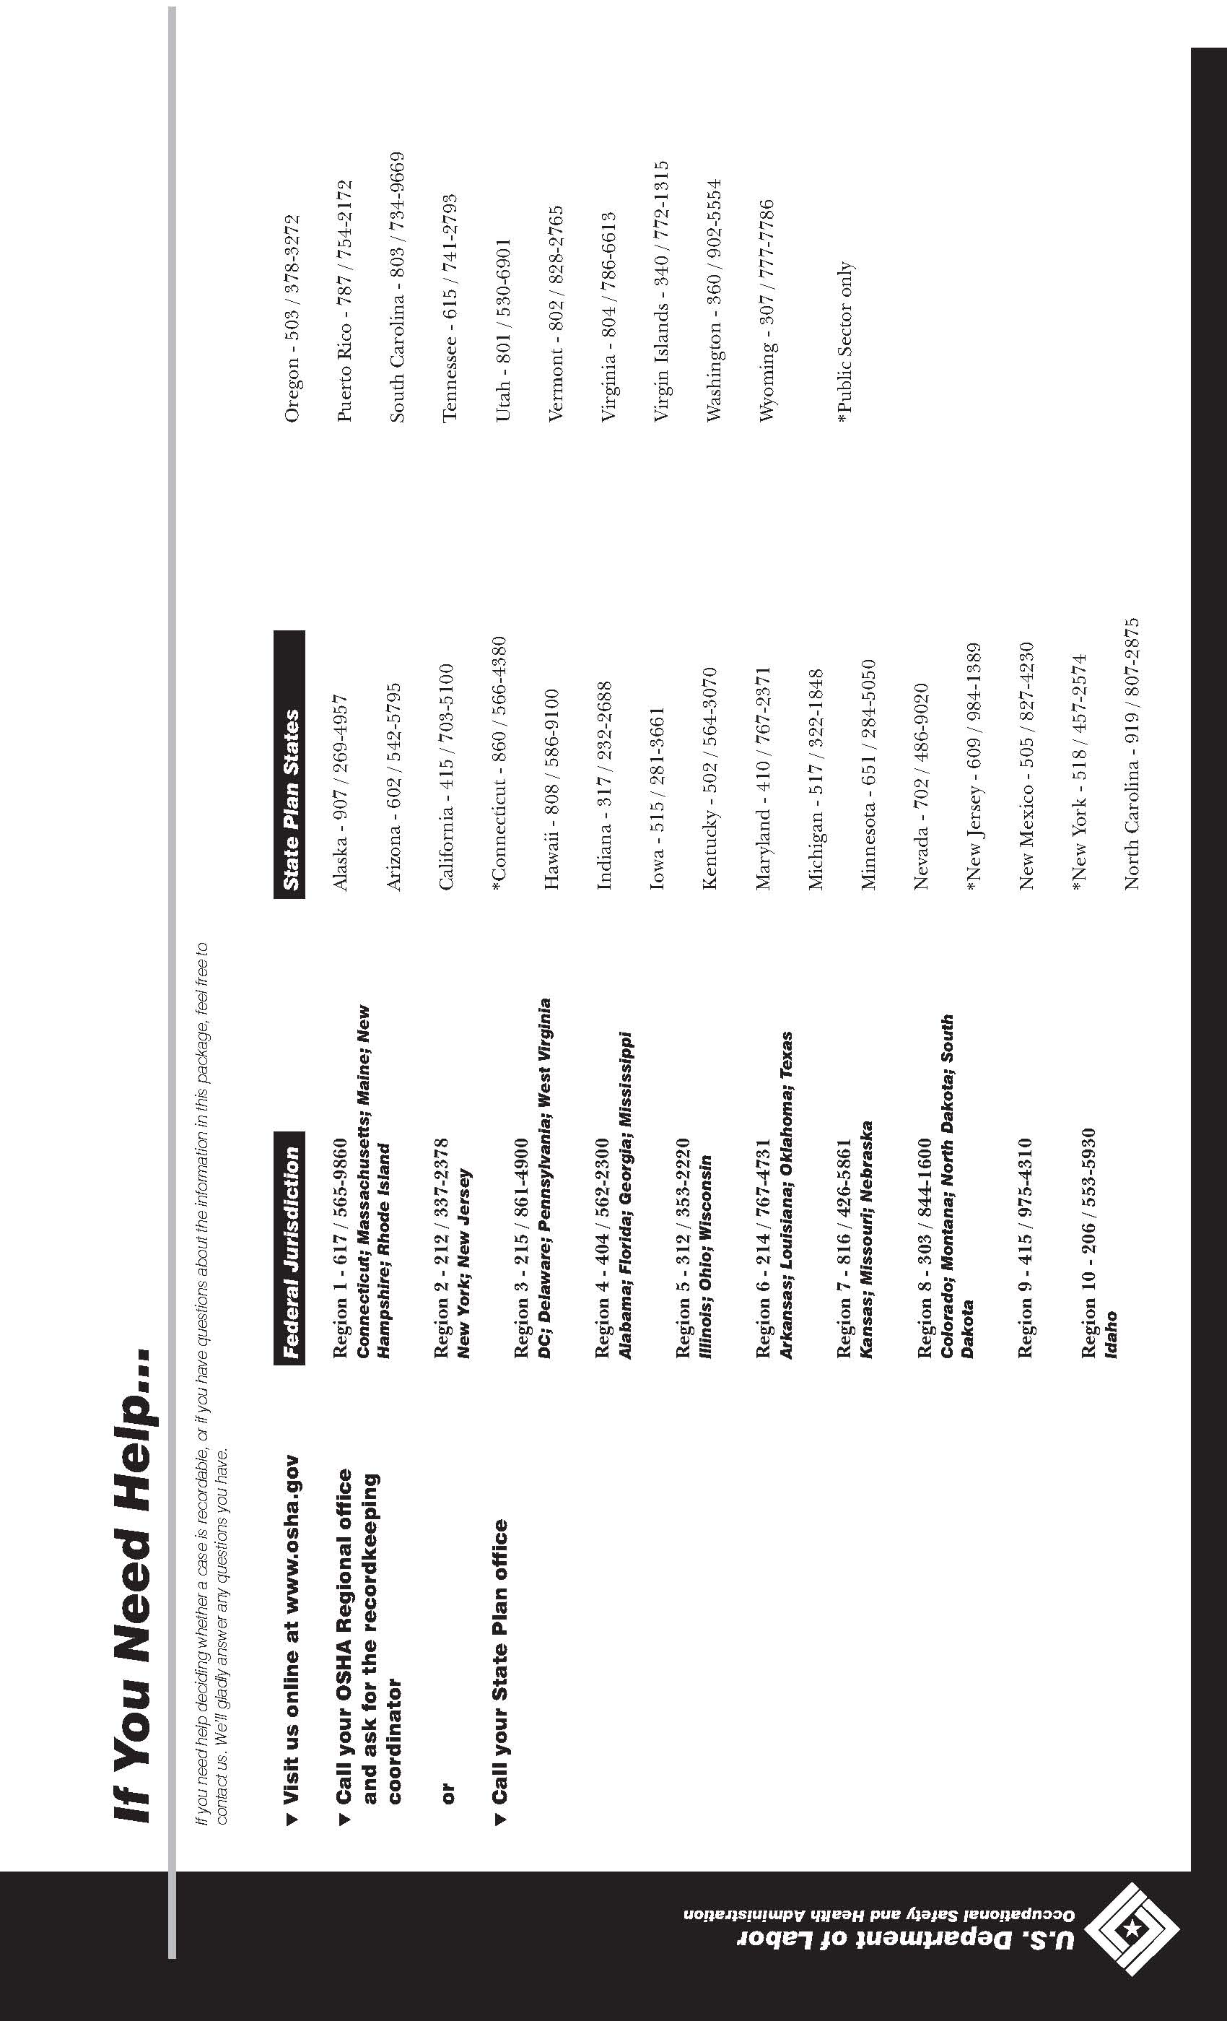

Section X – Acknowledgment Form
The rules, programs, and procedures stated within the Company’s Safety Program are not intended to cover all the possible situations you will be faced with on the job. The Company encourages you to act in a safe and responsible manner at all times, both on and off the job.
I have read the Company’s Safety Program, understand it, and agree to abide by it. I understand that violation of these rules may lead to dismissal.
Print Name:
Signature:
Date

RESERVED FOR FUTURE USE

APPENDIX A – Sample Safety Policy Statements
***************************************************************************
“The Occupational Safety and Health Act of 1970 clearly states our common goal of safe and healthful working conditions. The safety and health of our employees continues to be the first consideration in the operation of this business.”
***************************************************************************
“Safety and health in our business must be a part of every operation. Without question it is every employee's responsibility at all levels.”
***************************************************************************
“It is the intent of this company to comply with all laws. To do this we must constantly be aware of conditions in all work areas that can produce injuries. No employee is required to work at a job he or she knows is not safe or healthful. Your cooperation in detecting hazards and, in turn, controlling them is a condition of your employment. Inform your supervisor immediately of any situation beyond your ability or authority to correct.”
***************************************************************************
“The personal safety and health of each employee of this company is of primary importance. The prevention of occupationally-induced injuries and illnesses is of such consequence that it will be given precedence over operating productivity whenever necessary. To the greatest degree possible, management will provide all mechanical and physical facilities required for personal safety and health in keeping with the highest standards.”
***************************************************************************
“We will maintain a safety and health program conforming to the best practices of organizations of this type. To be successful, such a program must embody the proper attitudes toward injury and illness prevention on the part of management and employees. It also requires cooperation in all safety and health matters, not only between supervisor and employee, but also between each employee and his or her co-workers. Only through such a cooperative effort can a safety program in the best interest of all be established and preserved.”
***************************************************************************
“Our objective is a safety and health program that will reduce the number of injuries and illnesses to an absolute minimum, not merely in keeping with, but surpassing, the best experience of operations similar to ours. Our goal is zero accidents and injuries.”
***************************************************************************
“Our safety and health program will include:
- Providing mechanical and physical safeguards to the maximum extent possible.
- Conducting a program of safety and health inspections to find and eliminate unsafe working conditions or practices, to control health hazards, and to comply fully with the safety and health standards for every job.
- Training all employees in good safety and health practices.
- Providing necessary personal protective equipment and instructions for its use and care.
- Developing and enforcing safety and health rules and requiring that employees cooperate with these rules as a condition of employment.
- Investigating, promptly and thoroughly, every accident to find out what caused it and to correct the problem so that it won't happen again.
- Setting up a system of recognition and awards for outstanding safety service or performance."
***************************************************************************
“We recognize that the responsibilities for safety and health are shared:
- The employer accepts the responsibility for leadership of the safety and health program, for its effectiveness and improvement, and for providing the safeguards required to ensure safe conditions.
- Supervisors are responsible for developing the proper attitudes toward safety and health in themselves and in those they supervise, and for ensuring that all operations are performed with the utmost regard for the safety and health of all personnel involved, including themselves.
- Employees are responsible for “wholehearted, genuine cooperation with all aspects of the safety and health program, including compliance with all rules and regulations and for continuously practicing safety while performing their duties".
***************************************************************************

***************************************************************************
“It is the policy of this company that every employee is entitled to a safe and healthful place in which to work. To this end, every reasonable effort will be made in the interest of accident prevention, fire protection, and health preservation.”
***************************************************************************
“The safety of our employees is a major consideration in the operation of our organization. Management and supervisory personnel will be accountable for the safety of the employees working under their supervision and will be expected to conduct operations in a safe manner at all times. Management will also be responsible for establishing safe working conditions and promoting the health and safety of employees.”
***************************************************************************
“It is the desire of (company name) to comply with state and federal laws and to provide a safe working environment for its employees. The Company, however, recognizes that the responsibilities for safety and health are shared:
- The Company accepts the responsibility for leadership of the safety and health program, for its effectiveness and improvement, and for providing the safeguards required to ensure safe conditions.
- Supervisors are responsible for developing the proper attitude toward safety and health in themselves and in those they supervise. They are also responsible for ensuring that all operations are performed with the utmost regard for safety and health of all personnel involved, including themselves. When safety practices are necessary, the supervisor shall communicate them to the employee on his/her first day of employment. If safety procedures are not being followed, disciplinary action will be taken. This action might include, but is not limited to, reprimand, suspension, or dismissal of the employee. Periodic review of this policy with employees will be done by the supervisor.
- Employees are responsible for wholehearted cooperation in all aspects of the safety and health program including compliance with all rules and regulations – and for continuously practicing safety while performing their job functions.”
***************************************************************************
STATEMENT OF SAFETY POLICY
It is the policy of to strive for the highest safety standards
for its employees. Safety does not occur by chance. It is the result of careful attention to our work by all those involved. Managers, supervisors, and employees share the responsibility of maintaining a safe workplace.
This safety program has been developed to assure compliance with all State and Federal OSHA regulations. Regard for the safety of all employees, the general public, and subcontractors in our facilities is of great importance to
company. Accidents can be prevented and the safety of all is the goal we want to achieve.
Providing a safe place to work, the proper protective equipment and a work environment conducive to safe work practices and policies is a primary and a major concern for the management of this company.

President

Appendix B –
Sample Checklist – Planning for Emergencies
1. Has a contingency analysis been conducted to determine what emergencies might arise?
2. Have emergency plans and procedures been developed for potentially catastrophic events such as:

a. Fires
b. Explosions
c. Leaks and spills
d. Severe weather
e. Floods
f. Earthquakes
g. Bomb threats
h. Employee Violence
i. Theft/Robbery Attempts
j. Other

3. Do these plans provide for procedures for extinguishing different types of fires which might occur?
4. Do these plans have adequate evacuation and recovery procedures for each type of emergency?
5. Have responsibilities been assigned in the plan to specific personnel to direct operations and to respond to emergencies? Are these persons aware of their responsibilities? Are they qualified to lead in the necessary actions which might be required?
6. Are emergency crews qualified, designated and on site?
7. Are different communications channels assigned to support emergency operations?
8. Are there plans to evacuate personnel from each work site in the event of emergencies?
9. Are evacuation route and warning signals information posted in each work area? Are the evacuation routes and exits marked?
10. Can egress routes from work areas be followed by personnel in the dark or in smoke?
11. Are the emergency plans and procedures posted in prominent areas?
12. Have personnel received training in emergency procedures?
a. Workers
b. Supervisory personnel
c. Firefighters
d. Medical personnel
e Communications personnel
13. Are there drills on simulated emergencies being conducted periodically for personnel?
14. Is there a procedure to ensure that all personnel have been alerted to the emergency and those who will not combat it have been evacuated?
15. Are the egress provisions adequate (i.e., doors, stairways, elevators) for the evacuation in the event of an emergency?
16. Do all doors open in the proper direction to facilitate egress of personnel in emergencies?
17. Are there procedures to preclude obstructions to personnel or equipment in critical evacuation or emergency equipment access routes or areas?
18. Is the emergency equipment called for in the emergency procedures available at the facility, and is it operational? Can the equipment be reached easily if an emergency occurs?
19. Are warning systems installed (sirens, loudspeakers, etc.) and are they tested periodically? Are all personnel familiar with the meanings of warning signals and required action to be taken?
20. Is there a fire detection system at each facility? Are fire extinguishers sized, located, and of the types required by standards, and are they suitable for the types of fires which might occur?
21. Is there fire-fighting equipment located near flammables or hazardous areas?
22. Are emergency telephone numbers posted for the fire department, ambulance, hospital emergency room, law enforcement, and others?

RESERVED FOR FUTURE USE

Appendix C – Self-Inspection Checklist
The most widely accepted way to identify hazards is to conduct safety and health inspections. The only way you can be certain of the actual situation is for you to look at it from time to time.
Make a Self-Inspection of Your Business
Begin a program of seIf-inspection in your own workplace. Self-inspection is a must if you are to know where probable hazards exist and whether they are under control.
Later in this Section, you will find checklists designed to assist you in this fact-finding. They will give you some indication of where you should begin action to make your business safer and more healthful for all of your employees.
These checklists are by no means all inclusive. You may wish to add to them or delete portions that do not apply to your business. Consider carefully each item as you come to it and then make your decision.
Don't spend time with items that obviously have no application to your business. Make sure each item is seen by you or your designee, and leave nothing to memory or chance. Write down what you see, or don't see, and what you think you should do about it.
When you have completed the checklists, add this material to your injury information, your employee information, and your process and equipment information. You will now possess may facts that will help you determine what problems exist. Then, if you use the OSHA standards in your problem-solving process, it will be much easier for you to determine the action needed to solve these problems.
Once the hazards have been identified, you can institute control procedures.
Technical assistance in self-inspection may be available to you as a small business owner or manager through your insurance carrier, the local safety council and many local, state, and federal agencies, including the state consultation programs and OSHA Area Offices. Additional checklists are available from the National Safety Council, trade associations, insurance companies and other similar service organizations. Note the following self-inspection checklists taken from OSHA’s publication entitled OSHA Handbook for Small Businesses.
Self-Inspection Scope
The scope of your self-inspections should include the following:
- Processing, Receiving, Shipping and Storage — equipment, job planning, layout, heights, floor loads, projection of materials, materials-handling and storage methods.
- Building and Grounds Conditions — floors, walls, ceilings, exits, stairs, walkways, ramps, platforms, driveways, aisles.
- Housekeeping Program — waste disposal, tools, objects, materials, leakage and spillage, cleaning methods, schedules, work areas, remote areas, storage areas.
- Electricity — equipment, switches, breakers, fuses, switch-boxes, junctions, special fixtures, circuits, insulation, extensions, tools, motors, grounding, NEC compliance.
- Lighting — type, intensity, controls, conditions, diffusion, location, glare and shadow control.
- Heating and Ventilation — type, effectiveness, temperature, humidity, controls, natural and artificial ventilation and exhausting.
- Machinery — points of operation, flywheels, gears, shafts, pulleys, key ways, belts, couplings, sprockets, chains, frames, controls, lighting for tools and equipment, brakes, exhausting, feeding, oiling, adjusting, maintenance, lock out, grounding, work space, location, purchasing standards.

- Personnel — training, experience, methods of checking machines before use, type clothing, personal protective equipment, use of guards, tool storage, work practices, method of cleaning, oiling, or adjusting machinery.
- Hand and Power Tools — purchasing standards, inspection, storage, repair, types, maintenance, grounding, use and handling.
- Chemicals — storage, handling, transportation, spills, disposals, amounts used, toxicity or other harmful effects, warning signs, supervision, training, protective clothing and equipment.
- Fire Prevention — extinguishers, alarms, sprinklers, smoking rules, exits, personnel assigned, separation of flammable materials and dangerous operations, explosive-proof fixtures in hazardous locations, waste disposal.
- Maintenance — regularity, effectiveness, training of personnel, materials and equipment used, records maintained, method of locking out machinery, general methods.
- Personal Protective Equipment — type, size, maintenance, repair, storage, assignment of responsibility, purchasing methods, standards observed, training in care and use, rules of use, method of assignment.

CHECKLISTS
TABLE OF CONTENTS
ITEM PAGE
ABRASIVE WHEEL EQUIPMENT—GRINDERS C-9
COMPRESSED GAS CYLINDERS C-12
COMPRESSORS AIR RECEIVERS C-12
COMPRESSORS AND COMPRESSED AIR C-11
CONTROL OF HARMFUL SUBSTANCES BY VENTILATION C-20
ELECTRICAL C-17
ELEVATED SURFACES C-7
EMPLOYER POSTING C-4
ENTERING CONFINED SPACES C-13
ENVIRONMENTAL CONTROLS C-14
EXIT DOORS C-8
EXITING OR EGRESS C-7
FIRE PROTECTION C-5
FLAMMABLE AND COMBUSTIBLE MATERIALS C-15
FLOOR AND WALL OPENINGS C-6
FUELING C-18
GENERAL WORK ENVIRONMENT C-6
HAND TOOLS AND EQUIPMENT C-8
HAZARDOUS CHEMICAL EXPOSURE C-16
HAZARDOUS SUBSTANCES COMMUNICATION C-16
HOIST AND AUXILIARY EQUIPMENT C-12
IDENTIFICATION OF PIPING SYSTEMS C-19
INDUSTRIAL TRUCKS-FORKLIFTS C-13
LOCKOUT tAGOUT PROCEDURES C-10
MACHINE GUARDING C-9
MATERIAL HANDLING C-19
MEDICAL SERVICES AND FIRST-AID C-4
NOISE C-18
PERSONAL PROTECTIVE EQUIPMENT AND CLOTHING C-5
PORTABLE (POWER OPERATED) TOOLS AND EQUIPMENT C-9
PORTABLE LADDERS C-8
POWDER-ACTUATED TOOLS C-9
RECORDKEEPING C-4
SAFETY AND HEALTH PROGRAM C-4
SANITIZING EQUIPMENT AND CLOTHING C-20
SPRAYING OPERATIONS C-13
STAIRS AND STAIRWAYS C-7
TIRE INFLATION C-20
TRANSPORTING EMPLOYEES AND MATERIALS C-19
WALKWAYS C-6
WELDING, CUTTING AND BRAZING C-10

SELF-INSPECTION CHECKLISTS

These check lists are by no means all-inclusive. You should add to them or delete portions or items that do not apply to your operations: however, carefully consider each item as you come to it and then make your decision. You also will need to refer to OSHA standards for complete and specific standards that may apply to your work situation.
EMPLOYER POSTING
Is the required OSHA workplace poster displayed in a prominent location where all employees are likely to see it?
Are emergency telephone numbers posted where they can be readily found in case of emergency?
Where employees may be exposed to any toxic substances or harmful physical agents, has appropriate information concerning employee access to medical and exposure records and "Material Safety Data Sheets" been posted or otherwise made readily available to affected employees?
Are signs concerning "Exiting from buildings," room capacities, floor loading. biohazards, exposures to x-ray. microwave, or other harmful radiation or substances posted where appropriate?
Is the Summary of Occupational Illnesses and Injuries posted in the month of February?
RECORDKEEPING
Are all occupational injury or illnesses, except minor injuries requiring only first aid, being recorded as required on the OSHA 300 log?
Are employee medical records and records of employee exposure to hazardous substances or harmful physical agents up-to-date and in compliance with current OSHA standards?
Are employee training records kept and accessible for review by employees, when required by OSHA standards?
Have arrangements been made to maintain required records for the legal period of time for each specific type record? (Some records must be maintained for at least 40 years.)
Are operating permits and records up-to-date for such items as elevators, air pressure tanks, liquefied petroleum gas tanks, etc.?
SAFETY AND HEALTH PROGRAM
Do you have an active safety and health program in operation that deals with general safety and health program elements as well as the management of hazards specific to your worksite?
Is one person clearly responsible for the overall activities of the safety and health program?
Do you have a safety committee or group made up of management arid labor representatives that meets regularly and report in writing on its activities?
Do you have a working procedure for handling in-house employee complaints regarding safety and health?
Are you keeping your employees advised of the successful effort and accomplishments you and/or your safety committee have made in assuring they will have a workplace that is safe and healthful?
MEDICAL SERVICES AND FIRST-AID
Is there a hospital, clinic, or infirmary for medical care in proximity of your workplace?
If medical and first-aid facilities are not in proximity of your workplace, is at least one employee on each shift currently qualified to render first aid?
Have all employees who are expected to respond to medical emergencies as part of their work
(1) received first-aid training; (2) had hepatitis B vaccination made available to them; (3) had appropriate training on procedures to protect them from bloodborne pathogens, including universal precautions; and (4) have available and understand how to use appropriate personal protective equipment to protect against exposure to bloodborne diseases?
Where employees have had an exposure incident involving bloodborne pathogens, did you provide an immediate post-exposure medical evaluation and follow-up?
Are medical personnel readily available for advice and consultation on matters of employees' health?
Are emergency phone numbers posted?
Are first-aid kits easily accessible to each work area. with necessary supplies available, periodically inspected and replenished as needed?
Have first-aid kit supplies been approved by a physician. indicating that they are adequate for a particular area or operation?
Are means provided for quick drenching or flushing of the eyes and body in areas where corrosive liquids or materials are handled?

Pursuant to an OSHA memorandum July 1, 1992, employees who render first aid only as a collateral duty do not have to be offered preexposure hepatitis B vaccine only if the employer puts the following requirements into his/her exposure control plan and implements them: (1) the employer must record all first-aid incidents involving the presence of blood or other potentially infectious materials before the end of the work shift during which the first-aid incident occurred; (2) the employer must comply with post-exposure evaluation, prophylaxis, and follow-up requirements of the standard with respect to "exposure incidents," as defined by the standard; (3) the employer must train designated first-aid providers about the reporting procedure: (4) the employer must offer to initiate the hepatitis B vaccination series within 24 hours to all unvaccinated first-aid providers who have rendered assistance in any situation involving the presence of blood or other potentially infectious materials.
FIRE PROTECTION
Is your local fire department well acquainted with your facilities, its location and specific hazards?
If you have a fire alarm system, is it certified as required?
If you have a fire alarm system, is it tested at least annually?
If you have interior stand pipes and valves, are they inspected regularly?
If you have outside private fire hydrants, are they flushed at least once a year and on a routine preventive maintenance schedule?
Are fire doors and shutters in good operating condition?
Are fire doors and shutters unobstructed and protected against obstructions, including their counterweights?
Are fire door and shutter fusible links in place?
Are automatic sprinkler system water control valves, air and water pressure checked weekly/periodically as required?
Is the maintenance of automatic sprinkler systems assigned to responsible persons or to a sprinkler contractor?
Are sprinkler heads protected by metal guards, when exposed to physical damage?
Is proper clearance maintained below sprinkler heads?
Are portable fire extinguishers provided in adequate number and type?
Are fire extinguishers mounted in readily accessible locations?
Are fire extinguishers recharged regularly and noted on the inspection tag?
Are employees periodically instructed in the use of extinguishers and fire protection procedures?
PERSONAL PROTECTIVE EQUIPMENT AND CLOTHING
Are protective goggles or face shields provided and worn where there is any danger of flying particles or corrosive materials?
Are approved safety glasses required to be worn at all times in areas where there is a risk of eye injuries such as punctures, abrasions, contusions or burns?
Are employees who need corrective lenses (glasses or contacts) in working environments having harmful exposures, required to wear only approved safety glasses, protective goggles, or use other medically approved precautionary procedures.
Are protective gloves, aprons, shields, or other means provided and required where employees could be cut or where there is reasonably anticipated exposure to corrosive liquids, chemicals, blood, or other potentially infectious materials. See OSHA 29 CFR 1910.1030(b) for the definition of "other potentially infectious materials."
Are hard hats provided and worn where danger of falling objects exists?
Are hard hats inspected periodically for damage to the shell and suspension system?
Is appropriate foot protection required where there is the risk of foot injuries from hot, corrosive, poisonous substances, falling objects, crushing or penetrating actions?
Are approved respirators provided for regular or emergency use where needed?
Is all protective equipment maintained in a sanitary condition and ready for use?
Do you have eye wash facilities and a quick Drench Shower within the work area where employees are exposed to injurious corrosive materials?
Where special equipment is needed for electrical workers, is it available?
Where food or beverages are consumed on the premises, are they consumed in areas where there is no exposure to toxic material, blood, or other potentially infectious materials.
Is protection against the effects of occupational noise exposure provided when sound levels exceed those of the OSHA noise standard?

Are adequate work procedures, protective clothing and equipment provided and used when cleaning up spilled toxic or otherwise hazardous materials or liquids?
Are there appropriate procedures in place for disposing of or decontaminating personal protective equipment contaminated with, or reasonably anticipated to be contaminated with, blood or other potentially infectious materials?
GENERAL WORK ENVIRONMENT
Are all worksites clean, sanitary, and orderly?
Are work surfaces kept dry or appropriate means taken to assure the surfaces are slip-resistant?
Are all spilled hazardous materials or liquids, including blood and other potentially infectious materials, cleaned up immediately and according to proper procedures?
Is combustible scrap, debris and waste stored safely and removed from the worksite promptly?
Is all regulated waste, as defined in the OSHA bloodborne pathogens standard (29 CFR 1910.1030), discarded according to federal, state, and local regulations?
Are accumulations of combustible dust routinely removed from elevated surfaces including the overhead structure of buildings, etc.?
Is combustible dust cleaned up with a vacuum system to prevent the dust going into suspension?
Is metallic or conductive dust prevented from entering or accumulating on or around electrical enclosures or equipment?
Are covered metal waste cans used for oily and paint-soaked waste?
Are all oil and gas fired devices equipped with flame failure controls that will prevent flow of fuel if pilots or main burners are not working?
Are paint spray booths, dip tanks, etc., cleaned regularly?
Are the minimum number of toilets and washing facilities provided?
Are all toilets and washing facilities clean and sanitary?
Are all work areas adequately illuminated?
Are pits and floor openings covered or otherwise guarded?
WALKWAYS
Are aisles and passageways kept clear?
Are aisles and walkways marked as appropriate?
Are wet surfaces covered with nonslip materials?
Are holes in the floor, sidewalk, or other walking surface repaired properly, covered or otherwise made safe?
Is there safe clearance for walking in aisles where motorized or mechanical handling equipment is operating?
Are materials or equipment stored in such a way that sharp projectives will not interfere with the walkway?
Are spilled materials cleaned up immediately?
Are changes of direction or elevations readily identifiable?
Are aisles or walkways that pass near moving or operating machinery, welding operations or similar operations arranged so employees will not be subjected to potential hazards?
Is adequate headroom provided for the entire length of any aisle or walkway?
Are standard guardrails provided wherever aisle or walkway surfaces are elevated more than 30 inches above any adjacent floor or the ground?
Are bridges provided over conveyors and similar hazards?
FLOOR AND WALL OPENINGS
Are floor openings guarded by a cover, a guardrail, or equivalent on all sides (except at entrance to stairways or ladders)?
Are toeboards installed around the edges of permanent floor opening (where persons may pass below the opening)?
Are skylight screens of such construction and mounting that they will withstand a load of at least 200 pounds?
Is the glass in the windows, doors, glass walls, etc., which are subject to human impact, of sufficient thickness and type for the condition of use?
Are grates or similar type covers over floor openings such as floor drains of such design that foot traffic or rolling equipment will not be affected by the grate spacing?
Are unused portions of service pits and pits not actually in use either covered or protected by guardrails or equivalent?
Are manhole covers, trench covers and similar covers, plus their supports designed to carry a truck rear axle load of at least 20,000 pounds when located in roadways and subject to vehicle traffic?
Are floor or wall openings in fire resistive construction provided with doors or covers compatible with the fire rating of the structure and provided with self-closing feature when appropriate?

STAIRS AND STAIRWAYS
Are standard stair rails or handrails on all stairways having four or more risers?
Are all stairways at least 22 inches wide?
Do stairs have landing platforms not less than 30 inches in the direction of travel and extend 22 inches in width at every 12 feet or less of vertical rise?
Do stairs angle no more than 50 and no less than 30 degrees?
Are stairs of hollow-pan type treads and landings filled to the top edge of the pan with solid material?
Are step risers on stairs uniform from top to bottom?
Are steps on stairs and stairways designed or provided with a surface that renders them slip resistant?
Are stairway handrails located between 30 and 34 inches above the leading edge of stair treads?
Do stairway handrails have at least 3 inches of clearance between the handrails and the wall or surface they are mounted on?
Where doors or gates open directly on a stairway, is there a platform provided so the swing of the door does not reduce the width of the platform to less than 21 inches?
Are stairway handrails capable of withstanding a load of 200 pounds, applied within 2 inches of the top edge, in any downward or outward direction?
Where stairs or stairways exit directly into any area where vehicles may be operated, are adequate barriers and warnings provided to prevent employees stepping into the path of traffic?
Do stairway landings have a dimension measured in the direction of travel, at least equal to the width of the stairway?
Is the vertical distance between stairway landings limited to 12 feet or less?
ELEVATED SURFACES
Are signs posted, when appropriate, showing the elevated surface load capacity?
Are surfaces elevated more than 30 inches above the floor or ground provided with standard guardrails?
Are all elevated surfaces (beneath which people or machinery could be exposed to falling objects) provided with standard 4-inch toeboards?
Is a permanent means of access and egress provided to elevated storage and work surfaces?
Is required headroom provided where necessary?
Is material on elevated surfaces piled, stacked or racked in a manner to prevent it from tripping, falling, collapsing, rolling or spreading?
Are dock boards or bridge plates used when transferring materials between docks and trucks or rail cars?
EXITING OR EGRESS
Are all exits marked with an exit sign and illuminated by a reliable light source?
Are the directions to exits, when not immediately apparent, marked with visible signs?
Are doors, passageways or stairways. that are neither exits nor access to exits and which could be mistaken for exits, appropriately marked "NOT AN EXIT," "TO BASEMENT," "STOREROOM," etc.?
Are exit signs provided with the word "EXIT,” in lettering at least 5 inches high and the stroke of the lettering at least ½-inch wide?
Are exit doors sidehinged?
Are all exits kept free of obstructions?
Are at least two means of egress provided from elevated platforms, pits or rooms where the absence of a second exit would increase the risk of injury from hot, poisonous. corrosive, suffocating, flammable, or explosive substances?
Are there sufficient exits to permit prompt escape in case of emergency?
Are special precautions taken to protect employees during construction and repair operations?
Is the number of exits from each floor of a building and the number of exits from the building itself, appropriate for the building occupancy load?
Are exit stairways which are required to be separated from other parts of a building, enclosed by at least 2-hour fire-resistive construction in buildings more than four stories in height, and not less than 1-hour fire-resistive constructive elsewhere?
Where ramps are used as part of required exiting from a building, is the ramp slope limited to 1 ft. vertical and 12 ft. horizontal?
Where exiting will be through frameless glass doors, glass exit doors, storm doors, etc., are the doors fully tempered and meet the safety requirements for human impact?

EXIT DOORS
Are doors which are required to serve as exits designed and constructed so that the way of exit travel is obvious and direct?
Are windows which could be mistaken for exit doors, made inaccessible by means of barriers or railings?
Are exit doors openable from the direction of exit travel without the use of a key or any special knowledge or effort when the building is occupied?
Is a revolving, sliding or overhead door prohibited from serving as a required exit door?
Where panic hardware is installed on a required exit door, will it allow the door to open by applying a force of 15 pounds or less in the direction of the exit traffic?
Are doors on cold storage rooms provided with an inside release mechanism which will release the latch and open the door even if it's padlocked or otherwise locked on the outside?
Where exit doors open directly onto any street, alley or other area where vehicles may be operated, are adequate barriers and warnings provided to prevent employees stepping into the path of traffic?
Are doors that swing in both directions and are located between rooms where there is frequent traffic, provided with viewing panels in each door?
PORTABLE LADDERS
Are all ladders maintained in good condition, joints between steps and side rails tight, all hardware and fittings securely attached and moveable parts operating freely without binding or undue play?
Are non-sIip safety feet provided on each ladder?
Are non-slip safety feet provided on each metal or rung ladder?
Are ladder rungs and steps free of grease and oil?
Is it prohibited to place a ladder in front of doors opening toward the ladder except when the door is blocked open. locked or guarded?
Is it prohibited to place ladders on boxes, barrels, or other unstable bases to obtain additional height?
Are employees instructed to face the ladder when ascending or descending?
Are employees prohibited from using ladders that are broken, missing steps, rungs, or cleats, broken side rails or other faulty equipment?
Are employees instructed not to use the top step of ordinary stepladders as a step?
When portable rung ladders are used to gain access to elevated platforms, roofs, etc., does the ladder always extend at least 3 feet above the elevated surface?
Is it required that when portable rung or cleat type ladders are used, the base is so placed that slipping will not occur, or it is lashed or otherwise held in place?
Are portable metal ladders legibly marked with signs reading "CAUTION" – Do Not Use Around Electrical Equipment" or equivalent wording?
Are employees prohibited from using ladders as guys, braces, skids, gin poles, or for other than their intended purposes?
Are employees instructed to only adjust extension ladders while standing at a base (not while standing on the ladder or from a position above the ladder)?
Are metal ladders inspected for damage?
Are the rungs of ladders uniformly spaced at 12 inches, center to center?
HAND TOOLS AND EQUIPMENT
Are all tools and equipment (both company and employee-owned) used by employees at their workplace in good condition?
Are hand tools such as chisels, punches, etc. which develop mushroomed heads during use, reconditioned or replaced as necessary?
Are broken or fractured handles on hammers, axes and similar equipment replaced promptly?
Are worn or bent wrenches replaced regularly?
Are appropriate handles used on files and similar tools?
Are employees made aware of the hazards caused by faulty or improperly used hand tools?
Are appropriate safety glasses, face shields, etc. used while using hand tools or equipment which might produce flying materials or be subject to breakage?
Are jacks checked periodically to assure they are in good operating condition?
Are tool handles wedged tightly in the head of all tools?
Are tool cutting edges kept sharp so the tool will move smoothly without binding or skipping?
Are tools stored in dry, secure location where they won't be tampered with?
Is eye and face protection used when driving hardened or tempered spuds or nails?

PORTABLE (POWER OPERATED) TOOLS AND EQUIPMENT
Are grinders, saws and similar equipment provided with appropriate safety guards?
Are power tools used with the correct shield, guard, or attachment, recommended by the manufacturer?
Are portable circular saws equipped with guards above and below the base shoe?
Are circular saw guards checked to assure they are not wedged up, thus leaving the lower portion of the blade unguarded?
Are rotating or moving parts of equipment guarded to prevent physical contact?
Are all cord-connected, electrically-operated tools and equipment effectively grounded or of the approved double insulated type?
Are effective guards in place over belts, pulleys, chains, sprockets, on equipment such as concrete mixers, air compressors, etc.?
Are portable fans provided with full guards or screens having openings ½ inch or less?
Is hoisting equipment available and used for lifting heavy objects, and are hoist ratings and characteristics appropriate for the task?
Are ground-fault circuit interrupters provided on all temporary electrical 15 and 20 ampere circuits, used during periods of construction?
Are pneumatic and hydraulic hoses on power-operated tools checked regularly for deterioration or damage?
ABRASIVE WHEEL EQUIPMENT –
GRINDERS
Is the work rest used and kept adjusted to within 1/8 inch of the wheel?
Is the adjustable tongue on the top side of the grinder used and kept adjusted to within ¼ inch of the wheel?
Do side guards cover the spindle, nut, and flange and 75 percent of the wheel diameter?
Are bench and pedestal grinders permanently mounted?
Are goggles or face shields always worn when grinding?
Is the maximum RPM rating of each abrasive wheel compatible with the RPM rating of the grinder motor?
Are fixed or permanently mounted grinders connected to their electrical supply system with metallic conduit or other permanent wiring method?
Does each grinder have an individual on and off control switch?
Is each electrically operated grinder effectively grounded?
Before new abrasive wheels are mounted, are they visually inspected and ring tested?
Are dust collectors and powered exhausts provided on grinders used in operations that produce large amounts of dust?
Are splash guards mounted on grinders that use coolant to prevent the coolant reaching employees?
Is cleanliness maintained around grinders?
POWDER-ACTUATED TOOLS
Are employees who operate powder-actuated tools trained in their use and carry a valid operators card?
Is each powder-actuated tool stored In its own locked container when not being used?
Is a sign at least 7 inches by 10 inches with bold face type reading "POWDER-ACTUATED TOOL IN USE" conspicuously posted when the tool is being used?
Are powder-actuated tools left unloaded until they are actually ready to be used?
Are power-actuated tools inspected for obstructions or defects each day before use?
Do powder-actuated tool operators have and use appropriate personal protective equipment such as hard hats, safety goggles, safety shoes and ear protectors?
MACHINE GUARDING
Is there a training program to instruct employees on safe methods of machine operation?
Is there adequate supervision to ensure that employees are following safe machine operating procedures?
Is there a regular program of safety inspection of machinery and equipment?
Is all machinery and equipment kept clean and properly maintained?
Is sufficient clearance provided around and between machines to allow for safe operations, set up and servicing, material handling and waste removal?
Is equipment and machinery securely placed and anchored, when necessary to prevent tipping or other movement that could result in personal injury?
Is there a power shutoff switch within reach of the operator’s position at each machine?
Can electric power to each machine be locked out for maintenance, repair, or security?
Are the noncurrent-carrying metal parts of electrically operated machines bonded and grounded?

Are foot operated switches guarded or arranged to prevent accidental actuation by personnel or falling objects?
Are manually operated valves and switches controlling the operation of equipment and machines clearly identified and readily accessible?
Are all emergency stop buttons colored red?
Are all pulleys and belts that are within 7 feet of the floor or working level properly guarded?
Are all moving chains and gears properly guarded?
Are splash guards mounted on machines that use coolant to prevent the coolant from reaching employees?
Are methods provided to protect the operator and other employees in the machine area from hazards created at the point of operation, ingoing nip points, rotating parts, flying chips, and sparks?
Are machinery guards secure and so arranged that they do not offer a hazard in their use?
If special handtools are used for placing and removing material, do they protect the operator's hands?
Are revolving drums, barrels, and containers required to be guarded by an enclosure that is interlocked with the drive mechanism, so that revolution cannot occur unless the guard enclosure is in place, so guarded?
Do arbors and mandrels have firm and secure bearings and are they free from play?
Are provisions made to prevent machines from automatically starting when power is restored after a power failure or shutdown?
Are machines constructed so as to be free from excessive vibration when the largest size tool is mounted and run at full speed?
If machinery is cleaned with compressed air, is air pressure controlled and personal protective equipment or other safeguards utilized to protect operators and other workers from eye and body injury?
Are fan blades protected with a guard having openings no larger than ½ inch, when operating within 7 feet of the floor?
Are saws used for ripping, equipped with anti-kick back devices and spreaders?
Are radial arm saws so arranged that the cutting wheel will gently return to the back of the table when released?
LOCKOUT TAGOUT PROCEDURES
Is all machinery or equipment capable of movement, required to be de-energized or disengaged and tagged or locked-out during cleaning, servicing, adjusting or setting up operations, whenever required?
Where the power disconnecting means for equipment does not also disconnect the electrical control circuit:
Are the appropriate electrical enclosures identified?
Is means provided to assure the control circuit can also be disconnected and locked-out?
Is the locking-out of control circuits in lieu of locking-out main power disconnects prohibited?
Are all equipment control valve handles provided with a means for locking-out?
Does the lock-out procedure require that stored energy (mechanical, hydraulic, air, etc.) be released or blocked before equipment is locked-out for repairs?
Are appropriate employees provided with individually keyed personal safety locks?
Are employees required to keep personal control of their key(s) while they have safety locks in use?
Is it required that only the employee exposed to the hazard, place or remove the safety lock?
Is it required that employees check the safety of the lockout by attempting a start up after making sure no one is exposed?
Are employees instructed to always push the control circuit stop button prior to re-energizing the main power switch?
Is there a means provided to identify any or all employees who are working on locked-out equipment by their locks or accompanying tags?
Are a sufficient number of accident preventive signs or tags and safety padlocks provided for any reasonably foreseeable repair emergency?
When machine operations, configuration or size requires the operator to leave his or her control station to install tools or perform other operations, and that part of the machine could move if accidentally activated, is such element required to be separately locked or tagged out?
In the event that equipment or lines cannot be shut down, locked-out and tagged, is a safe job procedure established and rigidly followed?
WELDING, CUTTING AND BRAZING
Are only authorized and trained personnel permitted to use welding, cutting or brazing equipment?
Does each operator have a copy of the appropriate operating instructions and are they directed to follow them?
Are compressed gas cylinders regularly examined for obvious signs of defects, deep rusting, or leakage?
Is care used in handling and storage of cylinders, safety valves, relief valves, etc., to prevent damage?

Are precautions taken to prevent the mixture of air or oxygen with flammable gases, except at a burner or in a standard torch?
Are only approved apparatus (torches, regulators, pressure reducing valves, acetylene generators, manifolds) used?
Are cylinders kept away from sources of heat?
Are the cylinders kept away from elevators, stairs, or gangways?
Is it prohibited to use cylinders as rollers or supports?
Are empty cylinders appropriately marked and their valves closed?
Are signs reading: DANGER – NO SMOKING, MATCHES, OR OPENLIGHTS, or the equivalent, posted?
Are cylinders, cylinder valves, couplings, regulators, hoses, and apparatus kept free of oily or greasy substances?
Is care taken not to drop or strike cylinders?
Unless secured on special trucks, are regulators removed and valve-protection caps put in place before moving cylinders?
Do cylinders without fixed and wheels have keys, handles, or non-adjustable wrenches on stem valves when in service?
Are liquefied gases stored and shipped valve-end up with valve covers in place?
Are provisions made to never crack a fuel-gas cylinder valve near sources of ignition?
Before a regulator is removed, is the valve closed and gas released from the regulator?
Is red used to identify the acetylene (and other fuel-gas) hose, green for oxygen hose, and black for inert gas and air hose?
Are pressure-reducing regulators used only for the gas and pressures for which they are intended?
Is open circuit (No Load) voltage of arc welding and cutting machines as low as possible and not in excess of the recommended limits?
Under wet conditions, are automatic controls for reducing no load voltage used?
Is grounding of the machine frame and safety ground connections of portable machines checked periodically?
Are electrodes removed from the holders when not in use?
Is it required that electric power to the welder be shut off when no one is in attendance?
Is suitable fire extinguishing equipment available for immediate use?
Is the welder forbidden to coil or loop welding electrode cable around his body?
Are wet machines thoroughly dried and tested before being used?
Are work and electrode lead cables frequently inspected for wear and damage, and replaced when needed?
Do means for connecting cable lengths have adequate insulation?
When the object to be welded cannot be moved and fire hazards cannot be removed, are shields used to confine heat, sparks, and slag?
Are fire watchers assigned when welding or cutting is performed in locations where a serious fire might develop?
Are combustible floors kept wet, covered by damp sand, or protected by fire-resistant shields?
When floors are wet down, are personnel protected from possible electrical shock?
When welding is done on metal walls, are precautions taken to protect combustibles on the other side?
Before hot work is begun, are used drums, barrels, tanks, and other containers so thoroughly cleaned that no substances remain that could explode, ignite, or produce toxic vapors?
Is it required that eye protection helmets, hand shields and goggles meet appropriate standards?
Are employees exposed to the hazards created by welding, cutting, or brazing operations protected with personal protective equipment and clothing?
Is a check made for adequate ventilation in and where welding or cutting is performed?
When working in confined places, are environmental monitoring tests taken and means provided for quick removal of welders in case of an emergency?
COMPRESSORS AND COMPRESSED AIR
Are compressors equipped with pressure relief valves, and pressure gauges?
Are compressor air intakes installed and equipped so as to ensure that only clean uncontaminated air enters the compressor?
Are air filters installed on the compressor intake?
Are compressors operated and lubricated in accordance with the manufacturer's recommendations?
Are safety devices on compressed air systems checked frequently?
Before any repair work is done on the pressure system of a compressor, is the pressure bled off and the system locked-out?

Are signs posed to warn of the automatic starting feature of the compressors?
Is the belt drive system totally enclosed to provide protection for the front, back, top, and sides?
Is it strictly prohibited to direct compressed air towards a person?
Are employees prohibited from using highly compressed air for cleaning purposes?
If compressed air is used for cleaning off clothing, is the pressure reduced to less than 30 psi?
When using compressed air for cleaning, do employees wear protective chip guarding and personal protective equipment?
Are safely chains or other suitable locking devices used at couplings of high pressure hose lines where a connection failure would create a hazard?
Before compressed air is used to empty containers of liquid, is the safe working pressure of the container checked?
When compressed air is used with abrasive blast cleaning equipment, is the operating valve a type that must be held open manually?
When compressed air is used to inflate auto ties, is a clip-on chuck and an inline regulator preset to 40 psi required?
Is it prohibited to use compressed air to clean up or move combustible dust if such action could cause the dust to be suspended in the air and cause a fire or explosion hazard?
COMPRESSORS AIR RECEIVERS
Is every receiver equipped with a pressure gauge and with one or more automatic, spring-loaded safety valves?
Is the total relieving capacity of the safety valve capable of preventing pressure in the receiver from exceeding the maximum allowable working pressure of the receiver by more than 10 percent?
Is every air receiver provided with a drain pipe and valve at the lowest point for the removal of accumulated oil and water?
Are compressed air receivers periodically drained of moisture and oil?
Are all safety valves tested frequently and at regular intervals to determine whether they are in good operating condition?
Is there a current operating permit used by the Division of Occupational Safety and Health?
Is the inlet of air receivers and piping systems kept free of accumulated oil and carbonaceous materials?
COMPRESSED GAS CYLINDERS
Are cylinders with a water weight capacity over 30 pounds, equipped with means for connecting a valve protector device, or with a collar or recess to protect the valve?
Are cylinders legibly marked to clearly identify the gas contained?
Are compressed gas cylinders stored in areas which are protected from external heat sources such as flame impingement, intense radiant heat, electric arcs, or high temperature lines?
Are cylinders located or stored in areas where they will not be damaged by passing or falling objects or subjects to tampering by unauthorized persons?
Are cylinders stored or transported in a manner to prevent them from creating a hazard by tipping, falling or rolling?
Are cylinders containing liquefied fuel gas, stored or transported in a position so that the safety relief device is always in direct contact with the vapor space in the cylinder?
Are valve protectors always placed on cylinders when the cylinders are not in use or connected for use?
Are all valves closed off before a cylinder is moved, when the cylinder is empty, and at the completion of each job?
Are low pressure fuel-gas cylinders checked periodically for corrosion, general distortion, cracks, or any other defect that might indicate a weakness or render it unfit for service?
Does the periodic check of low pressure fuel-gas cylinders include a close inspection of the cylinders' bottom?
HOIST AND AUXILIARY EQUIPMENT
Is each overhead electric hoist equipped with a limit device to stop the hook travel at its highest and lowest point of safe travel?
Will each hoist automatically stop and hold any load up to 125 percent of its rated load if its actuating force is removed?
Is the rated load of each hoist legibly marked and visible to the operator?
Are stops provided at the safe limits of travel for trolley hoist?
Are the controls of hoist plainly marked to indicate the direction of travel or motion?
Is each cage-controlled hoist equipped with an effective warning device?
Are close-fitting guards or other suitable devices installed on hoist to assure hoist ropes will be maintained in the sheave groves?

Are all hoist chains or ropes of sufficient length to handle the full range of movement of the application while still maintaining two full wraps on the drum at all times?
Are nip points or contact points between hoist ropes and sheaves which are permanently located within seven feet of the floor, ground or working platform, guarded?
Is it prohibited to use chains or rope slings that are kinked or twisted?
Is it prohibited to use the hoist rope or chain wrapped around the load as a substitute, for a sling?
Is the operator instructed to avoid carrying loads over people?
INDUSTRIAL TRUCKS-FORKLIFTS
Are only employees who have been trained in the proper use of hoists allowed to operate them?
Are only trained personnel allowed to operate industrial trucks?
Is substantial overhead protective equipment provided on high lift rider equipment?
Are the required lift truck operating rules posed and enforced?
Is directional lighting provided on each industrial truck that operates in an area with less than 2 foot candles per square foot of general lighting?
Does each industrial truck have a warning horn, whistle, gong, or other device which can be clearly heard above the normal noise in the areas where operated?
Are the brakes on each industrial truck capable of bringing the vehicle to a complete and safe stop when fully loaded?
Will the industrial trucks' parking brake effectively prevent the vehicle from moving when unattended?
Are industrial trucks operating in areas where flammable gases or vapors, or combustible dust or ignitable fibers may be present in the atmosphere, approved for such locations?
Are motorized hand and hand/rider trucks so designed that the brakes are applied, and power to the drive motor shuts off when the operator releases his or her grip on the device that controls the travel?
Are industrial trucks with internal combustion engine, operated in buildings or enclosed areas, carefully checked to ensure such operations do not cause harmful concentration of dangerous gases or fumes?
SPRAYING OPERATIONS
Is adequate ventilation assured before spray operations are started?
Is mechanical ventilation provided when spraying operations is done in enclosed areas?
When mechanical ventilation is provided during spraying operations, is it so arranged that it will not circulate the contaminated air?
Is the spray area free of hot surfaces?
Is the spray area at least 20 feet from flames, sparks, operating electrical motors and other ignition sources?
Are portable lamps used to illuminate spray areas suitable for use in a hazardous location?
Is approved respiratory equipment provided and used when appropriate during spraying operations?
Do solvents used for cleaning have a flash point to 100ºF or more?
Are fire control sprinkler heads kept clean?
Are "NO SMOKING" signs posted in spray areas, paint rooms, paint booths, and paint storage areas?
Is the spray area kept clean of combustible residue?
Are spray booths constructed of metal, masonry, or other substantial noncombustible material?
Are spray booth floors and baffles noncombustible and easily cleaned?
Is infrared drying apparatus kept out of the spray area during spraying operations?
Is the spray booth completely ventilated before using the drying apparatus?
Is the electric drying apparatus properly grounded?
Are lighting fixtures for spray booths located outside of the booth and the interior lighted through sealed clear panels?
Are the electric motors for exhaust fans placed outside booths or ducts?
Are belts and pulleys inside the booth fully enclosed?
Do ducts have access doors to allow cleaning?
Do all drying spaces have adequate ventilation?
ENTERING CONFINED SPACES
Are confined spaces thoroughly emptied of any corrosive or hazardous substances, such as acids or caustics, before entry?
Are all lines to a confined space, containing inert, toxic, flammable, or corrosive materials valved off and blanked or disconnected and separated before entry?

Is it required that all impellers, agitators, or other moving equipment inside confined spaces be locked-out if they present a hazard?
Is either natural or mechanical ventilation provided prior to confined space entry?
Are appropriate atmospheric tests performed to check for Oxygen deficiency, toxic substances and explosive concentrations in the confined space before entry?
Is adequate illumination provided for the work to be performed in the confined space?
Is the atmosphere inside the confined space frequently tested or continuously monitored during conduct of work?
Is there an assigned safety standby employee outside of the confined space, when required, whose sole responsibility is to watch the work in progress, sound an alarm if necessary, and render assistance?
Is the standby employee appropriately trained and equipped to handle an emergency?
Is the standby employee or other employees prohibited from entering the confined space without lifelines and respiratory equipment if there is any question as to the cause of an emergency?
Is approved respiratory equipment required if the atmosphere inside the confined space cannot be made acceptable?
Is all portable electrical equipment used inside confined spaces either grounded and insulated, or equipped with ground fault protection?
Before gas welding or burning is started in a confined space, are hoses checked for leaks, compressed gas bottles forbidden inside of the confined space, torches lighted only outside of the confined area and the confined area tested for an explosive atmosphere each time before a lighted torch is to be taken into the confined space?
If employees will be using oxygen-consuming equipment such as salamanders, torches, furnaces, etc., in a confined space, is sufficient air provided to assure combustion without reducing the oxygen concentration of the atmosphere below 19.5 percent by volume?
Whenever combustion-type equipment is used in a confined space, are provisions made to ensure the exhaust gases are vented outside of the enclosure?
Is each confined space checked for decaying vegetation or animal matter which may produce methane?
Is the confined space checked for possible industrial waste which could contain toxic properties?
If the confined space is below the ground and near areas where motor vehicles will be operating, is it possible for vehicle exhaust or carbon monoxide to enter the space?
ENVIRONMENTAL CONTROLS
Are all work areas properly illuminated?
Are employees instructed in proper first-aid and other emergency procedures?
Are hazardous substances, blood, and other potentially infectious materials identified, which may cause harm by inhalation, ingestion, or skin absorption or contact?
Are employees aware of the hazards involved with the various chemicals they may be exposed to in their work environment, such as ammonia, chlorine, epoxies, caustics, etc.?
Is employee exposure to chemicals in the workplace kept within acceptable levels?
Can a less harmful method or product be used?
Is the work area's ventilation system appropriate for the work being performed?
Are spray painting operations done in spray rooms or booths equipped with an appropriate exhaust system?
Is employee exposure to welding fumes controlled by ventilation, use of respirators, exposure time, or other means?
Are welders and other workers nearby provided with flash shields during welding operations?
If forklifts and other vehicles are used in buildings or other enclosed areas, are the carbon monoxide levels kept below maximum acceptable concentration?
Has there been a determination that noise levels in the facilities are within acceptable levels?
Are steps being taken to use engineering controls to reduce excessive noise levels?
Are proper precautions being taken when handling asbestos and other fibrous materials?
Are caution labels and signs used to warn of hazardous substances (e.g., asbestos) and biohazards (e.g., bloodborne pathogens)?
Are wet methods used, when practicable, to prevent the emission of airborne asbestos fibers, silica dust and similar hazardous materials?
Are engineering controls examined and maintained or replaced on a scheduled basis?
Is vacuuming with appropriate equipment used whenever possible rather than blowing or sweeping dust?
Are grinders, saws, and other machines that produce respirable dusts vented to an industrial collector or central exhaust system?

Are all local exhaust ventilation systems designed and operating properly such as air flow and volume necessary for the application, ducts not plugged or belts slipping?
Is personal protective equipment provided, used and maintained wherever required?
Are there written standard operating procedures for the selection and use of respirators where needed?
Are restrooms and washrooms kept clean and sanitary?
Is all water provided for drinking, washing, and cooking potable?
Are all outlets for water not suitable for drinking clearly identified?
Are employees' physical capacities assessed before being assigned to jobs requiring heavy work?
Are employees instructed in the proper manner of lifting heavy objects?
Where heat is a problem, have all fixed work areas been provided with spot cooling or air conditioning?
Are employees screened before assignment to areas of high heat to determine if their health condition might make them more susceptible to having an adverse reaction?
Are employees working on streets and roadways where they are exposed to the hazards of traffic, required to wear bright colored (traffic orange) warning vests?
Are exhaust stacks and air intakes so located that contaminated air will not be recirculated within a building or other enclosed area?
Is equipment producing ultraviolet radiation properly shielded?
Are universal precautions observed where occupational exposure to blood or other potentially infectious materials can occur and in all instances where differentiation of types of body fluids or potentially infectious materials is difficult or impossible?
FLAMMABLE AND COMBUSTIBLE
MATERIALS
Are combustible scrap, debris and waste materials (oily rags, etc.) stored in covered metal receptacles and removed from the worksite promptly?
Is proper storage practiced to minimize the risk of fire including spontaneous combustion?
Are approved containers and tanks used for the storage and handling of flammable and combustible liquids?
Are all connections on drums and combustible liquid piping, vapor and liquid tight?
Are all flammable liquids kept in closed containers when not in use (e.g. parts cleaning tanks, pans, etc.)?
Are bulk drums of flammable liquids grounded and bonded to containers during dispensing?
Do storage rooms for flammable and combustible liquids have explosion-proof lights?
Do storage rooms for flammable and combustible liquids have mechanical or gravity ventilation?
Is liquefied petroleum gas stored, handled, and used in accordance with safe practices and standards?
Are no smoking signs posted on liquefied petroleum gas tanks?
Are liquefied petroleum storage stands guarded to prevent damage from vehicles?
Are all solvent wastes, and flammable liquids kept in fire resistant, covered containers until they are removed from the worksite?
Is vacuuming used whenever possible rather than blowing or sweeping combustible dust?
Are firm separators placed between containers of combustibles or flammables, when stacked one upon another, to assure their support and stability?
Are fuel gas cylinders and oxygen cylinders separated by distance, fire resistant barriers, etc. while in storage?
Are fire extinguishers selected and provided for the types of materials in areas where they are to be used?
Class A Ordinary combustible material fires.
Class B Flammable liquid, gas or grease fires.
Class C Energized-electrical equipment fires.
Are appropriate fire extinguishers mounted within 75 feet of outside areas containing flammable liquids, and within 10 feet of any inside storage area for such materials?
Are extinguishers free from obstructions or blockage?
Are all extinguishers serviced, maintained and tagged at intervals not to exceed one year?
Are all extinguishers fully charged and in their designated places?
Where sprinkler systems are permanently installed, are the nozzle heads so directed or arranged that water will not be sprayed into operating electrical switch boards and equipment?
Are "NO SMOKING" signs posted where appropriate in areas where flammable or combustible materials are used or stored?
Are safety cans used for dispensing flammable or combustible liquids at a point of use?

Are all spills of flammable or combustible liquids cleaned up promptly?
Are storage tanks adequately vented to prevent the development of excessive vacuum or pressure as a result of filling, emptying, or atmosphere temperature changes?
Are storage tanks equipped with emergency venting that will relieve excessive internal pressure caused by fire exposure?
Are "NO SMOKING" rules enforced in areas involving storage and use of hazardous materials?
HAZARDOUS CHEMICAL EXPOSURE
Are employees trained in the safe handling practices of hazardous chemicals such as acids, caustics, etc.?
Are employees aware of the potential hazards involving various chemicals stored or used in the workplace such as acids, bases, caustics, epoxies, phenols, etc.?
Is employee exposure to chemicals kept within acceptable levels?
Are eye wash fountains and safety showers provided In areas where corrosive chemicals are handled?
Are all containers, such as vats, storage tanks, etc., labeled as to their contents, e.g., “CAUSTICS"?
Are all employees required to use personal protective clothing and equipment when handling chemicals (gloves, eye protection, respirators, etc.)?
Are flammable or toxic chemicals kept in closed containers when not in use?
Are chemical piping systems clearly marked as to their content?
Where corrosive liquids are frequently handled in open containers or drawn from storage vessels or pipe lines, is adequate means readily available for neutralizing or disposing of spills or overflows properly and safely?
Have standard operating procedures been established and are they being followed when cleaning up chemical spills?
Where needed for emergency use, are respirators stored in a convenient, clean, and sanitary location?
Are respirators intended for emergency use adequate for the various uses for which they may be needed?
Are employees prohibited from eating in areas where hazardous chemicals are present?
Is personal protective equipment provided, used and maintained whenever necessary?
Are there written standard operating procedures for the selection and use of respirators where needed?
If you have a respirator protection program, are your employees instructed on the correct usage and limitations of the respirators? Are the respirators NIOSH approved for this particular application? Are they regularly inspected and cleaned, sanitized and maintained?
If hazardous substances are used in your processes, do you have a medical or biological monitoring system in operation?
Are you familiar with the Threshold Limit Values or Permissible Exposure Limits of airborne contaminants and physical agents used in your workplace?
Have control procedures been instituted for hazardous materials, where appropriate, such as respirators, ventilation systems, handling practices, etc.?
Whenever possible are hazardous substances handled in properly designed and exhausted booths or similar locations?
Do you use general dilution or local exhaust ventilation systems to control dusts, vapors, gases, fumes, smoke, solvents or mists which may be generated in your workplace?
Is ventilation equipment provided for removal of contaminants from such operations as: Production grinding, buffing, spray painting, and/or vapor degreasing, and is it operating properly?
Do employees complain about dizziness, headaches, nausea, irritation, or other factors of discomfort when they use solvents or other chemicals?
Is there a dermatitis problem? Do employees complain about dryness, irritation, or sensitization of the skin?
Have you considered the use of an industrial hygienist or environmental health specialist to evaluate your operation?
If internal combustion engines are used, is carbon monoxide kept within acceptable levels?
Is vacuuming used, rather than blowing or sweeping dusts whenever possible for clean-up?
Are materials which give off toxic asphyxiant, suffocating or anesthetic fumes, stored in remote or isolated locations when not in use?
HAZARDOUS SUBSTANCES
COMMUNICATION
Is there a list of hazardous substances used in your workplace?
Is there a current written exposure control plan for occupational exposure to bloodborne pathogens and other potentially infectious materials, where applicable?

Is there a written hazard communication program dealing with Material Safety Data Sheets (MSDS), labeling, and employee training?
Is each container for a hazardous substance (i.e., vats, bottles, storage tanks, etc.) labeled with product identity and a hazard warning (communication of the specific health hazards and physical hazards)?
Is there a Material Safety Data Sheet readily available for each hazardous substance used?
Is there an employee training program for hazardous substances?
Does this program include:
(1) An explanation of what an MSDS is and how to use and obtain one.
(2) MSDS contents for each hazardous substance or class of substances.
(3) Explanation of "Right to Know."
(4) Identification of where an employee can see the employer’s written hazard communication program and where hazardous substances are present in their work areas.
(5) The physical and health hazards of substances in the work area, and specific protective measures to be used.
(6) Details of the hazard communication program, including how to use the labeling system and MSDS's.
Does the employee training program on the bloodborne pathogens standard contain the following elements:
(1) an accessible copy of the standard and an explanation of its contents; (2) a general explanation of the epidemiology and symptoms of bloodborne diseases; (3) an explanation of the modes of transmission of bloodborne pathogens; (4) an explanation of the employer's exposure control plan and the means by which employees can obtain a copy of the written plan; (5) an explanation of the appropriate methods for recognizing tasks and the other activities that may involve exposure to blood and other potentially infectious materials; (6) an explanation of the use and limitations of methods that will prevent or reduce exposure including appropriate engineering controls, work practices, and personal protective equipment; (7) information on the types, proper use, location, removal, handling, decontamination, and disposal of personal protective equipment; (8) an explanation of the basis for selection of personal protective equipment; (9) information on the hepatitis B vaccine; (10) information on the appropriate actions to take and persons to contact in an emergency involving blood or other potentially infectious materials; (11) an explanation of the procedure to follow if an exposure incident occurs, including the methods of reporting the incident and the medical follow-up that will be made available; and (12) information on post-exposure evaluations and follow-up; (13) an explanation of signs, labels, and color coding?
Are employees trained in the following:
How to recognize tasks that might result in occupational exposure?
How to use work practice and engineering controls and personal protective equipment and to know their limitations?
How to obtain information on the types, selection, proper use, location, removal, handling, decontamination, and disposal of personal protective equipment.
Who to contact and what to do in an emergency?
ELECTRICAL
Do you specify compliance with OSHA for all contract electrical work?
Are all employees required to report as soon as practicable any obvious hazard to life or property observed in connection with electrical equipment or lines?
Are employees instructed to make preliminary inspections and/or appropriate tests to determine what conditions exist before starting work on electrical equipment or lines?
When electrical equipment or lines are to be serviced, maintained or adjusted, are necessary switches opened, locked out and tagged whenever possible?
Are portable electrical tools and equipment grounded or of the double insulated type?
Are electrical appliances such as vacuum cleaners, polishers, vending machines, etc., grounded?
Do extension cords being used have a grounding conductor?
Are multiple plug adapters prohibited?
Are ground-fault circuit interrupters installed on each temporary 15 or 20 ampere, 120 volt AC circuit at locations where construction, demolition, modifications, alterations or excavations are being performed?
Are all temporary circuits protected by suitable disconnecting switches or plug connectors at the junction with permanent wiring?
Do you have electrical installations in hazardous dust or vapor areas? If so, do they meet the National Electrical Code (NEC) for hazardous locations?
Is exposed wiring and cords with frayed or deteriorated insulation repaired or replaced promptly?
Are flexible cords and cables free of splices or taps?
Are clamps or other securing means provided on flexible cords or cables at plugs, receptacles, tools, equipment, etc., and is the cord jacket securely held in place?

Are all cord, cable and raceway connections intact and secure?
In wet or damp locations, are electrical tools and equipment appropriate for the use or location or otherwise protected?
Is the location of electrical power lines and cables (overhead, underground, underfloor, other side of walls, etc.) determined before digging, drilling or similar work is begun?
Are metal measuring tapes, ropes, handlines or similar devices with metallic thread woven into the fabric prohibited where they could come in contact with energized parts of equipment or circuit conductors?
Is the use of metal ladders prohibited in areas where the ladder or the person using the ladder could come in contact with energized parts of equipment, fixtures or circuit conductors?
Are all disconnecting switches and circuit breakers labeled to indicate their use or equipment served?
Are disconnecting means always opened before fuses are replaced?
Do all interior wiring systems include provisions for grounding metal parts of electrical raceways, equipment and enclosures?
Are all electrical raceways and enclosures securely fastened in place?
Are all energized parts of electrical circuits and equipment guarded against accidental contact by approved cabinets or enclosures?
Is sufficient access and working space provided and maintained about all electrical equipment to permit ready and safe operations and maintenance?
Are all unused openings (including conduit knockouts) in electrical enclosures and fittings closed with appropriate covers, plugs or plates?
Are electrical enclosures such as switches, receptacles, junction boxes, etc., provided with tight-fitting covers or plates?
Are disconnecting switches for electrical motors in excess of two horsepower, capable of opening the circuit when the motor is in a stalled condition, without exploding? (Switches must be horsepower rated equal to or in excess of the motor hp rating.)?
Is low voltage protection provided in the control device of motors driving machines or equipment which could cause probable injury from inadvertent starting?
Is each motor disconnecting switch or circuit breaker located within sight of the motor control device?
Is each motor located within sight of its controller or the controller disconnecting means capable of being locked in the open position or is a separate disconnecting means installed in the circuit within sight of the motor?
Is the controller for each motor in excess of two horsepower, rated in horsepower equal to or in excess of the rating of the motor it serves?
Are employees who regularly work on or around energized electrical equipment or lines instructed in the cardio-puImonary resuscitation (CPR) methods?
Are employees prohibited from working alone on energized lines or equipment over 600 volts?
NOISE
Are there areas in the workplace where continuous noise levels exceed 85dBA?
Is there an ongoing preventive health program to educate employees in: safe levels of noise, exposures; effects of noise on their health; and the use of personal protection?
Have work areas where noise levels make voice communication between employees difficult been identified and posted?
Are noise levels being measured using a sound level meter or an octave band analyzer and records being kept?
Have engineering controls been used to reduce excessive noise levels? Where engineering controls are determined to not be feasible, are administrative controls (i.e. worker rotation) being used to minimize individual employee exposure to noise?
Is approved hearing protective equipment (noise attenuating devices) available to every employee working in noisy areas?
Have you tried isolating noisy machinery from the rest of your operation?
If you use ear protectors, are employees properly fitted and instructed in their use?
Are employees in high noise areas given periodic audiometric testing to ensure that you have an effective hearing protection system?
FUELING
Is it prohibited to fuel an internal combustion engine with a flammable liquid while the engine is running?
Are fueling operations done in such a manner that likelihood of spillage will be minimal?
When spillage occurs during fueling operations, is the spilled fuel washed away completely, evaporated, or other measures taken to control vapors before restarting the engine?

Are fuel tank caps replaced and secured before starting the engine?
In fueling operations, is there always metal contact between the container and the fuel tank?
Are fueling hoses of a type designed to handle the specific type of fuel?
Is it prohibited to handle or transfer gasoline in open containers?
Are open lights, open flames, or sparking, or arcing equipment prohibited near fueling or transfer of fuel operations?
Is smoking prohibited in the vicinity of fueling operations?
Are fueling operations prohibited in building or other enclosed areas that are not specifically ventilated for this purpose?
Where fueling or transfer of fuel is done through a gravity flow system, are the nozzles of the self-closing type?
IDENTIFICATION OF PIPING SYSTEMS
When nonpotable water is piped through a facility, are outlets or taps posted to alert employees that it is unsafe and not to be used for drinking, washing or other personal use?
When hazardous substances are transported through above ground piping, is each pipeline identified at points where confusion could introduce hazards to employees?
When pipelines are identified by color painting, are all visible parts of the line so identified?
When pipelines are identified by color painted bands or tapes, are the bands or tapes located at reasonable intervals and at each outlet, valve or connection?
When pipelines are identified by color, is the color code posted at all locations where confusion could introduce hazards to employees?
When the contents of pipelines are identified by name or name abbreviation, is the information readily visible on the pipe near each valve or outlet?
When pipelines carrying hazardous substances are identified by tags, are the tags constructed of durable materials, the message carried clearly and permanently distinguishable and are tags installed at each valve or outlet?
When pipelines are heated by electricity, steam or other external source, are suitable warning signs or tags placed at unions, valves, or other serviceable parts of the system?
MATERIAL HANDLING
Is there safe clearance for equipment through aisles and doorways?
Are aisleways designated, permanently marked, and kept clear to allow unhindered passage?
Are motorized vehicles and mechanized equipment inspected daily or prior to use?
Are vehicles shut off and brakes set prior to loading or unloading?
Are containers of combustibles or flammables, when stacked while being moved, always separated by dunnage sufficient to provide stability?
Are dock boards (bridge plates) used when loading or unloading operations are taking place between vehicles and docks?
Are trucks and trailers secured from movement during loading and unloading operations?
Are dock plates and loading ramps constructed and maintained with sufficient strength to support imposed loading?
Are hand trucks maintained in safe operating condition?
Are chutes equipped with sideboards of sufficient height to prevent the materials being handled from falling off?
Are chutes and gravity roller sections firmly placed or secured to prevent displacement?
At the delivery end of the rollers or chutes, are provisions made to brake the movement of the handled materials?
Are pellets usually inspected before being loaded or moved?
Are hooks with safety latches or other arrangements used when hoisting materials so that slings or load attachments won't accidentally slip off the hoist hooks?
Are securing chains, ropes, chockers or slings adequate for the job to be performed?
When hoisting material or equipment, are provisions made to assure no one will be passing under the suspended loads?
Are material safely data sheets available to employees handling hazardous substances?
TRANSPORTING EMPLOYEES AND
MATERIALS
Do employees who operate vehicles on public thoroughfares have valid operator's licenses?
When seven or more employees are regularly transported in a van, bus or truck, is the operator's license appropriate for the class of vehicle being driven?

Is each van, bus or truck used regularly to transport employees, equipped with an adequate number of seats?
When employees are transported by truck, are provisions provided to prevent their falling from the vehicle?
Are vehicles used to transport employees equipped with lamps, brakes, horns, mirrors, windshields and turn signals in good repair?
Are transport vehicles provided with handrails, steps, stirrups or similar devices, so placed and arranged that employees can safely mount or dismount?
Are employee transport vehicles equipped at all times with at least two reflective type flares?
Is a full charged fire extinguisher, in good condition, with at least 4 B:C rating maintained in each employee transport vehicle?
When cutting tools or tools with sharp edges are carried in passenger compartments of employee transport vehicles, are they placed in closed boxes or containers which are secured in place?
Are employees prohibited from riding on top of any load which can shift, topple, or otherwise become unstable?
CONTROL OF HARMFUL SUBSTANCES
BY VENTILATION
Is the volume and velocity of air in each exhaust system sufficient to gather the dusts, fumes, mists, vapors or gases to be controlled, and to convey them to a suitable point of disposal?
Are exhaust inlets, ducts and plenums designed, constructed, and supported to prevent collapse or failure of any part of the system?
Are clean-out ports or doors provided at intervals not to exceed 12 feet in all horizontal runs of exhaust ducts?
Where two or more different type of operations are being controlled through the same exhaust system, will the combination of substances being controlled, constitute a fire, explosion or chemical reaction hazard in the duct?
Is adequate makeup air provided to areas where exhaust systems are operating?
Is the source point for makeup air located so that only clean, fresh air, which is free of contaminants, will enter the work environment?
Where two or more ventilation systems are serving a work area, is their operation such that one will not offset the functions of the other?
SANITIZING EQUIPMENT AND CLOTHING
Is personal protective clothing or equipment that employees are required to wear or use, of a type capable of being cleaned easily and disinfected?
Are employees prohibited from interchanging personal protective clothing or equipment, unless it has been properly cleaned?
Are machines and equipment, which process, handle or apply materials that could be injurious to employees, cleaned and/or decontaminated before being overhauled or placed in storage?
Are employees prohibited from smoking or eating in any area where contaminates that could be injurious if ingested are present?
When employees are required to change from street clothing into protective clothing, is a clean change room with separate storage facility for street and protective clothing provided?
Are employees required to shower and wash their hair as soon as possible after a known contact has occurred with a carcinogen?
When equipment, materials, or other items are taken into or removed from a carcinogen regulated area, is it done in a manner that will contaminate non-regulated areas or the external environment?
TIRE INFLATION
Where tires are mounted and/or inflated on drop center wheels, is a safe practice procedure posted and enforced?
Where tires are mounted and/or inflated on wheels with split rims and/or retainer rings, is a safe practice procedure posted and enforced?
Does each tire inflation hose have a clip-on chuck with at least 24 inches of hose between the chuck and an inIine hand valve and gauge?
Does the tire inflation control valve automatically shutoff the air flow when the valve is released?
Is a tire restraining device such as a cage, rack or other effective means used while inflating tires mounted on split rims, or rims using retainer rings?
Are employees strictly forbidden from taking a position directly over or in front of a tire while it's being Inflated?

Appendix D – Safety And Health Audio Visuals

FARM/AGRI-BUSINESS SAFETY
#119 Farm Safety Means Farm Safely (20 min) – Features segments with actual farmers, emergency personnel and experts talking with their experiences and safety lessons learned.
#120 Agricultural Equipment Operator Safety Series – 7 short segments on one DVD designed as a training resource for farm machinery operator safety. Suggested audience: youth engaged in agricultural machinery operations and other farm questions.
1. Starting & Stopping Tractors (8:09 min)
2. Tractor Safety on the Farm (8:49 min)
3. Tractor Hitches, PTO’s & Hydraulics (10:25 min)
4. Tractor Safety on the Road (8:43 min)
5. Why Farm Machinery Accidents Occur (9:50 min)
6. Farm Machinery Accident Situations (8:22 min)
7. Farmstead Safety (9:39 min)
#207 A Tractor Accident Can Happen to Anyone (8 min) – This DVD stresses the importance of installing Rollover Protective Structures (ROPS), as well as wearing seat-belts and exercising caution when operating a tractor.
#209 Dispensing Propane Safely – Dispensing Propane Safely is an employee training program funded by the Propane Education & Research Council that details the many tasks associated with the safe and effective dispensing of propane into several types of propane cylinders and tanks, including those found at retail locations, bulk plant and forklift operations. Propane autogas dispensing operations, as well as emerging propane technologies such as refillable one pound propane cylinders are also highlighted.
#210 Anhydrous Ammonia (33 min) – Anhydrous Ammonia DVD is a safety training video about the hazards of Anhydrous Ammonia and safe responses to incidents involving this dangerous gas.
#240 NH3 Farmer Safety (12 min) – The DVD focuses on elements that farmers need to remember when they are working with ammonia and ammonia equipment. We chose to concentrate on practices that will lessen the chances of an accident or ammonia release while in transport or during application in the field.
#244 Reducing Grain Bin Entry Risks (22 min) – Entering grain bins is a common occurrence at grain elevators and farms. While there are many dangers to grain bin entry, it can be accomplished safely. This video produced by the Grain Handling Safety Coalition will walk the viewer through the steps necessary to reduce the risks of entering a grain bin. Topics covered include: identifying risks and hazards, reducing the spoilage and proper grain storage techniques, safety standards, how to enter a bin safely, alternatives of bin entry, and best practices for overall grain handling safety.

DRIVING SAFETY
#129 Rules of the Road (105 min) – Get Street Smart! Rules of the Road introduces teens to safe, smart and skillful driving. Know what to do in case of auto accident with the “In Case of Emergency” bonus features. Interactive quizzes and tests. Topics cover driving basics, city and residential driving, highway driving, the driver’s exam, safety tips, tips for hazardous conditions, drug and alcohol awareness.
#204 Driving Distractions “Are You Playing With a Full Deck” (27 min) – Eating, drinking, operating a cell phone, PDA or navigation devices. These are all potentially dangerous activities. The explosion of vehicle electronics and “eat while you drive” fast food now makes concentrating on your driving more difficult than ever. Every driver needs to be prepared for the things that may happen when our driving focus becomes blurred by our new technology or other distractions. Driving Distraction Are you Playing with a Full Deck makes your drivers more aware of driving distractions.
#206 Young Drivers The High Risk Years (16 min) – This video listens to 16 year-olds tell why they want their driver’s licenses and what driving means to them. Parents of teenagers who died in crashes tell how they tragedies happened and how their families have been affected. The DVD includes summaries of state laws on learner’s periods, night driving restrictions, and passenger restrictions.
#208 Defensive Driving 15 Passenger Vans (11 min) – This valuable program will provide your drivers with important safety tips to help them operate the large vans safely, protect the passengers and avoid possible accidents. The DVD covers loading and handling, common causes of rollovers, safety guidelines, and buckling up.
#222 Distracted Driving (18 min) – Distracted Driving provides the information employees need to drive cars, vans and small trucks safely, both on and off the job. Topics covered are: the cost of distracted driving, “multi-tasking”, technology and distraction, eliminating distractions before you drive, cell phones, and fighting distraction on the road.
#223 Driving Defensively (18 min) – Whether they are speeding, tailgating, or just not paying attention to what they’re doing, other drivers can put you at risk. Driving Defensively provides the information employees need to drive cars, vans and small trucks defensively, both on and off the job. The DVD cover a range of topics: the fundamentals of driving defensively, dealing with distracted drivers, coping with aggressive drivers, using your headlights, driving safely in bad weather, handling a blowout, and sharing the road with trucks and buses.
#224 Driving Safety (20 min) – Driving Safety provides the information employees need to drive cars, vans, and small trucks safely, both on and off the job. It covers inspecting the vehicle (adjusting seats, mirrors, and other equipment), mental preparation and concentration, passing another vehicle, sharing the road with trucks and buses, school bus encounters, driving at night, adverse weather conditions, skidding, and hydroplaning, distracted driving, road rage, and what to do in case of an accident.
#241 Drive Safe, Save Lives (15 min) – The DVD has 3 short clips:
1. Stay Focused: Don’t Drive Distracted
2. Dangers of Impaired Driving and Speeding
3. Stay Safe with Seat Belts and Safety Seats

EMPLOYEE SAFETY
#200 Safe Lifting (17 min) – Our latest release on the topic Safe Lifting emphasizes to your employees the importance of overall back care, both at work and at home. It also provides them with other information on how to protect their back from injury including exercises and weight control. Topics included are: how the back works, common types and causes of back injuries, effects of back injuries, injury prevention and safety practices, and proper lifting techniques.
#201 Electrical Safety for Qualified Workers (13 min) – This program explains the safety precautions qualified electrical workers must always take to avoid needless tragedies while performing any type of electrical work. The DVD includes definition of a qualified worker, approach boundaries, the shock hazard of electricity, voltage-rated gloves and PPE, the arc flash boundary, creating and verifying an electrically safe work condition, and exceptions when energized work is allowed.
#202 Electrical Safety for Everyone (11 min) – This video provides viewers with a general understanding of how electricity works while showing them the actions they can take to prevent becoming a part of an energized electrical conduit. Topics include: why electricity is dangerous, resistance and Ohm’s law, two electrical safety concepts, avoiding electrical contact and grounding, safe work practices, use of double-insulated tools and GFCIs, and response to a shock event.
#203 Winter Walking Staying on Your Feet (10 min) – Winter walking is a seasonal safety issue which is usually limited to several months. But during those several months thousands of serious injuries happen. This informative video helps the viewer understand the need to adjust our walking behavior and techniques when the snow begins to fall. The DVD covers why we need to adjust our walking techniques in winter, winter hazards to be alert for, walking techniques for winter conditions, procedures for winter conditions, procedures for staying on your feet, and techniques to minimize the effects of a fall.
#205 Common Sense Construction Safety (26 min) – This is the video you need to prevent accidents and save you money, time and energy. The DVD covers what is OSHA, fall protection, electrical, ladders, scaffolds, mobile equipment, personal protective equipment, housekeeping, and additional OSHA standards.
#211 To the Point About: Lock-Out/Tag-Out (13 min) English & Spanish combo – This program trains your employees in the proper methods to control hazardous energy to prevent injuries and save lives. The DVD quickly gets to the point about the important topic of Lock-Out/Tag-Out and explains OSHA’s required training points to your employees. Covered in the DVD are energy control program, why LOTO is required, affected employees, authorized employees, other workers, and Lock-Out/Tag-Out devices.
#212 To the Point About: Confined Space Entry (12 min) English & Spanish Combo – Controlling access to confined spaces and the hazards they contain can prevent injuries and save lives. The DVD includes topics such as: the confined space entry permit, atmospheric hazards, atmospheric testing and monitoring, other confined space hazards and how they are controlled, and the duties of the entry supervisor, the attendant and the entrant.

#217 Hazard Communication in Construction Environments (18 min) – This video introduces employees to the Hazard Communication regulations and provides training on the various groups of chemicals found in the construction environment. It covers many topics: background of the regulation; GHS Safety Data Sheets and container labels, toxins, corrosives and irritants; flammables, combustibles and gases; exposure situations; personal protective equipment; and chemical storage, spills and clean-up.
#218 Construction Fall Protection: We All Win (20 min) – This program covers the information that construction workers need to protect themselves from falls. The video is a 5-part modular video presentation that can be used to educate both new and experienced workers. The modules cover introduction to fall protection, fall prevention systems, personal fall arrest systems, using personal fall arrest systems, and rescue.
#219 Hand and Power Tool Safety-Basic Training (21 min) English & Spanish version – This Basic Training program reviews various types of hand and power tools and how to handle them in a safe manner. It trains your employees to understand that tools are extremely useful but they can also be dangerous if not used correctly. Included in the DVD are why safeguards should never be bypassed, the importance of manufacturer’s safety instructions, and the employee’s responsibility to use tools safely.
#230 Fall Protection (12 min) – Fall Protection provides the information employees need to work safely when they are “off the ground”, and assist in satisfying the major training requirements in the OSHA Standard on Fall Protection. Covers: the seriousness of fall hazards, types of environments where fall may occur, the “Fall Protection Plan”, concentrating and keeping a clear head, the importance of housekeeping in preventing falls, measure that can be taken to protect against falls, and protective equipment.
#232 Ladder Safety (13 min) – Many employees take ladders for granted, and don’t take the appropriate precautions when using ladders. The dvd covers ladder selection, inspection before use, setting up and moving ladders, climbing on ladders, and ladder accidents.
#233 Ladder Safety in Construction Environments (13 min) – Many employees take ladders for granted, and don’t take the appropriate precautions when using ladders. The DVD covers ladder selection, inspection before use, setting up and moving ladders, climbing on ladders, and ladder accidents.
#234 Supported Scaffolding (20 min) – Helps employees understand the dangers of working with scaffolds, and how these risks can be minimized by knowing the correct ways to erect, maintain and use scaffolding equipment. Topics included in this dvd are: responsibilities of a “scaffold expert”, creating a level and stable foundation, platforms and planking, the danger of power lines, ramps and walkways, platform hazards, personal fall arrest systems, and guarding against falling objects.
#235 Supporting Scaffolding in Construction Environments (20 min) – Helps employees understand the dangers of working with scaffolds, and how these risks can be minimized by knowing the correct ways to erect, maintain and use scaffolding equipment. Topics included in this dvd are: responsibilities of a “scaffold expert”, creating a level and stable foundation, platforms and planking, the danger of power lines, ramps and walkways, platform hazards, personal fall arrest systems, and guarding against falling objects.
#236 Slips Trips and Falls (17 min) – Shows employees the situations that can lead to slips, trips and falls, and what they can do to avoid or prevent these accidents. It covers why slips, trips, and falls occur, common causes of accidents, potential health effects of resulting injuries, techniques used to avoid injury, the importance of safety shoes, and how to fall safely.
#237 Slips Trips and Falls in Construction Environments (17 min) – Shows employees the types of situations on construction sites that can lead to slips, trips and falls, and what they can do to avoid or prevent these accidents. Topics covered are: center of gravity and balance, trips and slips, walking surfaces, housekeeping and maintenance, footwear, how to fall properly, and personal protective equipment.
#238 Safe Lifting in Construction Environments (17 min) – Safe Lifting in Construction Environments provides the information employees need to protect their backs when they are lifting and carrying. Included are the back’s structure and function, preparing for a lift, the mechanics of safe lifting, and planning a “carry”.
#239 Personal Protective Equipment in Construction Environments (17 min) – Created to assist construction workers in selecting proper Personal Protective Equipment. Topics include general workplace injury information, PPE for head hazards, PPE for eye and face hazards, PPE for respiratory hazards, PPE for hand and finger hazards, PPE for foot hazards, and PPE for electrical hazards.

GENERAL SAFETY
#213 Garage and Repair Shop Safety (12min) – A garage or repair shop has virtually every hazard you can imagine due to the wide variety of work that is performed there. This comprehensive program trains your employees about what hazards may exist and what they must each day to prevent injury. The topics covered include PPE, electrical safety, chemical safety, and back injury prevention.
#214 Injury Prevention in Restaurants and Food Service (16 min) – This video examines some of the more common hazards in Food Service and discusses choices workers can make to protect themselves and co-workers. Strains, sprains, bruises and fractures; cuts, lacerations and punctures; burns and scalds; and safety tips for kitchen staff, servers, bus people, bar staff, and dishwashers are all included as topics.
#215 Convenience Store Safety (10 min) – This training program is designed to train employees on the proper actions they must take to prevent robberies, as well as how to act during and after a robbery or robbery attempt. It also discusses other important training points for employees to be aware of such as proper housekeeping and safe lifting procedures.
#216 Office Safety (19 min) – This program on Office Safety trains employees what hazards exist in office environments, and how important it is to use good safety practices as they go about their work. Topics covered include: avoiding falls, putting yourself at risk, setting up your workstation, preventing computer eyestrain, using powered equipment, handling office supplies, and fire safety.
#220 Accident Investigation (13 min) – The Accident Investigation training video provides employees with the information they need to understand the goals of an accident investigation, the process itself, and how they can participate in the process to help make their workplace safer. It covers accidents and near misses, investigations and root cause analysis, the role of tools and equipment in accidents, the importance of training, the role procedures play in preventing accidents, and learning from accidents.
#221 Compressed Gas Cylinders (12 min) – Compressed Gas Cylinder training video provides the information employees need to handle and transport these potentially volatile storage containers. Included on the DVD are associated hazards, moving and transporting cylinders safely, positioning cylinders properly, proper “hook-up” procedures, safe storage practices, and storage “incompatibilities.”
#225 Safety Audits (15 min) – Provides employees with an understanding of the goals and procedures that are involved in a safety audit, show them how they can help in in the audit processes and describe specific safe work practices. Includes performing a “workplace analysis”, “systems of control”, evaluating your work area, performing a “personal” safety audit, and dealing with accidents.
#226 Electrocution Hazards Part 11...Employer Requirements (15 min) – Discusses the major types of electrocution hazards, and how employees can protect themselves from electrical hazards and electrocution in construction environments, as well as employer’s responsibilities in these areas. Covers electrical hazards and electrocution, power lines and isolation, tools and equipment, assured equipment grounding conductor programs, lock-out/tag-out/ and employee training.
#227 Electrocution Hazards Part 1...Types of Hazards and How You Can Protect Yourself (22 min) – Discusses the major types of electrocution hazards and how employees can protect themselves from electrical hazards and electrocution in construction environments. Included are: electrical hazards and electrocution, major types of electrocution hazards, power lines and GFCIs, power tools and extension cords, and lock-out/tag-out.
#228 Welding Safety (14 min) – Reminds employees that there are indeed a number of hazards associated with welding and provides the information they need to work safely when involved with welding operations. Topics included are: getting “authorization” for welding operations, sparking and the risk of fire, guards and protective barriers, hazardous fumes and ventilation, the use of respirators and other personal protective equipment, eye protection (welding helmets, filters, glasses and goggles), inspecting welding equipment, and proper welding safety procedures.
#229 DOT Hazmat Safety Training (18 min) – DOT Hazmat Safety Training focuses on employees who handle hazardous materials. The DVD makes employees aware of the hazards associated with the materials and shows them how to work with the materials safely. Covers hazardous materials labels, shipping papers and the safety data sheet, packaging and loading HAZMATS, shipping and receiving HAZMATS, emergency response information, the emergency response guidebook, emergency actions, and first aid procedures.
#231 Forklift/Powered Industrial Truck Safety (28 min) – This DVD was specifically created to assist facilities in complying with OSHA’s Powered Industrial Truck Standard. Included topics are: OSHA’s certification process, the seven classes of industrial trucks, equipment checkout and maintenance, a forklift’s stability triangle, safe operating procedures, lifting and lowering loads, and trucks and loading docks.
#242 U.S. Chemical Safety Board Safety – Informs the industry, workers, and the public about the causes of chemical accidents and recommended practices to prevent them. Contains 3 separate discs.
#243 Hazard Communication and the Global Harmonizing System (22 min) – As mandated by OSHA chemical safety data must be conveyed through the use of the standard communication elements found in the Global Harmonized System for the Labeling and Classification of Chemicals. This dvd explains each of these communication elements in detail so your employees will understand how chemical hazards are communicated and how to use this information to ensure their safety when storing, handing, and using hazardous substances.
#245 Reducing the Risk (70 min) – Created by noted legal expert Richard Hammer, Reducing the Risk is a turn-key training program featuring an interactive DVD. Within a few hours, your ministry workers learn how to screen and select workers, implement solid supervision policies, and respond to allegations, keeping your church safe for children of all ages.

♦ ♦ ♦ ♦ ♦ ♦ ♦

If you would like to use any of the audio visuals, please contact:

Corporate Loss Control

Grinnell Mutual Reinsurance Company

4215 Highway 146

PO Box 790

Grinnell, IA 50112-0790

Phone: (800) 362-2041

Audiovisuals are available on a free loan basis.

Please be sure to indicate the desired audiovisual by title and/or number. The audiovisual should be reserved at least two weeks in advance to assure availability. Please return promptly when finished. If returning more than one video, please add an additional $100 in UPS insurance for each video.

RESERVED FOR FUTURE USE

Appendix E – Resources
Resources Applicable to All States

RESOURCES FOR SAFETY AND HEALTH INFORMATION
Safety & Secure TV Channel, LLC
1616 Sevem Drive
Annapolis, MD 21409
(443) 949-0456

ILLINOIS

RESOURCES FOR SAFETY AND HEALTH INFORMATION

Iowa/Illinois Safety Council
8013 Douglas Avenue
Urbandale, IA 50322-4724
(515) 276-4724
www.iisc.org
Construction Safety Council of Illinois
4100 Madison St.
Hillside, IL 60162
(708) 544-2082
www.buildsafe.org

Professor & Extension Safety Specialist
Dr. Robert Aherin
University of Illinois Chicago
Agricultural Engineering Sciences Building
360R AESB, MC-644
1304 W. Pennsylvania Avenue
Urbana, IL 61801
Ph: (217) 333-9417
Fax:(217) 244-0323
http://abe.illinois.edu/faculty/R_Aherin

Illinois Dept. of Commerce & Economic Opportunity
Industrial Services Division
100 West Randolph St. – Suite 3-400
Chicago, IL 60601
(312) 814-2337
(Provides free OSHA safety & health consultation)
www.illinoisosha.com
(Click on “Resources)

Illinois Manufacturers’ Association Headquarters
1301 W 22nd St, Suite 610
Oak Brook, IL 60523
(630) 368-5300
(800) 482-0462
(Regulatory & Compliance Information)
www.ima-net.org

Illinois Network for Agriculture Safety & Health
Chip Petrea
University of Illinois
Agr & Bio Engineering
1304 W Pennsylvania Ave.
Urbana, IL 61801
(217) 333-5035
http://web.extension.uiuc.edu/agsafety/inash/

Illinois Occupational & Environmental Health & Safety Education & Research Center
The University of Illinois at Chicago
2121 W. Taylor
Chicago, IL 60612
(312) 996-7887
www.uic.edu/sph/glakes/ce

National Safety Council
1121 Spring Lake Drive
Itasca, IL 60143-3201
(630) 285-1121
(800) 621-7619
www.nsc.org

Safety & Health Policy Center
National Safety Council
1025 Connecticut Ave., NW, Suite 1200
Washington, DC 20036
(202) 293-2270
www.nsc.org

OSHA
www.osha.gov

Regional Office
230 Dearborn Street
Room 3244
Chicago, IL 60604
(312) 353-2220

State Offices
OSHA – Calumet City Area Office
1600 167th Street – Suite 12
Calumet, IL 60409
(708) 891-3800
OSHA – Chicago Area Office
701 Lee Street – Suite 950
Des Plaines, IL 60016
(847) 803-4800
OSHA – North Aurora Area Office
365 Smoke Tree Plaza
North Aurora, IL 60542
(630) 896-8700
OSHA – Peoria Area Office
2918 West Willow Knolls Rd.
Peoria, IL 61614-1223
(309) 671-7033

INDIANA

RESOURCES FOR SAFETY AND HEALTH INFORMATION

Agricultural Safety and Health Program
Purdue University
Department of Agricultural & Biological Engineering
225 South University Street
West Lafayette, IN 47907-2093
Phone: (765) 494-1191
Fax: (765) 496-1356
http://pasture.ecn.purdue.edu/~agsafety/ASH/index.html
Indiana Division of Labor
Bureau of Safety, Education, and Training (INSafe)
402 West Washington
Room W195
Indianapolis, IN 46204-2287
(317) 232-2688
(Provides free OSHA safety & health consultation)
www.in.gov/labor/insafe/index.html

Indiana Rural Safety & Health Council
Purdue University
Agricultural Engineering Department
1146 ABE Building
W. Lafayette, IN 47907-1146
(765) 494-1191
www.farmsafety.org
(Go to safetylinks.html)

Extension Safety Specialist
William E. Field, Professor
Purdue University
Department of Agricultural & Biological Engineering
225 South University Street
West Lafayette, IN 47907-2093
Phone: (765) 494-1191
Fax: (765) 496-1356
http://pasture.ecn.purdue.edu/~agsafety/ASH/staff.html

OSHA
www.osha.gov

Regional Office
230 South Dearborn Street
Room 3244
Chicago, IL 60604
(312) 353-2220

State Office
Indianapolis Area Office
46 East Ohio Street, Room 423
Indianapolis, Indiana 46204
(317) 226-7290

Central/Southern IN Served by National Safety Council, KY Office
3176 Richmond Rd, Suite 236
Lexington, KY 40509
(859) 294-4242
www.nsc.org
Northwestern IN Served by National Safety Council, Chicago Chapter
1121 Spring Lake Dr. Suite 100
Itasca, IL 60143-3201
(800) 621-2855
(630) 775-2213
www.chicago.nsc.org

National Safety Council
1121 Spring Lake Drive
Itasca, Il 60143-3201
(630) 285-1121
(800) 621-7619
www.nsc.org

IOWA

RESOURCES FOR SAFETY AND HEALTH INFORMATION

Iowa State University
College of Agriculture
138 Curtiss Hall
Ames, IA 50011-1051
(515)294-4111
www.abe.iastate.edu/safety

I-CASH
100 Oakdale Campus,
124 IREH
Iowa City, IA 52242-5000
Phone: 319-335-4438
www.public-health.uiowa.edu/ICASH/index.html

Iowa AgrAbility
92 LeBaron Hall
Iowa State University
Ames, IA 50014
515-294-8520
www.extension.iastate.edu/agrability/

Extension Safety Specialist

Charles Schwab, Ph.D.
Associate Professor
Iowa State University
214 D Davidson Hall
Ames, IA 50014-3080
(515) 294-4131
www.abe.iastate.edu/safety

EPA

https://www.epa.gov/sites/production/files/2017-01/documents/comparison_chart_wps_011117_cwpb.pdf

Iowa Workforce Development
Steve Slater, Program Manager
Bureau of Consultation and Education
100 E. Grand Avenue
Des Moines, IA 50319
(515) 281-7629
(Provides free OSHA safety & health consultation)
www.iowaworkforce.org/labor/iosh/consultation

Iowa-Illinois Safety Council
8013 Douglas Avenue
Urbandale, Iowa 50322-2453
Phone: (515) 276-4724
www.iisc.org

National Safety Council
1121 Spring Lake Drive
Itasca, Il 60143-3201
(630) 285-1121
(800) 621-7619
www.nsc.org

OSHA
www.osha.gov

Regional Office
City Center Square
1100 Main Street, Suite 800
Kansas City, MO 64105
(816) 426-5861

State Office
Des Moines Area Office
210 Walnut Street, Room 815
Des Moines, IA 50309
(515) 284-4794

MINNESOTA

RESOURCES FOR SAFETY AND HEALTH INFORMATION

MNOSHA AREA OFFICES
St Paul Area Office
443 Lafayette Road North
St. Paul, MN 55155-4307
(651) 284-5050
(877) 470-6742
Duluth Area Office
5 North 3rd Ave. West, Suite 402
Duluth, MN 55802-1611
(218) 733-7830
Mankato Area Office
Nichols Office Center, Suite 520
410 Jackson Street
Mankato, MN 56001
(507) 389-6507
Minnesota Department of Labor and Industry
Occupational Safety & Health Division
443 Lafayette Road North
St. Paul, MN 55155-4307
(651) 284-5060
(800) 657-3776
http://www.doli.state.mn.us/mnosha.html
Minnesota Safety Council, Inc.
474 Concordia Avenue
St. Paul, MN 55103-2430
(651) 291-9150
(800) 444-9150
www.mnsafetycouncil.org
Minnesota Department of Labor and Industry
James Collins, Program Director
Consultation Division
443 Lafayette Road North
St. Paul, MN 55155
(651) 284-5060
(Provides free OSHA safety & health consultation)
www.doli.state.mn.us/wsc.html
University of Minnesota Duluth
Environmental Health & Safety Office
31-32 Durland Admin. Building
1049 University Drive
Duluth, MN 55812
(218) 726-7273 or (218) 726-7139
www.d.umn.edu

National Safety Council
1121 Spring Lake Drive
Itasca, Il 60143-3201
(630) 285-1121
(800) 621-7619
www.nsc.org
OSHA
www.osha.gov
Regional Office
230 South Dearborn Street, Room 3244
Chicago, IL 60604
(312) 353-2220
State Offices
Eau Claire Area Office
1310 W. Clairemont Avenue
Eau Claire, WI 54701
(715) 832-9019
Extension Safety Specialist
John Shutske
University of Minnesota
1390 Eckles Avenue
St. Paul, MN 55108
(612) 626-1250
Minnesota Department of Agriculture
https://www.mda.state.mn.us/protecting/farmsafety.aspx#mda

MISSOURI

RESOURCES FOR SAFETY AND HEALTH INFORMATION

Extension Safety Specialist/Safety Specialist
David Baker
University of Missouri
2-28 Ag Building
Columbia, Missouri 65211
(573) 882-6385
www.cafnr.missouri.edu
Missouri Department of Labor & Industrial Relations
3315 W. Truman Boulevard, Room 213
Jefferson City, Missouri 65102
(573) 751-4091
www.dolir.mo.gov
Missouri On Site Consultation Program
Robert Simmons, Program Mgr. –
Department of Labor & Standards
P.O. Box 449
Jefferson City, MO 65102
(573) 751-3403
(Provides free OSHA safety & health consultation)
http://www.dolir.mo.gov/ls/safetyconsultation/
OSHA
www.osha.gov
Regional Office
1100 Main St, Suite 800
Kansas City, MO 64105
(816) 426-5861
State Offices
Kansas City Area Office
6200 Connecticut Ave., Suite 100
Kansas City, Missouri 64106
(816) 483-9531
Toll Free {Missouri Residents Only}:
(800) 892-2674
St. Louis Area Office
911 Washington Ave, Room 420
St. Louis, MO 63101
(314) 425-4249
Toll Free {Missouri Residents Only}:
(800) 392-7743
National Safety Council
1121 Spring Lake Drive
Itasca, Il 60143-3201
(630) 285-1121
(800) 621-7619
www.nsc.org
Safety & Health Council of Western Missouri &
Kansas
5829 Troost Ave.
Kansas City, MO 64110
(816) 842-5223
www.safetycouncilmoks.com
Safety Council of the Ozarks
1111 South Glenstone
Springfield, MO 65804
(417) 869-2121
www.nscozarks.org
St. Joseph Safety Council
118 S. 5th, Lower Level
St. Joseph, MO 64501
(816) 233-3330
Safety Council of Greater St. Louis
1015 Locust Street, Suite 902
St. Louis, MO 63101
(314) 621-9200
www.stlsafety.org
University of Missouri Extension
https://extension.missouri.edu/main/DisplayCategory.aspx?C=49

NEBRASKA

RESOURCES FOR SAFETY AND HEALTH INFORMATION

University of Nebraska – Lincoln
Environmental Health & Safety
Lincoln, NE 68588
(402) 472-7211
http://ehs.unl.edu
OSHA 21(d) Consultation Program
Eldon Diedrichs, Program Mgr.
301 Centennial Mall South
Lincoln, NE 68509
(402) 471-4717
www.dol.state.ne.us
Staff also available in Omaha
(402) 595-3168
and
North Platte
(308) 535-8165
(Provides free OSHA safety & health consultation)

National Safety Council
1121 Spring Lake Drive
Itasca, Il 60143-3201
(630) 285-1121
(800) 621-7619
www.nsc.org
Nebraska Safety Council, Inc
4600 Valley Road – Suite 300
Lincoln, NE 68501
(402) 483-2581
www.nesafetycouncil.org
National Safety Council, Greater Omaha Chapter
11620 M Circle
Omaha, NE 68137-2231
(402) 896-0454
(800) 592-9004
www.safenebraska.org
OSHA
www.osha.gov
Regional Office
1100 Main St., Suite 800
Kansas City, MO 64105
(816) 426-5861
State Office
Omaha Area Office
Overland-Wolf Building
6910 Pacific Street, Room 100
Omaha, Nebraska 68106
(402) 221-3182
Toll Free {Nebraska Residents Only}:
(800) 642-8963

Extension Safety Specialist
William Campbell
Biological Systems Engineering
204 L.W. Chase Hall
Lincoln, NE 68583
(402) 472-6714

Nebraska Dairy Extension
https://dairy.unl.edu/farm-safety-making-it-daily-habit

NORTH DAKOTA

RESOURCES FOR SAFETY AND HEALTH INFORMATION

Safety & Environmental Health
University of North Dakota
3851 Campus Road
Auxiliary Services Bldg
Grand Forks, ND 58202
(701) 777-3341
Workforce Safety & Insurance
1600 E. Century Avenue, Suite 1
Bismarck, ND 58506
(701) 328-3800
(800) 777-5033
www.workforcesafety.com/workers
North Dakota Department of Health
Injury Prevention & Control
2nd Floor – Judicial Wing
600 E. Blvd. Avenue, Dept 301
Bismarck, ND 58505-02200
(701) 328-4536
North Dakota Safety Council
111 North 6th Street
Bismarck, ND 58501
(701) 223-6372
(800) 932-8890
www.ndsc.org
North Dakota Occupational Safety & Health
Albert Koch
Consultation – Bismarck State College
Corporate & Continuing Education
1815 Shater St.
Bismarck, ND 58501
(701) 224-5778
(Provides free OSHA safety & health consultation)
www.bismarckstate.edu/ndsafety/

National Safety Council
1121 Spring Lake Drive
Itasca, Il 60143-3201
(630) 285-1121
(800) 621-7619
www.nsc.org
OSHA
www.osha.gov
Regional Office
1999 Broadway, Suite 1690
PO Box 46550
Denver, CO 80201-6550
(720) 264-6550
State Office
Bismarck Area Office
Federal Office Building
1640 East Capitol Avenue
Bismarck, ND 58501
(701) 250-4521

OHIO

RESOURCES FOR SAFETY AND HEALTH INFORMATION

Ohio State University
Dr. Tom Bean, Director
Great Lakes Center for Agricultural Safety & Health
590 Woody Hayes Drive
(614) 292-9455
http://agsafety.osu.edu/ash/index.html
Ohio State University Extension Center at Piketon
1864 Shyville Road
Piketon, OH 45661-9749
Phone: (740) 289-2071
Columbus Number: (614) 292-4900
www.southcenters.osu.edu
Ohio State University Extension Center at Wooster
1680 Madison Ave.
Wooster, OH 44691-4096
Phone: (330) 263-3799
Voice Mail: (330) 202-3555
www.woostercenter.osu.edu
Public Employment Risk Reduction Program (PEERRP) OSHA On-Site Consultation Program
Ohio BWC Division of Safety & Hygiene
The customer contact center is open from
7:30 a.m. to 5:30 p.m. EST.
Toll-free: 1-800-OHIOBWC (1-800-644-62920
TTY: 1-800-BWC-4-TDD (1-800-292-4833)
Fax: 1-877-520-OHIO (6446)
Mailing address: BWC 30 W. Spring St.
Columbus, OH 43215-2256
http://www.ohiobwc.com/employer/programs/safety/SandHOSHAand PERRP.asp
Extension Safety Specialist
Dr. Tom Bean
Food, Ag & Biological Engineering Department
590 Woody Hayes Dr.
Columbus, OH 43210
(614) 292-9455
The Ohio State University
Agricultural Safety and Health Program
Ag Safety S.T.A.T. – Safe Tactics for Ag Today

https://agsafety.osu.edu/newsletter/ag-safety-stat

National Safety Council
1121 Spring Lake Drive
Itasca, Il 60143-3201
(630) 285-1121
(800) 621-7619
www.nsc.org
National Safety Council, Central OH Chapter
919 Old Henderson Rd.
Columbus, OH 43220
(614) 324-5934
www.nsc-centralohio.org
National Safety Council, Northern OH Chapter
Ohio One Building – Room 338
25 East Boardman St.
Youngstown, OH 44503
(330) 747-8657
(800) 715-0358
www.nscnohio.org

OSHA
www.osha.gov
Regional Office
230 Dearborn Street, Room 3244
Chicago, IL 60604
(312) 353-2220
State Offices
Cincinnati Area Office
36 Triangle Park Drive
Cincinnati, Ohio 45246
(513) 841-4132
Cleveland Area Office
Federal Office Building
1240 East 9th Street, Room 899
Cleveland, Ohio 44199
(216) 522-3818
Columbus Area Office
Federal Office Building
200 North High Street, Room 620
Columbus, Ohio 43215 (614) 469-5582
Toledo Area Office
Ohio Building
420 Madison Avenue, Suite 600
Toledo, Ohio 43604
(419) 259-7542

SOUTH DAKOTA

RESOURCES FOR SAFETY AND HEALTH INFORMATION

South Dakota Safety Council
1108 NW Avenue
Sioux Falls, SD 57104
605-361-7785 or 1-800-952-5539
www.southdakotasafetycouncil.org
South Dakota Division of Labor & Management
Kneip Building
700 Governors Drive
Pierre, SD 57501-2291
(605) 773-3681
South Dakota State University
Engineering Extension
James Manning, Department Head
West Hull 118, Box 510
907 Harvey Dunn St.
Brookings, SD 57007
(605) 688-4101
(Provides free OSHA safety & health consultation)

National Safety Council
1121 Spring Lake Drive
Itasca, Il 60143-3201
(630) 285-1121
(800) 621-7619
www.nsc.org
OSHA
www.osha.gov
Regional Office
1999 Broadway, Suite 1690
PO Box 46550
Denver, CO 80201-6550
(720) 264-6550
NO Area office in South Dakota
Contact Regional Office

WISCONSIN

RESOURCES FOR SAFETY AND HEALTH INFORMATION

University of Wisconsin
Center for Agricultural Safety & Health
Dept. of Biological Systems Engineering
Cheryl Sdjolaas
Sr. Outreach Specialist
460 Henry Mall
Madison, WI 53706
(608) 262-6330
www.wiscash.uwex.edu
Wisconsin Council of Safety
501 E. Washington Avenue
Madison, WI 53703-2944
(608) 258-3400
(800) 236-3400
http://www.wmc.org/
Wisconsin OSHA Consultation Program (Health)
University of WI State Laboratory of Hygiene
Environmental Health Division
2601 Agricultural Drive
Madison, WI 53707
(608) 226-5240
(Provides free OSHA safety & health consultation)
www.slh.wisc.edu
Wisconsin Department of Commerce (Safety)
Division of Marketing, Advocacy & Tech Development
144 NW Barstow Street
Waukesha, WI 53188
(262) 512-5198 or (800) 947-0553
(Provides free OSHA safety & health consultation)
www.commerce.state.wi.us
Extension Safety Specialist
Cheryl Skjolaas
University of Wisconsin
460 Henry Mall
Madison, WI 53706
(608) 265-0568
Wisconsin Department of Health Services
Farm Worker Health and Safety
https://www.dhs.wisconsin.gov/occupational-health/farm-health.htm

National Safety Council
1121 Spring Lake Drive
Itasca, Il 60143-3201
(630) 285-1121
(800) 621-7619
www.nsc.org
OSHA
www.osha.gov
Regional Office
City Center Square
1100 Main Street, Suite 800
Kansas City, Missouri 64105
(816) 426-5861
State Offices

Appleton Area Office
1648 Tri Park Way
Appleton, WI 54914
(920) 734-4521
Eau Claire Area Office
1310 W. Clairemont Avenue
Eau Claire, WI 54701
(715) 832-9019
Madison Area Office
4802 E. Broadway
Madison, WI 53716
(608)441-5388
Milwaukee Area Office
Henry S. Reuss Building, Suite 1180
310 West Wisconsin Avenue
Milwaukee, WI 53203
(414) 297-3315

